Computer Organization & Architecture
Question Bank – Solved Study Material
SY B.Tech • PCCOE Pune • AY 2026-27 • Summative exam (30 marks)

Unit I – Basic Structure of Computer
Unit II – CPU Design
Unit III – Memory Subsystem
Unit IV – I/O Subsystem

How to use this material
Summative exam: 30 marks, 1 hr 15 min, 4 questions (one block per unit), all compulsory, with options inside Q3 and Q4. Questions carry 2, 4 or 5 marks.
Question | Parts | Marks
Q.1 (compulsory) | A: i), ii) B: i), ii) | 5 + 2
Q.2 (compulsory) | A and B | 4 + 4
Q.3 | A: any one of i)/ii) B: compulsory | 5 + 2
Q.4 | Any two of A, B, C | 4 + 4

How long should my answer be?
Marks | Write about | Must include
2 marks | 4–6 lines (≈50–70 words) | Definition + 2 key points or one example
4 marks | ≈ 1 page (≈120–160 words) | Definition, 4–5 points, a diagram or table if it fits
5 marks | 1–1.5 pages (≈160–220 words) | Intro, 5–6 points / steps, labelled diagram, example, short conclusion
6 marks | 1.5 pages (≈220–260 words) | Everything for 5 marks + comparison table or worked example

Exam tips: underline key words, draw neat labelled diagrams (they earn marks even when text is short), use point-wise answers, and end long answers with a one-line conclusion. The green "Remember" boxes give a short trick to recall each answer.

Contents
How to use this material 2
Contents 3
Unit I: Basic Structure of Computer 8
Q1. Illustrate the different functional units of a computer with suitable diagram. 8
Q2. Differentiate between Computer Architecture and Computer Organization with examples 8
Q3. Draw a block diagram showing CPU, memory, and I/O interconnection and Explain the roles of: Control unit, ALU, Registers 9
Q4. Elaborate the evolution of Intel x86 processors from 8086 to modern x86-64 10
Q5. List and explain the steps involved in the execution of a complete instruction cycle. List the basic symbols used in register transfer Language 10
Q6. Explain the bus structure in detail with neat diagram. 11
Q7. Explain various types of computer registers with block diagrams. 11
Q8. Define Performance of a computer system. Illustrate the factors on which performance of a computer is measured. 12
Q9. Differentiate between Response Time and Throughput with examples. 13
Q10. Describe the modes of data transfer and its usage in detail. 13
Q11. Define a multicore processor and list its advantages over single-core CPUs 13
Q12. Illustrate the fetch–decode–execute cycle with a neat diagram. 14
Q13. Draw a diagram of a typical bus interconnection structure and explain its working. 15
Q14. Justify the Von Neumann bottlenecks and how can it be reduced? 15
Q15. Compare Harvard and Von Neumann architectures with a labeled diagram. Elaborate the same with example. 16
Q16. Explain the basic components of Generic Computing system regardless of its internal architecture with practical real time examples 17
Q17. Describe the Instruction set Architecture of simple computer. 17
Q18. A computer uses a shared system bus connecting CPU, memory, and I/O devices. If two devices attempt to use the bus simultaneously, what problem occurs and how can it be resolved? 18
Q19. List and explain the purpose of different registers for the basic computer 19
Q20. A processor needs to fetch instructions while simultaneously accessing data. Justify why Harvard architecture may provide better performance than Von Neumann architecture in this situation. 19
Q21. A computer system is experiencing poor performance even though its processor has a high clock frequency. Analyse which components other than the CPU may be responsible. 20
Q22. Differentiate between multiprocessor and multicomputer systems. Give two real-world examples of multiprocessor systems. 21
Q23. Analyse the roles of the ALU, control unit, registers, and buses during the execution of an arithmetic instruction. 22
Q24. Consider an Instruction x= ( A+ B)/C , explain each stage in an instruction execution cycle and write the phases of Instruction cycle. Devise the steps in two-address instruction format 23
Q25. With a neat schematic, explain the steps involved in fetch and decode phases using register transfer instructions. Draw suitable diagram showing the contents of register with data flow. 24
Q26. Narrate the following Execution time/Response time, access time, CPU cycle, Pulse time , Latency as Performance parameters with suitable example. 25
Q27. Justify the need of Bus structure in computer organization. Draw the figure to show how functional units are interconnected using a bus and explain it. 25
Q28. A system has four processors sharing a common main memory. If one processor updates a memory location, the other processors should see the updated value. Which architecture is most appropriate? Justify the answer. 26
Q29. A system consists of eight processors, each having its own local memory. Processors communicate by explicitly sending messages through an interconnection network. Identify the system and justify the answer. 27
Quick Revision – Unit I 28
Unit II: CPU design 30
Q1. Draw the internal organization of CPU, elaborating the functionalities of each component 30
Q2. Define the following terms: 1.Instruction Set 2.Instruction Format 3. Addressing Mode 30
Q3. List different addressing modes with one example each. 31
Q4. Define Interrupt and list its types. 31
Q5. Elaborate the concept of pipelining? List its advantages. 32
Q6. Describe various instruction formats (zero-address, one-address, two-address, three-address) with examples. 32
Q7. Classify different Types of Instructions used in Computer Organization with an example 33
Q8. Explain direct and immediate addressing Modes. 34
Q9. Draw a neat diagram of a hardwired control unit and explain its working. 34
Q10. Explain the design of a micro programmed control unit with the help of a block diagram. 35
Q11. Illustrate the advantages of Direct addressing Mode with suitable example. 36
Q12. Illustrate the advantages of Indirect addressing Mode with suitable example. 37
Q13. Illustrate the disadvantages of displacement addressing Mode with suitable example. 37
Q14. Draw and explain Processor and memory architecture of computer system. 38
Q15. Justify the significance of Instruction Format with suitable example. Define the opcode and operands. 39
Q16. Compare CISC and RISC architectures based on: Instruction complexity, Execution time, Pipelining support, Hardware requirement 39
Q17. Compare hardwired control and micro programmed control in terms of speed, cost, and flexibility. Which is preferred for modern CPUs? 40
Q18. Draw and explain the flowchart of instruction cycle for Z=( (A+B)/(D*E)) Explain any three addressing modes with example. 40
Q19. Explain how the expression X=A X B + C X C will be executed in one address, two address and three address processors in an accumulator organization. 41
Q20. Discuss design issues and performance trade-offs in RISC vs CISC processors with real-world examples (ARM, Intel). 42
Q21. A machine supports 3-address, 2-address, and 1-address instructions. For a complex arithmetic expression like (A*B + C*D) / (E+F), show how the number of instructions varies with each format. Which format leads to minimal memory traffic? 43
Q22. For given complex arithmetic expressions (A + B) * (C + D), (((A+B)+C)+D), (AB) / (CD) + (E+F) ), Show how the number of instructions varies in 3-address, 2-address, and 1-address instructions. 44
Q23. Explain how interrupts can alter the normal instruction cycle. What architectural mechanisms are needed to preserve program correctness? 44
Q24. A machine uses a 32-bit instruction word. If 8 bits are reserved for opcode and 24 bits for addressing, how many unique instructions can be supported? 45
Q25. Explain with examples the following addressing modes: Immediate, Direct, Indirect, Indexed, and Relative. 46
Q26. Justify why is Indexed addressing mode widely used in array processing? 47
Q27. Justify why do RISC processors prefer simple, fixed-length instructions? 47
Q28. Explain the difference between general-purpose registers (GPRs) and special-purpose registers (SPRs) with examples. 48
Q29. Draw the pipeline execution diagram for the following instructions: I1: LOAD R1, A I2: ADD R2, R1, R3 I3: SUB R4, R2, R5 48
Q30. Compare various addressing formats. (w.r.t.Instruction Format, Data Storage, Execution Speed, Used In,Instruction Length) 50
Q31. Draw a suitable interrupt cycle diagram and justify the role of the Program Counter (PC), Stack Pointer (SP), and Interrupt Service Routine (ISR) during this process. 51
Q32. ADD R1, Operand where the CPU needs to add an operand (say the value of variable X = 50) to register R1. write the same instruction using different addressing modes with very simple examples. Assume as: Variable X = 50 is stored at memory location 2000 51
Quick Revision – Unit II 52
Unit III: Memory Subsystem 54
Q1. List and explain the different types of computer memory with suitable examples. 54
Q2. Discuss the function and significance of cache memory in improving system performance. 54
Q3. Define SRAM and DRAM. Explain their structure, operation, and applications. 55
Q4. What is ROM? Explain its purpose and describe different types of ROM. 56
Q5. Explain the concept of memory hierarchy with a neat diagram. 56
Q6. Explain the need and role of secondary memory in a computer system with examples. 57
Q7. Describe the basic RAID levels and their features. 58
Q8. Explain the function and operation of hard disk drives (HDD) and solid-state drives (SSD). 59
Q9. List and explain any two types of optical storage devices. 60
Q10. Compare SRAM and DRAM in terms of speed, cost, and usage. 61
Q11. Justify How cache memory reduces average memory access time. 62
Q12. Analyze how RAID improves performance and reliability in secondary storage. 63
Q13. Discuss the trade-off between speed, cost, and capacity across the memory hierarchy. 63
Q14. Compare HDD, SSD, and Optical disks in terms of speed, cost, and storage capacity. 64
Q15. Design a memory hierarchy for an efficient embedded system. 65
Q16. Critically evaluate the shift from HDD to SSD in modern computing systems. 65
Q17. Evaluate how cache levels (L1, L2, L3) affect CPU performance. 66
Q18. A 128×16 RAM is used in a system. How many address and data lines are needed? 67
Q19. Determine the total number of external pins for a 256×32 RAM, assuming 2 control lines 68
Q20. Consider a direct mapped cache / Fully associative cache of size 16 KB with block size 256 bytes. The size of main memory is 128 KB. Find- Number of bits in tag; Tag directory size 68
Q21. Consider a direct mapped cache / Fully associative cache of size 512 KB with block size 1 KB. There are 7 bits in the tag. Find- Size of main memory; Tag directory size 69
Q22. Consider a direct mapped / Fully associative cache with block size 4 KB. The size of main memory is 16 GB and there are 10 bits in the tag. Find- Size of cache memory; Tag directory size 69
Q23. An 8 KB direct-mapped write back cache is organized as multiple blocks, each of size 32 bytes. The processor generates 32 bit addresses. The cache controller maintains the tag information for each cache block comprising of the following- 1 valid bit; 1 modified bit; As many bits as the minimum needed to identify the memory block mapped in the cache. What is the total size of memory needed at the cache controller to store meta data (tags) for the cache? 70
Q24. Consider a 2-way set associative mapped cache of size 16 KB with block size 256 bytes. The size of main memory is 128 KB. Find- Number of bits in tag; Tag directory size 70
Q25. Consider a 8-way set associative mapped cache of size 512 KB with block size 1 KB. There are 7 bits in the tag. Find- Size of main memory; Tag directory size 71
Q26. Consider a 4-way set associative mapped cache with block size 4 KB. The size of main memory is 16 GB and there are 10 bits in the tag. Find- Size of cache memory; Tag directory size 71
Q27. Consider a 8-way set associative mapped cache. The size of cache memory is 512 KB and there are 10 bits in the tag. Find the size of main memory. 71
Q28. Given a cache with 4 block slots (initially empty) and the following block reference string: Reference Sequence: 1, 2, 3, 4, 1, 2, 5, 1, 2, 3, 4. Calculate the number of Cache Misses, Cache Hits, Hit Ratio and Miss Ratio using: FIFO (First-In, First-Out); LRU (Least Recently Used); MRU (Most Recently Used); LFU (Least Frequently Used) 72
Q29. Explain the three main cache mapping techniques—Direct Mapping, Fully Associative Mapping, and Set-Associative Mapping. Provide their block address structure and discuss the primary trade-offs of each. 73
Q30. Compare the hardware lookup mechanisms of a Direct-Mapped Cache versus a 4-Way Set-Associative Cache. Explain why fully associative caches are rarely implemented for large L2/L3 caches in modern processors. 74
Q31. What is cache thrashing? Describe a software code example that causes severe thrashing in a direct-mapped cache, and explain two architectural ways to mitigate it. 75
Q32. Compare Direct-Mapped, Set-Associative, and Fully Associative cache mapping techniques 76
Quick Revision – Unit III 76
Unit IV: I/O Subsystem 78
Q1. Explain the concept of an I/O subsystem and its role in computer architecture. 78
Q2. Draw and explain the functions of an I/O module with suitable examples. 78
Q3. What are I/O commands? Describe the different types of I/O commands used. 79
Q4. Explain the working principle of Programmed I/O and mention its limitations. 80
Q5. Define Memory-Mapped I/O and describe how it differs from Isolated I/O. 80
Q6. Explain the concept of Interrupt Driven I/O with its advantages over Programmed I/O. 81
Q7. Describe the purpose and features of the Intel 82C59A Interrupt Controller. 82
Q8. Define Direct Memory Access (DMA) and explain its need in a computer system. 83
Q9. Explain how I/O devices are interfaced to the processor and memory. 83
Q10. Discuss the working/ role and operation of the Intel 8237A DMA Controller. 84
Q11. What is an I/O interface? Explain how it helps connect peripherals to the processor. 85
Q12. Define an Interrupt and explain its classification based on functionality. 86
Q13. Draw and discuss the functions of Intel 82C59A Interrupt Controller. 87
Q14. Explain the interrupt processing steps with a flow diagram. 87
Q15. Compare Programmed I/O and Interrupt Driven I/O. 88
Q16. Analyze the advantages of DMA over Programmed I/O. 89
Q17. Elaborate how the CPU interacts with peripheral devices through I/O ports. 90
Q18. Differentiate between Memory-Mapped I/O differs and Isolated I/O. 91
Q19. Analyze the timing sequence of an interrupt-driven I/O operation. 91
Q20. Compare the performance of Programmed I/O vs DMA in data transfer. 92
Q21. Design an I/O subsystem for high-speed data transfer using DMA. 93
Q22. Propose a method to prioritize multiple interrupt sources using Intel 82C59A. 95
Q23. Justify the need for interrupt hierarchy in multiprocessor systems. 96
Q24. Develop a flowchart for interrupt processing using the Intel 82C59A controller. 97
Q25. Critically evaluate DMA vs Interrupt-Driven I/O for real-time applications. 98
Q26. Propose enhancements to I/O device interfacing for improved data throughput. 98
Q27. Suggest improvements in interrupt handling mechanisms for modern processors. 99
Q28. Evaluate how I/O subsystem architecture affects overall system performance. 100
Quick Revision – Unit IV 101

Unit I: Basic Structure of Computer

Q1. Illustrate the different functional units of a computer with suitable diagram.
Understand • Low • CO1
A computer is made of five functional units that work together under the control unit.
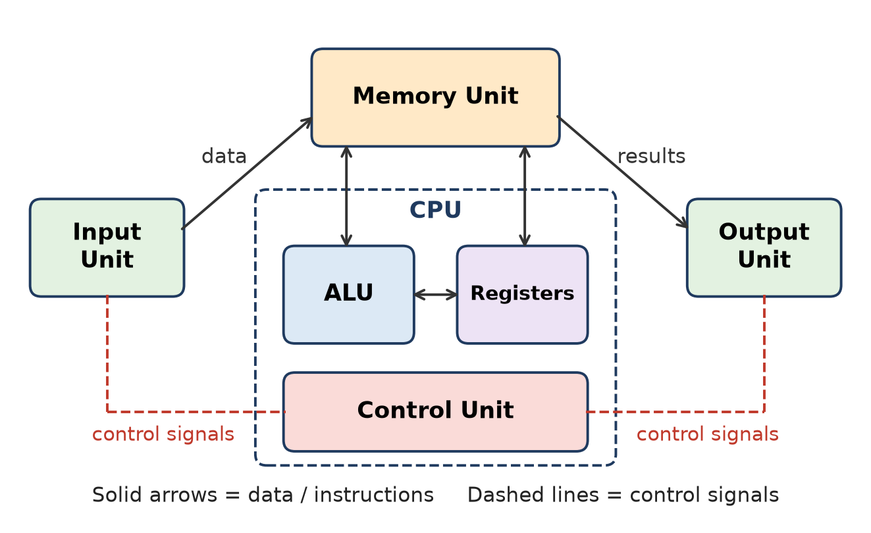
Figure: Functional units of a computer
1. Input unit – accepts data and programs from the user and converts them to binary (keyboard, mouse, scanner).
2. Memory unit – stores programs and data. Primary memory (RAM, ROM, cache) is fast; secondary memory (HDD, SSD) is large and permanent.
3. ALU (Arithmetic Logic Unit) – performs arithmetic (ADD, SUB, MUL, DIV) and logic (AND, OR, NOT, compare) operations.
4. Control unit (CU) – fetches and decodes instructions and sends control signals to all other units. ALU + CU + registers = CPU.
5. Output unit – gives results to the user (monitor, printer, speaker).
Remember: I-M-A-C-O: Input, Memory, ALU, Control, Output – "I Must Always Check Output".

Q2. Differentiate between Computer Architecture and Computer Organization with examples
Understand • Low • CO1
Architecture = attributes visible to the programmer (what the computer does). Organization = operational units and their interconnection that realise the architecture (how it does it).
Point | Computer Architecture | Computer Organization
Meaning | Logical / functional design seen by programmer | Physical implementation of that design
Concern | What to do | How to do it
Includes | Instruction set, data types, addressing modes, number of bits for data, I/O mechanism | Control signals, memory technology, interfaces, bus structure, hardwired or microprogrammed CU
Example question | Does the CPU have a multiply instruction? | Is multiply done by a special unit or by repeated addition?
Level | High level (designer of ISA) | Low level (hardware engineer)
Real example | Intel x86 ISA is the same from 8086 to Core i7 | Each x86 model has different cache, pipeline, cores

Many models can share one architecture with different organizations (e.g., IBM System/370 family), so old software runs on new, faster machines.
Remember: Architecture = "What" (programmer's view); Organization = "How" (hardware view).

Q3. Draw a block diagram showing CPU, memory, and I/O interconnection and Explain the roles of: Control unit, ALU, Registers
Understand • Low • CO1
The CPU, main memory and I/O modules are connected by the system bus (data, address and control lines).
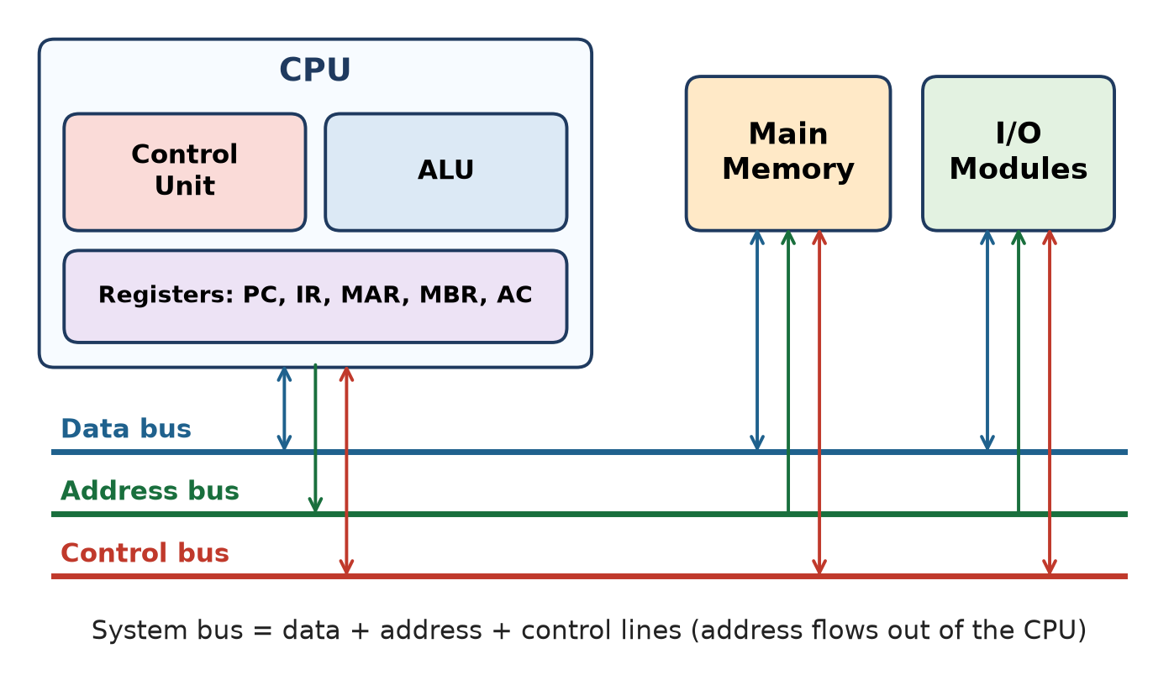
Figure: CPU, memory and I/O connected by the system bus
1. Control Unit (CU) – the "manager" of the CPU. It fetches an instruction, decodes the opcode and generates timing and control signals (memory read/write, ALU operation, register load). It does not process data itself.
2. ALU – the "calculator". It performs arithmetic (add, subtract, multiply, divide) and logical operations (AND, OR, NOT, compare, shift) and sets flags (zero, carry, sign, overflow).
3. Registers – very fast storage inside the CPU that hold data, addresses and instructions currently in use: PC (next instruction address), IR (current instruction), MAR (memory address), MBR (memory data), AC/general-purpose registers (operands and results).
Remember: CU directs, ALU computes, Registers hold – like a manager, a worker and his work-table.

Q4. Elaborate the evolution of Intel x86 processors from 8086 to modern x86-64
Understand • Low • CO1
The x86 family is a CISC architecture whose instruction set has stayed backward compatible from 1978 till today.
Year | Processor | Key feature
1978 | 8086 | First 16-bit x86; 20-bit address = 1 MB memory; instruction prefetch queue (8088 used in IBM PC)
1982 | 80286 | 16 MB address space; protected mode
1985 | 80386 | First 32-bit x86; multitasking, paging / virtual memory (4 GB)
1989 | 80486 | On-chip cache, built-in floating-point unit, instruction pipelining
1993 | Pentium | Superscalar – two instructions per clock
1995 | Pentium Pro | Register renaming, branch prediction, speculative execution
1997–2000 | Pentium II, III, 4 | MMX, SSE and SSE2 multimedia / floating-point instructions
2003–04 | x86-64 | 64-bit extension (AMD64, then Intel 64 / EM64T); 64-bit registers and addresses
2006 | Core, Core 2 | Dual-core (later quad-core); Core 2 is 64-bit
2008 on | Core i3/i5/i7/i9 | Many cores, on-chip memory controller, large shared L3 cache, integrated graphics

Remember: 16 → 32 → 64 bits; single core → multicore; each new chip still runs old 8086 code.

Q5. List and explain the steps involved in the execution of a complete instruction cycle. List the basic symbols used in register transfer Language
Understand • Low • CO1
The instruction cycle is the sequence of steps the CPU follows to fetch and execute one instruction.
1. Fetch – address in PC goes to MAR; instruction is read from memory into IR; PC ← PC + 1.
2. Decode – CU interprets the opcode and finds the addressing mode.
3. Operand address calculation / fetch – effective address is found and operand is read (indirect cycle if needed).
4. Execute – ALU performs the operation (data operation).
5. Store – result is written to a register or memory.
6. Interrupt check – if an interrupt is pending, the interrupt cycle runs; else go to next fetch.
Basic RTL symbols (Mano):
Symbol | Meaning | Example
Capital letters (and numerals) | A register | MAR, R2
Parentheses ( ) | Part of a register | R2(0-7), R2(L)
Arrow ← | Transfer of information | R2 ← R1
Comma , | Two micro-operations done together | R2 ← R1, R1 ← R2
Square brackets [ ] | Memory word at an address | DR ← M[AR]
Colon : | Control condition | P: R2 ← R1

Remember: Fetch-Decode-Execute-Store, then check interrupt – "Five Dogs Eat Sweet Ice-cream".

Q6. Explain the bus structure in detail with neat diagram.
Understand • Low • CO1
A bus is a shared communication path of parallel wires connecting two or more devices. The system bus (typically 50–100 lines) connects CPU, memory and I/O.
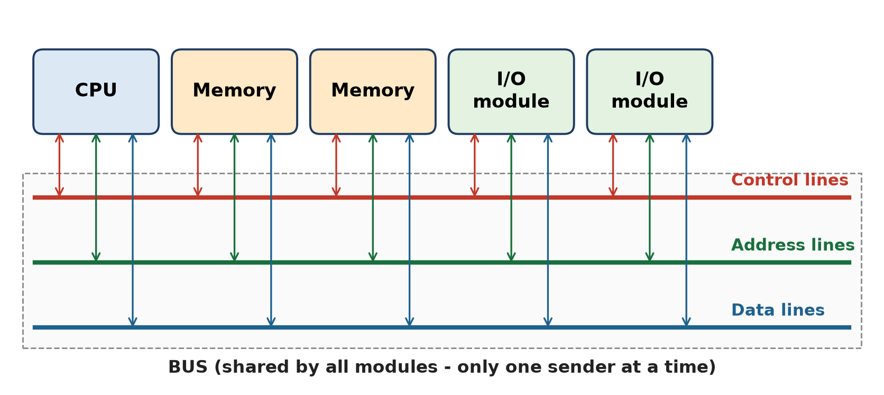
Figure: Bus interconnection scheme
1. Data lines (data bus) – carry data and instructions between modules; bidirectional. Width (8/16/32/64 bits) decides how many bits move at a time – a key factor of performance.
2. Address lines (address bus) – carry the address of the memory location or I/O port; mostly from CPU outward. Width decides maximum memory: n lines → 2ⁿ locations (e.g., 16 lines → 64 K).
3. Control lines (control bus) – carry command and timing signals: Memory Read/Write, I/O Read/Write, Bus Request/Grant, Interrupt Request/ACK, Clock, Reset.
Working: a module that wants to send data must (i) obtain the bus and (ii) transfer data. Only one device may transmit at a time. Large systems use multiple buses (local, system, expansion) to avoid a bottleneck.
Remember: Data = "what", Address = "where", Control = "when / how".

Q7. Explain various types of computer registers with block diagrams.
Understand • Low • CO1
Registers are the fastest, smallest storage inside the CPU. Stallings divides them into two groups.
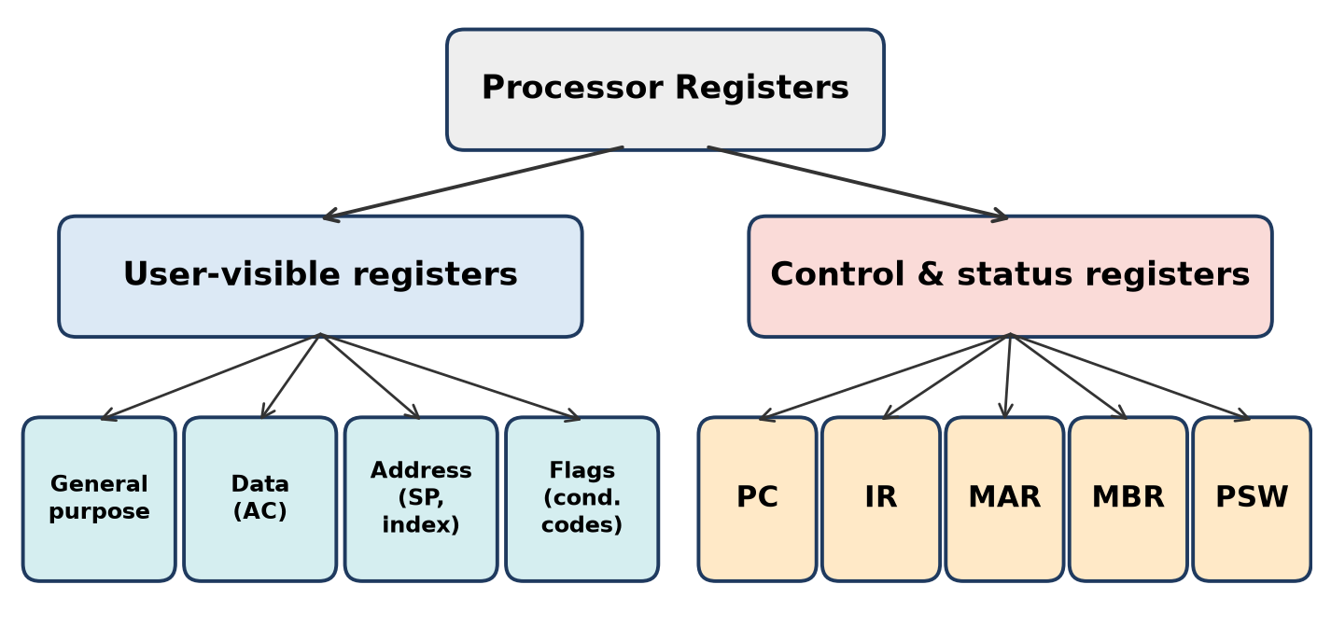
Figure: Types of processor registers
A. User-visible registers (used by programmer / compiler):
1. General-purpose registers (R0–Rn) – hold any operand or address.
2. Data registers (e.g., Accumulator AC) – hold data only.
3. Address registers – segment, index and stack pointer (SP) registers.
4. Condition codes (flags) – Zero, Carry, Sign, Overflow bits set by the ALU.
B. Control and status registers (used by the CU):
1. PC – address of the next instruction.
2. IR – the instruction being executed.
3. MAR – address of the memory location to be read/written.
4. MBR (MDR) – data read from or written to memory.
5. PSW – flags, interrupt enable bit, user/supervisor mode.
Remember: Users see GP-Data-Address-Flags; the CU uses PC-IR-MAR-MBR-PSW.

Q8. Define Performance of a computer system. Illustrate the factors on which performance of a computer is measured.
Understand • Low • CO1
Performance = how fast a computer finishes a task. Performance = 1 ÷ Execution time; the shorter the time, the better.
Basic equation: CPU time T = Instruction count (Ic) × CPI × Clock cycle time (τ) = Ic × CPI ÷ f
Factors:
1. Clock speed (f) – more cycles per second (GHz) → faster.
2. CPI – average cycles per instruction; depends on ISA and pipelining.
3. Instruction count – depends on program, compiler and instruction set.
4. Memory and cache – size and speed of cache/RAM; cache misses add delay.
5. Bus width and speed – more bits per transfer → more data per second.
6. Parallelism – pipelining, superscalar and multicore execution.
7. I/O and storage speed (SSD vs HDD).
Example: Ic = 2 × 10⁹, CPI = 1.5, f = 3 GHz → T = 2 × 10⁹ × 1.5 ÷ (3 × 10⁹) = 1 s.
Remember: T = Ic × CPI × τ – cut any one of the three to go faster.

Q9. Differentiate between Response Time and Throughput with examples.
Understand • Low • CO1
Point | Response Time (Execution time) | Throughput
Meaning | Time from start to finish of one task | Number of tasks completed per unit time
Unit | Seconds (ms, ns) | Jobs/sec, transactions/sec, MIPS
Better when | Lower | Higher
Viewpoint | Individual user | System manager / server
Improved by | Faster CPU, faster clock | More processors, pipelining, parallel servers
Example | A Google search returns results in 0.3 s | A bank server processes 5,000 transactions per second

Adding more cores raises throughput but may not reduce the response time of one task; a faster processor improves both.
Remember: Response time = "how fast for me"; Throughput = "how many for all".

Q10. Describe the modes of data transfer and its usage in detail.
Understand • Low • CO1
Data transfer between the CPU/memory and I/O devices is done in three modes:
1. Programmed I/O – CPU runs a program that keeps checking the device status flag (polling) and moves each word itself. Simple but wastes CPU time (busy waiting). Usage: simple, slow devices, embedded controllers.
2. Interrupt-initiated I/O – CPU continues other work; the device sends an interrupt when ready, and the CPU runs an ISR to transfer the data. No polling. Usage: keyboard, mouse, printer.
3. Direct Memory Access (DMA) – a DMA controller takes control of the bus (bus request / bus grant) and transfers a whole block directly between device and memory; CPU is interrupted only at the end. Usage: disk, network card, graphics – high-speed bulk transfer.
Mode | CPU involvement | Speed
Programmed I/O | Full (polling) | Slow
Interrupt I/O | Per word, via ISR | Medium
DMA | Only at start and end | Fast

Remember: P-I-D: Polling, Interrupt, DMA – CPU work goes from "all" to "almost none".

Q11. Define a multicore processor and list its advantages over single-core CPUs
Understand • Low • CO1
A multicore processor is a single chip (one piece of silicon) that contains two or more cores; each core is a complete processing unit (ALU, CU, registers, L1 cache) that can execute its own instruction stream.
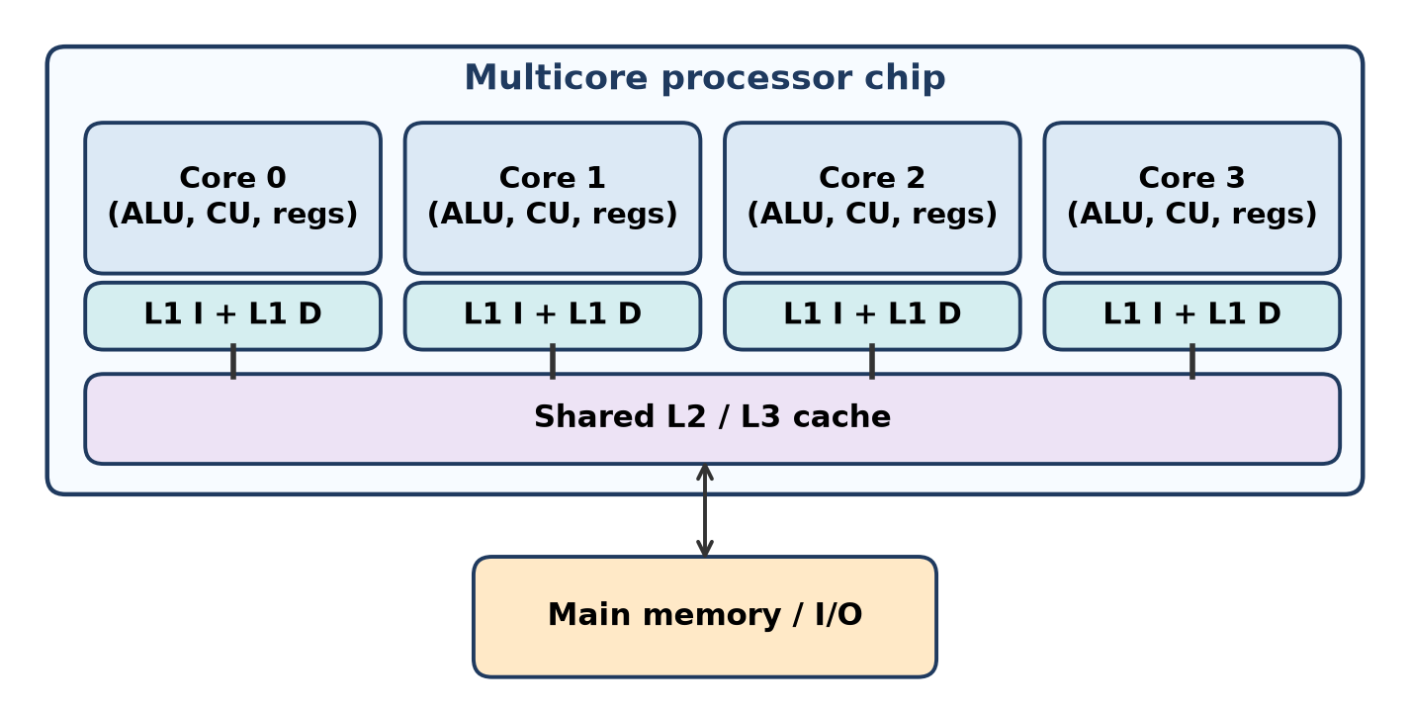
Figure: Multicore processor structure
Advantages over single-core:
1. True parallelism – several threads/programs run at the same time → higher throughput.
2. Better performance per watt – two slower cores use less power and heat than one very fast core.
3. Shared cache (L2/L3) gives fast data sharing between cores.
4. Better multitasking and responsiveness.
5. Less space and cost than multiple separate CPU chips.
Example: Intel Core i7, AMD Ryzen, Apple M-series.
Remember: Many cores on one chip = many workers in one office.

Q12. Illustrate the fetch–decode–execute cycle with a neat diagram.
Understand • Low • CO1
The CPU repeats the fetch–decode–execute cycle for every instruction until it halts.
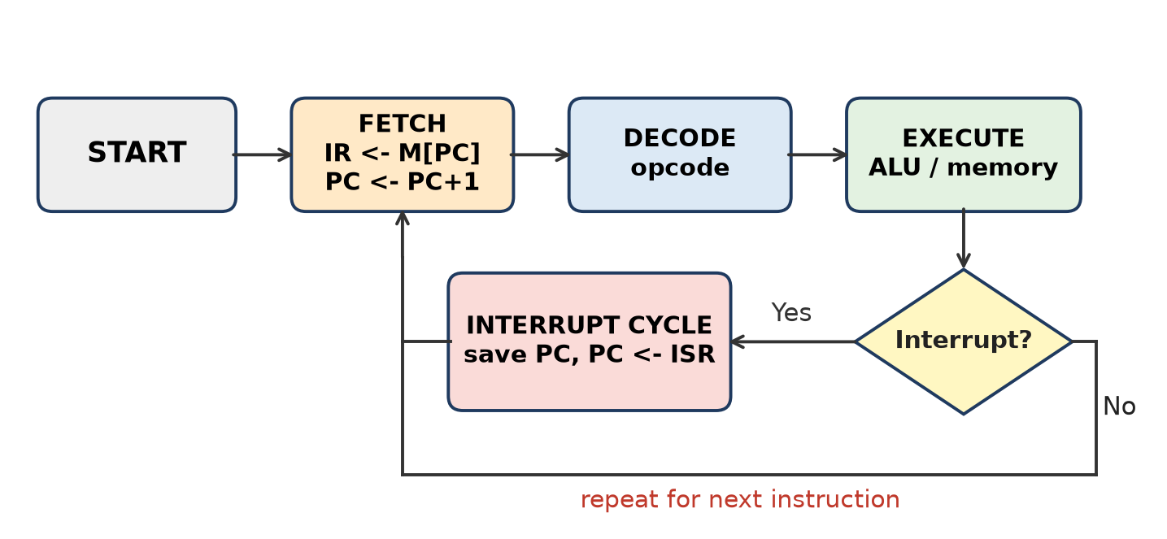
Figure: Fetch-decode-execute cycle
1. Fetch – MAR ← PC; MBR ← M[MAR]; IR ← MBR; PC ← PC + 1 (points to the next instruction).
2. Decode – the CU decodes the opcode in IR, finds the operand addresses and selects the needed hardware.
3. Execute – operands are fetched, the ALU does the operation, and the result is stored in a register or memory.
4. Interrupt check – if an interrupt is pending, the return address is saved and control goes to the ISR; otherwise the next fetch starts.
Example: for ADD R1, X – fetch the instruction, decode "ADD with memory operand", read X, add to R1.
Remember: PC points, IR holds, CU decodes, ALU executes – then PC moves on.

Q13. Draw a diagram of a typical bus interconnection structure and explain its working.
Understand • Low • CO1
In a typical bus interconnection, every module (CPU, memory modules, I/O modules) is connected to one shared set of data, address and control lines.
Figure: Typical bus interconnection structure
Working:
1. To send data: a module (i) obtains the use of the bus, (ii) puts the address on the address lines, the data on the data lines and the command (e.g., Memory Write) on the control lines.
2. To receive data: a module obtains the bus, sends a request (address + Memory Read) and waits for the other module to place the data on the bus.
3. Arbitration – if several modules want the bus, a bus arbiter (centralized or distributed) gives it to one master at a time.
4. Timing – synchronous (all events tied to a clock) or asynchronous (handshake).
Problem: too many devices → longer bus, more delay, bottleneck. Solution: hierarchy of buses (local, system, expansion/PCI).
Remember: Get the bus, then talk – only one speaker on the bus at a time.

Q14. Justify the Von Neumann bottlenecks and how can it be reduced?
Apply • Moderate • CO1
In the Von Neumann architecture, instructions and data are stored in the same memory and travel over one shared bus. The CPU can do only one memory access at a time – either fetch an instruction or read/write data.
Why it is a bottleneck (justification):
1. CPU speed has grown much faster than memory speed, so the CPU often waits for memory.
2. Instruction fetch and data access compete for the same bus, so they happen one after another.
3. The bus bandwidth limits the rate at which the CPU can be fed, however fast its clock is.
4. Every extra memory access adds latency and power.
Ways to reduce it:
1. Cache memory (L1, L2, L3) – keeps frequently used code/data close to the CPU.
2. Split L1 caches (separate instruction and data caches) – a modified Harvard design inside the CPU.
3. Instruction prefetching and pipelining – fetch next instructions while executing the current one.
4. Wider and faster buses, multiple buses, DDR memory.
5. More registers – fewer memory accesses (RISC load/store).
6. Branch prediction, multithreading and multicore to keep the CPU busy.
Remember: One road for both trucks (code and data) causes a jam – build caches and a second road.

Q15. Compare Harvard and Von Neumann architectures with a labeled diagram. Elaborate the same with example.
Apply • Moderate • CO1
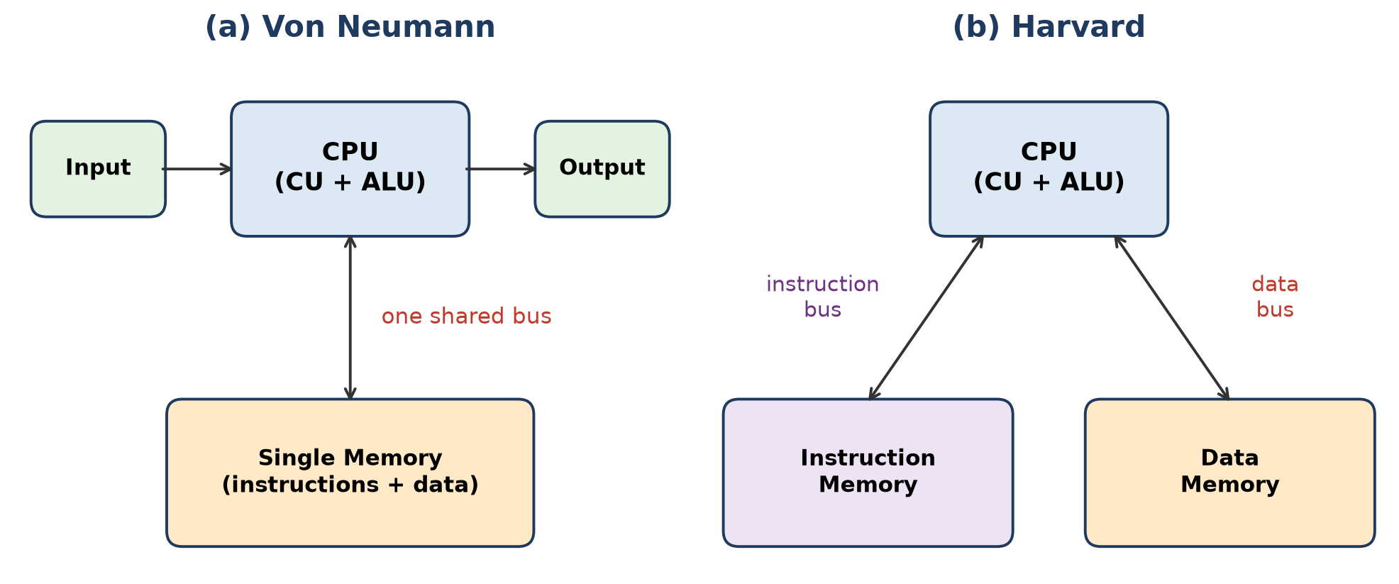
Figure: Von Neumann vs Harvard architecture
Feature | Von Neumann | Harvard
Memory | Single memory for instructions and data | Separate instruction memory and data memory
Buses | One common bus | Separate instruction bus and data bus
Simultaneous access | Not possible – fetch or data, one at a time | Possible – fetch and data access together
Speed | Slower (bottleneck) | Faster, an instruction can finish in one cycle
Cost / complexity | Cheaper, simpler | Costlier, more complex
Memory use | Flexible – free space shared | Fixed split, may waste space
Used in | PCs, laptops, general-purpose computers | DSPs, microcontrollers (PIC, AVR in Arduino), embedded systems

Example: In a PC (Von Neumann), ADD R1, X needs one bus cycle to fetch the instruction and another to read X. In a PIC microcontroller (Harvard), the next instruction is fetched from program flash while X is read from data RAM, so it works faster.
Modern CPUs are modified Harvard: Von Neumann main memory but separate L1 instruction and data caches.
Remember: Von Neumann = one door for all; Harvard = two doors, code and data walk in together.

Q16. Explain the basic components of Generic Computing system regardless of its internal architecture with practical real time examples
Apply • Moderate • CO1
Every computing system – PC, phone or washing machine – has the same generic building blocks, whatever its internal design (Von Neumann, Harvard, RISC, CISC).
Figure: Generic computing system components
1. Input – captures data from the outside world. ATM: card reader, keypad. Smartphone: touch screen, camera, mic, sensors.
2. Processing unit (CPU) – ALU + CU + registers execute instructions. Phone: ARM SoC; washing machine: microcontroller.
3. Memory / storage – primary (RAM, ROM/firmware) for running programs; secondary (flash, SSD, HDD) for permanent storage. ATM: stores account session and transaction log.
4. Output – shows or acts on the result. ATM: screen, cash dispenser, receipt printer. Washing machine: motor, display.
5. Interconnection (buses) – data, address and control paths linking the units.
6. Control – sequencing of all operations by the control unit according to the stored program.
7. Communication interface – network/USB/Bluetooth to talk to other systems (ATM to bank server).
These match Stallings' four functions: data processing, data storage, data movement and control.
Remember: Any computer = Input → Process ↔ Store → Output, joined by buses, run by control.

Q17. Describe the Instruction set Architecture of simple computer.
Understand • Low • CO1
The ISA is the programmer-visible part of a computer: instruction formats, registers, addressing modes and the instruction set. Mano's Basic Computer is the standard "simple computer".
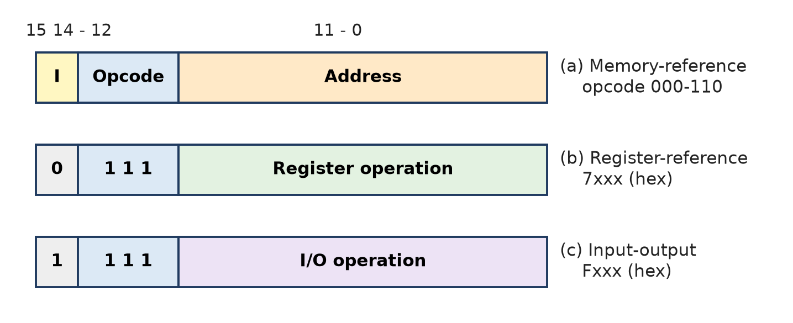
Figure: Instruction formats of the Basic Computer
1. Memory: 4096 × 16 words; instruction = 16 bits.
2. Format: bit 15 = I (0 direct, 1 indirect), bits 14–12 = opcode, bits 11–0 = address (12 bits → 4096 words).
3. Three instruction types:
- Memory-reference (opcode 000–110): AND, ADD, LDA, STA, BUN, BSA, ISZ.
- Register-reference (7xxx): CLA, CLE, CMA, CME, CIR, CIL, INC, SPA, SNA, SZA, SZE, HLT.
- Input-output (Fxxx): INP, OUT, SKI, SKO, ION, IOF.
4. Registers: AC, DR, AR, PC, IR, TR, INPR, OUTR, flip-flops E, I, IEN, FGI, FGO.
5. Addressing modes: direct and indirect; register-reference instructions use the implied AC.
In total there are 25 instructions – enough to be functionally complete (arithmetic, logic, transfer, control, I/O).
Remember: I-Opcode-Address = 1 + 3 + 12 bits; 7 memory, 12 register, 6 I/O = 25 instructions.

Q18. A computer uses a shared system bus connecting CPU, memory, and I/O devices. If two devices attempt to use the bus simultaneously, what problem occurs and how can it be resolved?
Apply • Moderate • CO1
Situation: two devices (e.g., CPU and a DMA disk controller) try to drive the shared bus at the same time.
Problem – bus contention / conflict:
1. Both put signals on the same lines → data is corrupted (garbled).
2. Electrical conflict can damage drivers; transfers fail and must be repeated.
3. System may hang or give wrong results.
Solution – Bus arbitration: only one bus master is allowed at a time; others wait.
1. Centralized arbitration – one bus arbiter (bus controller, often in the CPU) receives Bus Request and gives Bus Grant to one device.
- Daisy chaining – grant passes device to device; nearest device has highest priority. Simple but unfair.
- Polling – arbiter checks devices one by one using address lines.
- Independent request – each device has its own request/grant lines; fastest, more wires.
2. Distributed arbitration – no central controller; each device has arbitration logic and they decide priority together (e.g., by comparing ID numbers).
3. Priority rules – fast or critical devices (DMA, memory refresh) get higher priority; time-sharing avoids starvation.
4. Multiple / hierarchical buses reduce the number of devices competing.
Conclusion: contention is solved by arbitration – request, grant, transfer, release.
Remember: "Raise your hand (Bus Request), wait for permission (Bus Grant), then speak."

Q19. List and explain the purpose of different registers for the basic computer
Understand • Low • CO1
Mano's Basic Computer has eight registers connected to a 16-bit common bus.
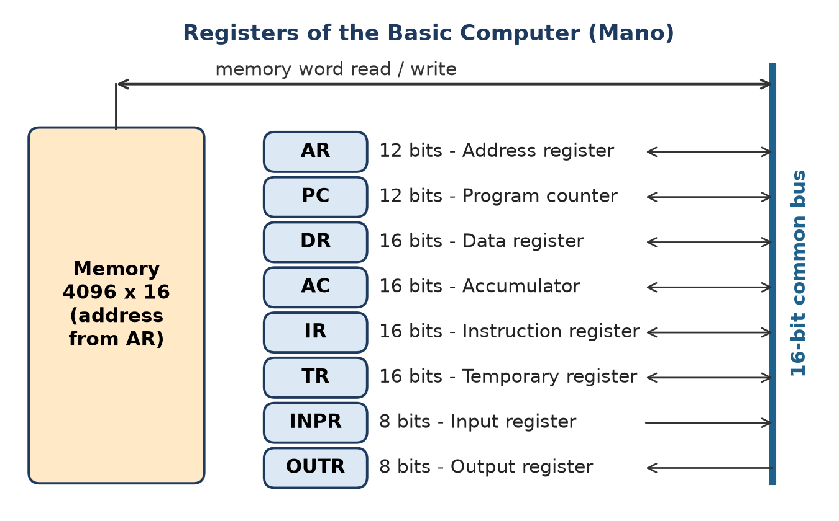
Figure: Registers of the Basic Computer
Register | Bits | Name | Purpose
DR | 16 | Data register | Holds memory operand
AR | 12 | Address register | Holds address for memory
AC | 16 | Accumulator | Processor register for results
IR | 16 | Instruction register | Holds instruction code
PC | 12 | Program counter | Holds address of next instruction
TR | 16 | Temporary register | Holds temporary data
INPR | 8 | Input register | Holds input character
OUTR | 8 | Output register | Holds output character

AR and PC are 12 bits because memory has 4096 (2¹²) words; data registers are 16 bits because each word is 16 bits.
Remember: "DAAI-PT-IO": Data, Address, Accumulator, Instruction, PC, Temp, Input, Output.

Q20. A processor needs to fetch instructions while simultaneously accessing data. Justify why Harvard architecture may provide better performance than Von Neumann architecture in this situation.
Apply • High • CO1
Situation: each instruction (e.g., ADD R1, X) needs an instruction fetch and a data access in the same period.
Figure: Von Neumann vs Harvard architecture
In Von Neumann:
1. Instructions and data share one memory and one bus.
2. The CPU must fetch the instruction first and then read X – two sequential memory cycles.
3. The bus becomes the Von Neumann bottleneck; the CPU sits idle while waiting.
In Harvard:
1. Separate instruction memory and data memory with separate buses (instruction bus, data bus, and their own address buses).
2. The next instruction is fetched at the same time as the current instruction reads/writes its data → parallel access.
3. This allows pipelining without structural hazards – fetch stage and memory stage never compete for memory.
4. Instruction width can differ from data width (e.g., 14-bit instructions, 8-bit data in PIC) – more efficient.
5. Many instructions can complete in one cycle, giving higher throughput.
Point | Von Neumann | Harvard
Memory accesses per cycle | 1 | 2 (instruction + data)
Cycles for ADD R1, X (memory part) | 2 | 1
Pipeline conflict on memory | Yes | No

Example: DSP chips filtering audio must fetch a multiply instruction and two samples every cycle – only Harvard-style separate paths make this possible.
Conclusion: because fetch and data access overlap, Harvard gives roughly double memory bandwidth and better performance; modern CPUs copy this with separate L1 I-cache and D-cache.
Remember: Two separate roads = no waiting at the signal; code and data travel together.

Q21. A computer system is experiencing poor performance even though its processor has a high clock frequency. Analyse which components other than the CPU may be responsible.
Apply • Moderate • CO1
Situation: a fast (high GHz) CPU but slow system – the CPU is waiting for other parts. Performance T = Ic × CPI × τ; a short τ is wasted if CPI rises due to stalls.
Possible culprits:
1. Small or slow main memory (RAM) – not enough RAM causes paging/swapping to disk; slow DRAM increases memory latency.
2. Cache – small cache or high miss rate makes the CPU wait for main memory.
3. System bus – narrow or slow data bus limits bandwidth (Von Neumann bottleneck).
4. Secondary storage – HDD with high seek time and rotational latency; an SSD is much faster.
5. I/O devices and I/O mode – programmed I/O wastes CPU time; slow network or graphics card.
6. Pipeline stalls – hazards and branch mispredictions waste cycles.
7. Thermal throttling / power – overheating lowers the actual clock.
8. Software – single-threaded programs on a multicore chip, too many background tasks.
Recommendations: add RAM, use SSD, larger multi-level cache, DMA for I/O, wider/faster bus, better cooling, and parallel software.
Conclusion: a computer is only as fast as its slowest component – clock speed alone is not performance.
Remember: A Ferrari engine on a mud road still goes slow – fix memory, cache, bus and disk.

Q22. Differentiate between multiprocessor and multicomputer systems. Give two real-world examples of multiprocessor systems.
Apply • Moderate • CO1
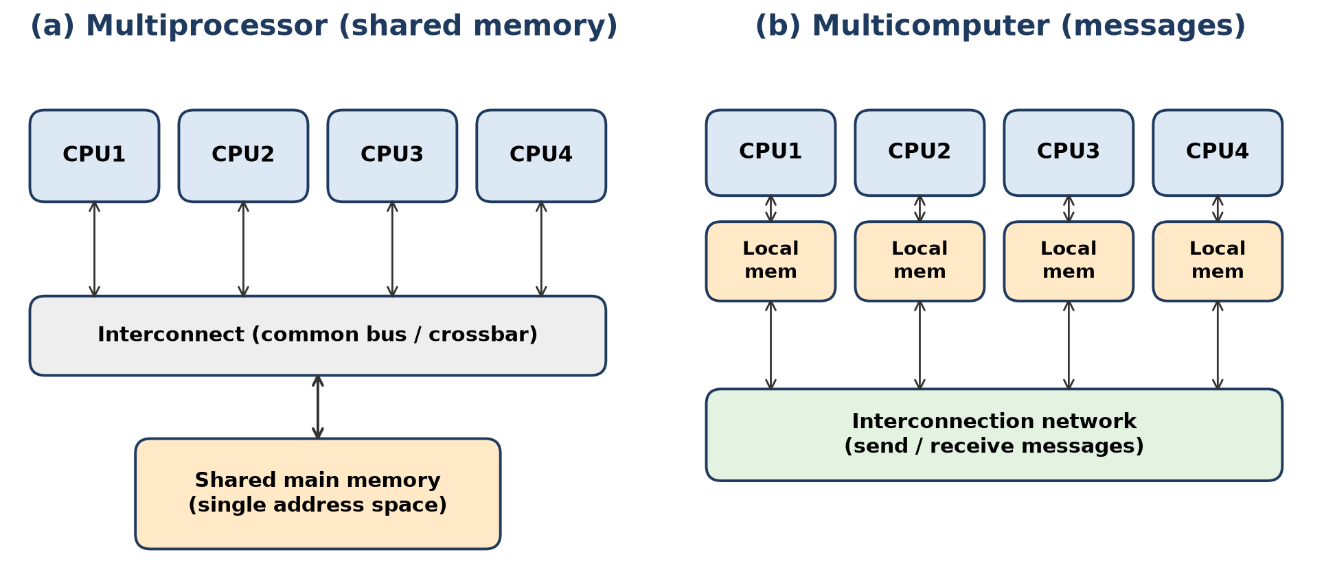
Figure: Multiprocessor vs multicomputer
Point | Multiprocessor | Multicomputer
Definition | One computer with two or more CPUs sharing a common memory | Many complete computers (CPU + own memory) joined by a network
Memory | Shared, single address space | Distributed, private local memory
Communication | Through shared variables in memory | By message passing over interconnection network
Coupling | Tightly coupled | Loosely coupled
Computing type | Parallel computing | Distributed computing
Programming | Easier | Harder (explicit send/receive)
Cost / scalability | Costly, limited scaling (memory contention) | Cheaper, easier to build and scale
Interconnection | Time-shared bus, multiport memory, crossbar switch | LAN, mesh, hypercube network

Examples of multiprocessor systems:
1. Dual-socket servers (e.g., a server board with two Intel Xeon processors sharing RAM) used in data centres.
2. Multicore desktop/laptop/phone chips (Intel Core i7, Apple M-series) – symmetric multiprocessing (SMP) with shared memory.
Remember: Multiprocessor = one house, one fridge (shared memory); multicomputer = many houses that phone each other.

Q23. Analyse the roles of the ALU, control unit, registers, and buses during the execution of an arithmetic instruction.
Analyze • High • CO1
Example instruction: ADD R1, X (R1 ← R1 + M[X]), stored at address 100.
Figure: CPU, memory and I/O connected by the system bus
Step | Registers | Buses | Control unit | ALU
1. Fetch | MAR ← PC (100); IR ← MBR; PC ← 101 | Address bus carries 100; data bus brings instruction | Issues Memory Read, increments PC | Idle (or computes PC+1)
2. Decode | IR holds ADD, R1, X | – | Decodes opcode, selects mode | Idle
3. Operand fetch | MAR ← X; MBR ← M[X] | Address bus carries X; data bus returns operand | Issues Memory Read | Idle
4. Execute | R1 and MBR feed ALU | Internal CPU bus | Sends "ADD" function code | Adds, sets flags Z, C, S, V
5. Write back | R1 ← result | Internal bus | Load signal to R1 | Output result

Roles in short:
1. Control unit – the coordinator; generates timed control signals for every step (read, load, add).
2. Registers – PC (sequence), IR (instruction), MAR/MBR (memory interface), R1 (operand and result), PSW (flags).
3. ALU – performs the actual addition and updates the status flags.
4. Buses – the address bus selects memory location, the data bus moves instruction and operand, the control bus carries Memory Read and timing; the internal bus links registers and ALU.
Conclusion: the CU directs, registers hold, buses carry, and the ALU computes – all four are needed in every arithmetic instruction.
Remember: Conductor (CU), musicians' stands (registers), corridors (buses), and the singer (ALU).

Q24. Consider an Instruction x= ( A+ B)/C , explain each stage in an instruction execution cycle and write the phases of Instruction cycle. Devise the steps in two-address instruction format
Apply • Moderate • CO1
Phases of the instruction cycle (Stallings): IAC → IF → IOD → OAC → OF → DO → OAC → OS.
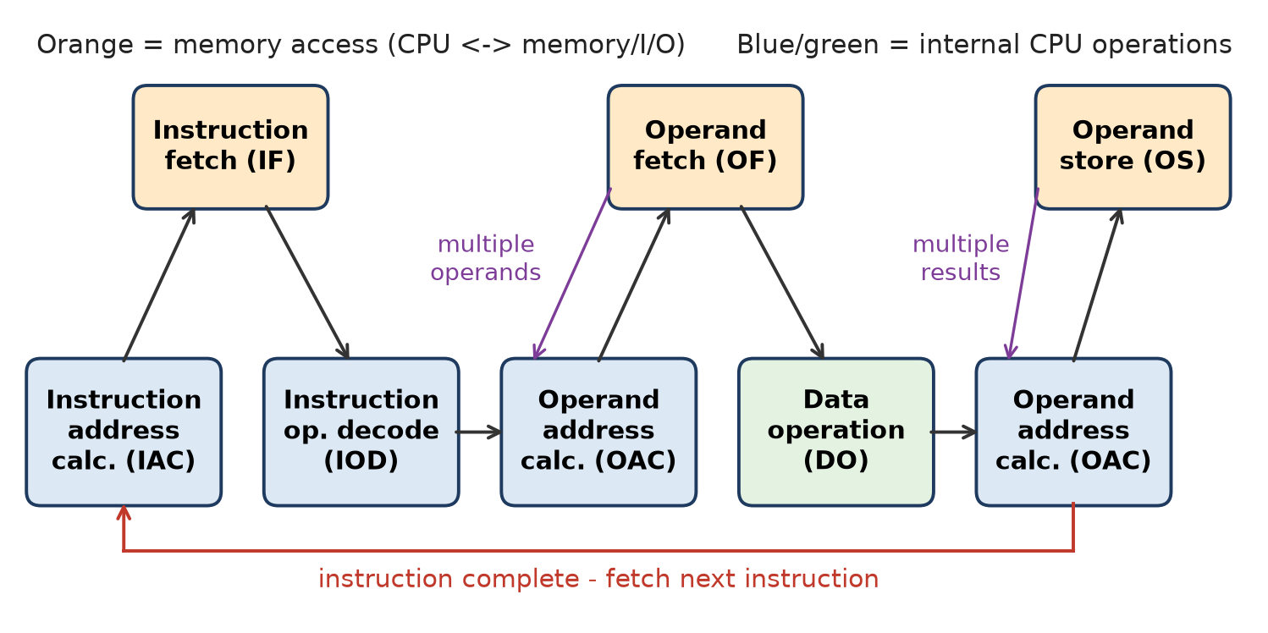
Figure: Instruction cycle state diagram
Stages for one instruction, e.g. `ADD R1, B`:
1. Instruction address calculation (IAC) – next address comes from PC.
2. Instruction fetch (IF) – IR ← M[PC]; PC ← PC + 1.
3. Instruction operation decoding (IOD) – CU finds "ADD, register R1, memory operand B".
4. Operand address calculation (OAC) – effective address of B is found (direct mode: EA = B).
5. Operand fetch (OF) – read M[B].
6. Data operation (DO) – ALU computes R1 + M[B].
7. Operand store (OS) – result written into R1.
Two-address program for X = (A + B) / C:
Instruction | Action (RTL)
MOV R1, A | R1 ← M[A]
ADD R1, B | R1 ← R1 + M[B]
DIV R1, C | R1 ← R1 ÷ M[C]
MOV X, R1 | M[X] ← R1

Each of the 4 instructions passes through the full cycle; the first operand field is both source and destination.
Remember: 2-address rule: "Load, operate, operate, store" – the first field gets overwritten.

Q25. With a neat schematic, explain the steps involved in fetch and decode phases using register transfer instructions. Draw suitable diagram showing the contents of register with data flow.
Apply • Moderate • CO1
In Mano's Basic Computer, fetch and decode are done in timing states T0, T1, T2 produced by the sequence counter.
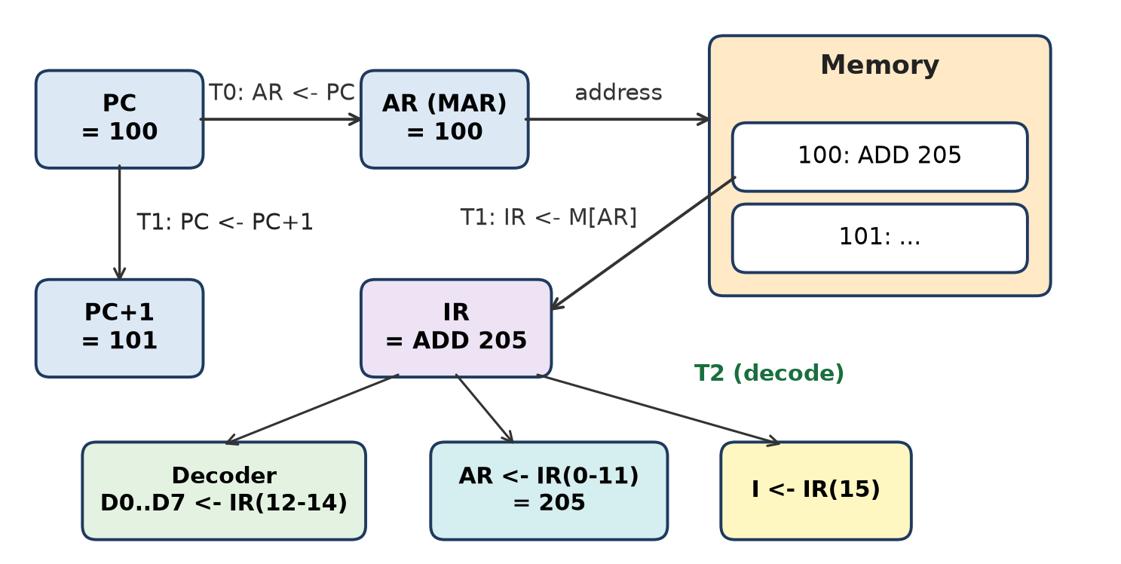
Figure: Fetch and decode data flow (PC = 100, instruction ADD 205)
Register transfer statements:
1. T0: AR ← PC – address of the instruction (100) is copied to AR.
2. T1: IR ← M[AR], PC ← PC + 1 – instruction "ADD 205" is read into IR; PC becomes 101.
3. T2: D0…D7 ← Decode IR(12-14), AR ← IR(0-11), I ← IR(15) – opcode is decoded into one of D0–D7, the address part (205) goes to AR, and the mode bit goes to flip-flop I.
Register contents (example):
Timing | PC | AR | IR | I
Start | 100 | – | – | –
After T0 | 100 | 100 | – | –
After T1 | 101 | 100 | ADD 205 | –
After T2 | 101 | 205 | ADD 205 | 0 (direct)

At T3 the CU checks D7 and I to decide between memory-reference, register-reference or I/O execution.
Remember: T0 copy, T1 read and bump, T2 split and decode.

Q26. Narrate the following Execution time/Response time, access time, CPU cycle, Pulse time , Latency as Performance parameters with suitable example.
Apply • High • CO1
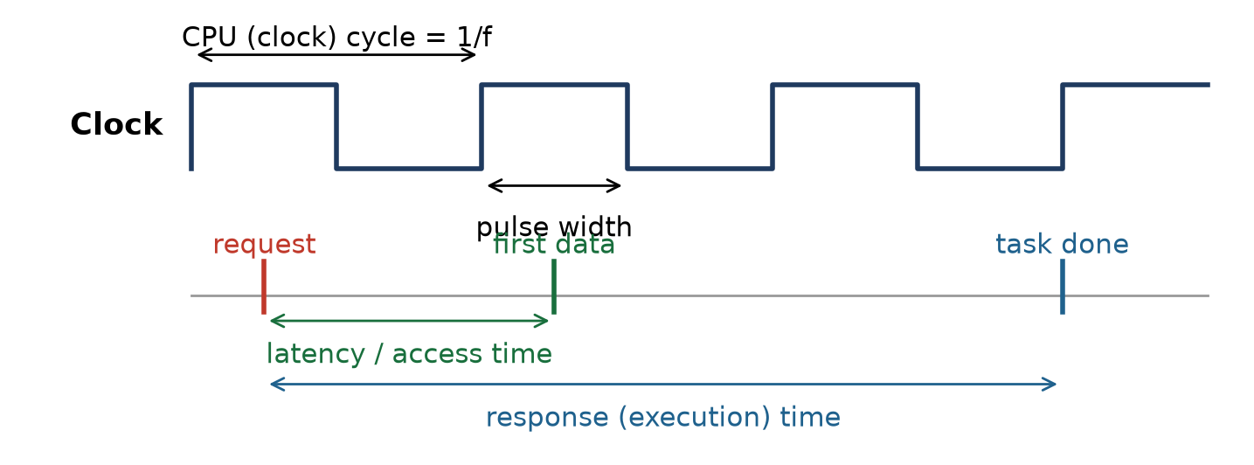
Figure: Timing parameters
1. Execution time / Response time – total time from submitting a task to getting its result, including CPU, memory, I/O and waiting. CPU time = Ic × CPI × τ. Example: 10⁹ instructions, CPI 2, 2 GHz → 10⁹ × 2 ÷ (2 × 10⁹) = 1 s.
2. Access time – time from issuing a read/write request to the memory until the data is available (or stored). Example: cache ≈ 1–2 ns, DRAM ≈ 50–70 ns, HDD ≈ several ms.
3. CPU cycle (clock cycle) – one period of the processor clock; τ = 1 ÷ f. It is the basic unit of time for micro-operations. Example: 2 GHz → τ = 0.5 ns.
4. Pulse time (pulse width) – the duration for which a clock or control pulse stays active (high). With a 50 % duty cycle it is half the cycle. Example: 2 GHz clock → pulse width = 0.25 ns; registers load on that pulse/edge.
5. Latency – the delay before a transfer or operation begins after it is requested. Example: HDD rotational latency at 7200 rpm = half a rotation = 60 ÷ 7200 ÷ 2 ≈ 4.17 ms; pipeline latency = time for one instruction to pass all stages.
Parameter | Measures | Typical unit
Response time | Whole task | s, ms
Access time | One memory operation | ns, ms
CPU cycle | One clock period | ns
Pulse time | Active part of a clock pulse | ns
Latency | Waiting before start | ns, ms

Conclusion: lower values of all five mean better performance; response time is the user's final measure.
Remember: Cycle = 1/f; pulse = high part; latency = wait to start; access = wait for data; response = whole job.

Q27. Justify the need of Bus structure in computer organization. Draw the figure to show how functional units are interconnected using a bus and explain it.
Apply • High • CO1
Need for a bus structure (justification):
1. Fewer wires – without a bus every unit would need separate links to every other unit (n units → n(n − 1)/2 links). A shared bus connects all with one set of lines.
2. Low cost and simple design – one standard interface for all modules.
3. Easy expansion – new memory or I/O devices can be plugged into the bus (PCI slots).
4. Standardization – devices from different makers work together.
5. Controlled communication – address and control lines decide who talks to whom and when.
Figure: Functional units interconnected by a single bus
Explanation of the figure:
1. CPU, memory modules and I/O modules are all attached to a common system bus.
2. Data lines carry instructions and data (bidirectional).
3. Address lines carry the location in memory or the I/O port number.
4. Control lines carry Memory Read/Write, I/O Read/Write, Bus Request/Grant, Interrupt, Clock, Reset.
5. A module first gets control of the bus (arbitration), then transfers data; others listen and only the addressed module responds.
Drawback: only one transfer at a time; many devices increase delay → modern systems use multiple buses (local, system, high-speed, expansion).
Conclusion: the bus is the "highway" that makes the computer one working system at low cost.
Remember: No bus = spaghetti of wires; one bus = one highway with traffic rules.

Q28. A system has four processors sharing a common main memory. If one processor updates a memory location, the other processors should see the updated value. Which architecture is most appropriate? Justify the answer.
Apply • High • CO1
Answer: a shared-memory (tightly coupled) multiprocessor, i.e., a Symmetric Multiprocessor (SMP / UMA) with cache coherence.
Figure: Shared-memory multiprocessor (a) vs multicomputer (b)
Justification:
1. All four CPUs access one common main memory with a single address space – exactly the given condition.
2. When P1 writes to location X, the value is in the same physical memory, so P2–P4 read the new value – communication is through shared variables, not messages.
3. CPUs are connected to memory through a time-shared common bus, multiport memory or crossbar switch.
4. Each CPU has a private cache, so a cache-coherence protocol (e.g., snooping with MESI, write-invalidate) is needed to make sure stale copies are invalidated or updated.
5. Synchronization (locks, semaphores, atomic read-modify-write) prevents two CPUs from updating X at the same time.
6. A multicomputer would not fit because each node has private memory; an update in one is invisible to others unless a message is sent.
Requirement | How SMP meets it
Common memory | Single shared main memory
Updated value visible | Same location + cache coherence
Equal access | Uniform memory access (UMA)

Examples: dual-socket Xeon servers, multicore PCs.
Conclusion: a shared-memory multiprocessor with a coherence protocol is the most appropriate.
Remember: Shared notice-board: one writes, everyone reads the same board.

Q29. A system consists of eight processors, each having its own local memory. Processors communicate by explicitly sending messages through an interconnection network. Identify the system and justify the answer.
Apply • High • CO1
Answer: it is a multicomputer – a distributed-memory, loosely coupled, message-passing system (e.g., a cluster).
Figure: Multiprocessor (a) vs multicomputer (b)
Justification:
1. Own local memory: each of the 8 nodes has private memory accessible only by its own processor – no global shared memory. This is the defining feature of a multicomputer.
2. Explicit message passing: data is exchanged by send/receive operations (e.g., MPI) over an interconnection network – not by shared variables.
3. Loose coupling: each node is almost a full computer (CPU + memory + often I/O); nodes can work independently.
4. Distributed computing: a large task is divided among nodes; results are combined by messages.
5. Network topologies: mesh, ring, hypercube, switched Ethernet / InfiniBand.
6. Scalable and cost-effective – easier to add nodes than in a shared-memory multiprocessor; but programming is harder and message latency is high.
Feature in question | Multicomputer property
8 processors, own memory | Distributed memory
Explicit messages | Message passing
Interconnection network | Loosely coupled nodes

Examples: Beowulf clusters, supercomputer clusters, Hadoop server clusters.
Conclusion: private memory + message passing = multicomputer (not a multiprocessor).
Remember: Own memory + messages = multicomputer; shared memory = multiprocessor.

Quick Revision – Unit I
Term | Key fact
Architecture vs Organization | What the programmer sees vs how hardware implements it
Functional units | Input, Memory, ALU, Control Unit, Output
Four computer functions | Data processing, storage, movement, control
System bus | Data (what), Address (where), Control (when/how) lines
Address bus width | n lines → 2ⁿ addressable locations
Instruction cycle | Fetch → Decode → Operand fetch → Execute → Store → Interrupt check
Fetch in RTL | T0: AR ← PC; T1: IR ← M[AR], PC ← PC + 1
CPU time | T = Ic × CPI × τ = Ic × CPI ÷ f
Response time vs throughput | Time for one job vs jobs per second
Von Neumann | Single memory and bus for code and data → bottleneck
Harvard | Separate instruction and data memories and buses → parallel access
Multicore | Several cores on one chip sharing L2/L3 cache
Multiprocessor | Shared memory, tightly coupled, parallel computing
Multicomputer | Private memories, message passing, distributed computing
Data transfer modes | Programmed I/O, Interrupt I/O, DMA
x86 milestones | 8086 (16-bit) → 80386 (32-bit) → x86-64 (64-bit) → multicore Core

Unit II: CPU design

Q1. Draw the internal organization of CPU, elaborating the functionalities of each component
Understand • Low • CO2
The CPU is made of the control unit, ALU and registers, joined by an internal CPU bus.
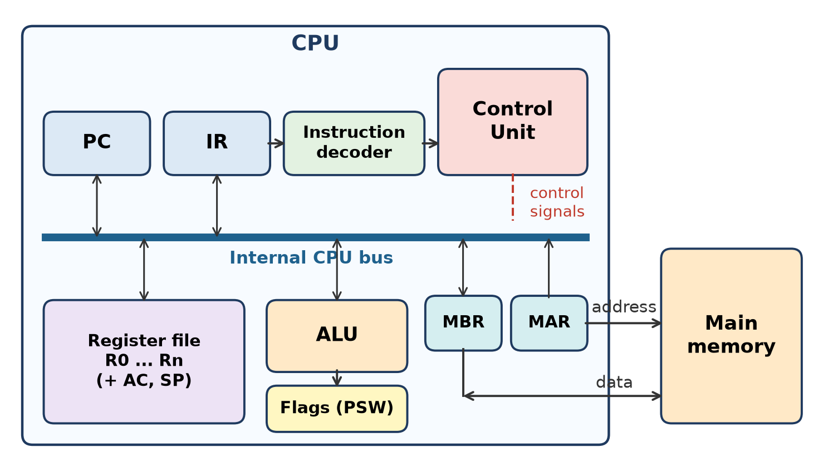
Figure: Internal organization of a CPU
1. Program Counter (PC) – holds the address of the next instruction.
2. Instruction Register (IR) – holds the instruction just fetched.
3. Instruction decoder – splits the instruction into opcode and operand fields.
4. Control Unit (CU) – generates timing and control signals for every micro-operation.
5. ALU – performs arithmetic and logic operations; result goes to a register.
6. Flags / PSW – zero, carry, sign, overflow bits set by the ALU.
7. Register file – general-purpose registers (R0–Rn), accumulator, stack pointer: fastest operand storage.
8. MAR and MBR – interface to memory: MAR sends the address, MBR holds data read/written.
9. Internal bus – path for data between all the above.
Remember: PC points, IR holds, decoder splits, CU commands, ALU computes, MAR/MBR talk to memory.

Q2. Define the following terms: 1.Instruction Set 2.Instruction Format 3. Addressing Mode
Understand • Low • CO2
1. Instruction set – the complete collection of machine instructions a CPU can understand and execute (data transfer, arithmetic, logical, control, I/O). Example: x86 has MOV, ADD, JMP, CALL…; Mano's Basic Computer has 25 instructions.
2. Instruction format – the layout of bits of an instruction, divided into fields: an opcode (operation), address fields (operands) and often a mode field. Example: 16-bit format = I (1 bit) + opcode (3 bits) + address (12 bits).
3. Addressing mode – the rule for interpreting the address field to find the effective address (EA) of the operand. Example: immediate MOV R1, #5 (operand in instruction), direct LOAD 2000 (EA = 2000), register indirect MOV R1, (R2) (EA = R2).
Remember: Set = vocabulary, Format = sentence layout, Mode = how to find the noun (operand).

Q3. List different addressing modes with one example each.
Understand • Low • CO2
Addressing mode | Rule | Example
Implied | Operand implied by opcode | CMA (complement AC)
Immediate | Operand = address field | MOV R1, #25
Direct | EA = A | LDA 2000
Indirect | EA = M[A] | ADD @3000
Register | Operand in register R | MOV R1, R2
Register indirect | EA = (R) | MOV R1, (R2)
Auto-increment / decrement | EA = (R), then R ← R ± 1 | MOV R1, (R2)+
Relative | EA = PC + A | BEQ LABEL (PC = 826, A = 24 → EA = 850)
Indexed | EA = A + XR | MOV R1, 1000(R3)
Base register | EA = BR + A | MOV R1, [BX + 20]

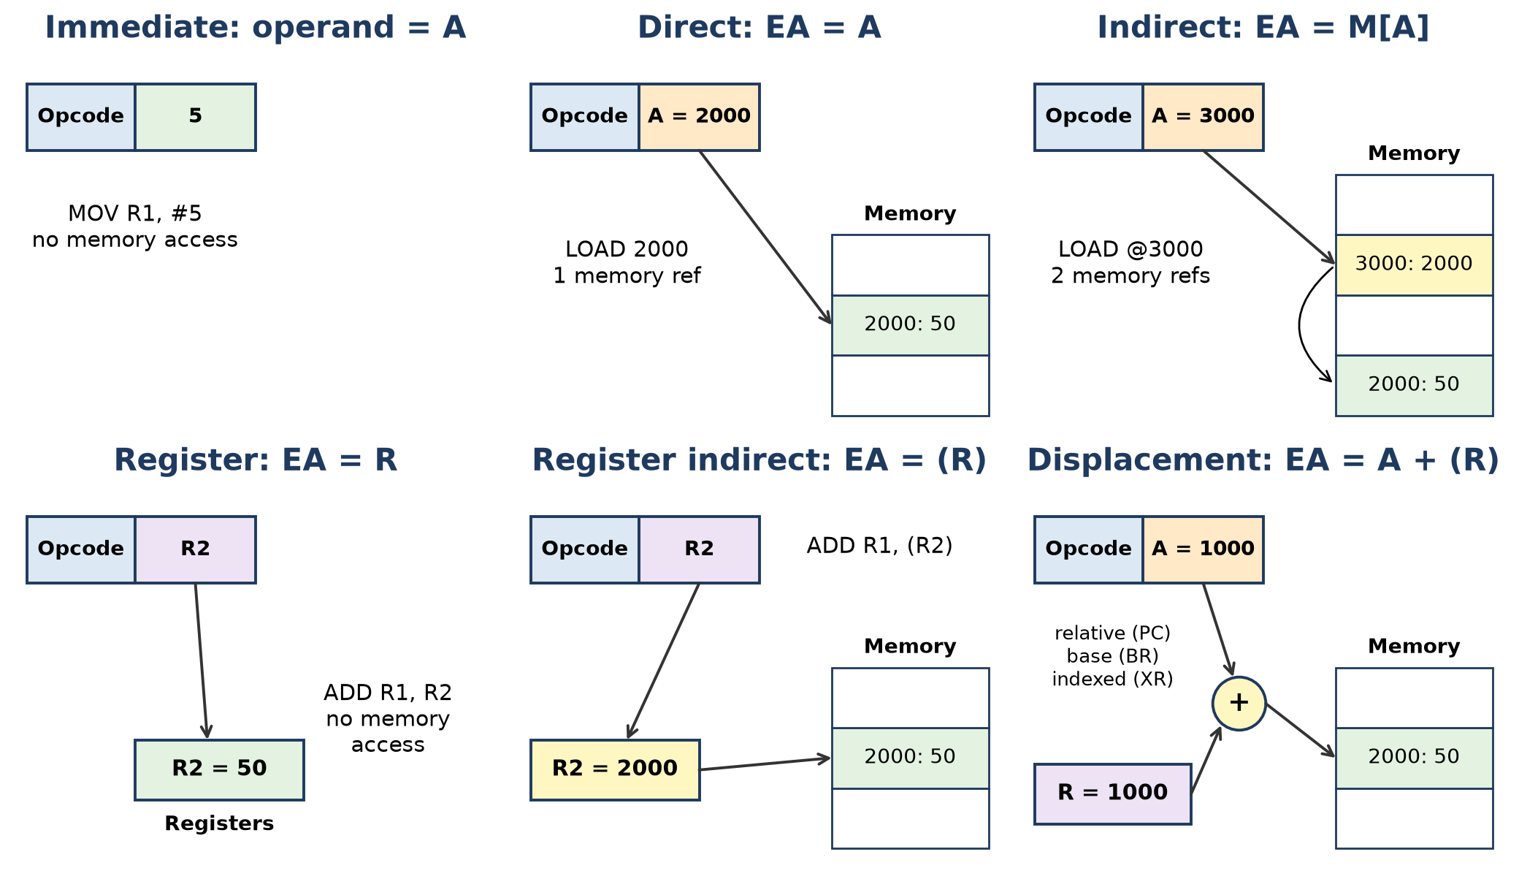
Figure: Common addressing modes
Remember: "I-I-D-I-R-R-A-R-I-B": Implied, Immediate, Direct, Indirect, Register, Reg-indirect, Auto, Relative, Indexed, Base.

Q4. Define Interrupt and list its types.
Understand • Low • CO2
An interrupt is a signal (from hardware or software) that makes the CPU suspend the current program, save its state, execute an Interrupt Service Routine (ISR), and then return to the interrupted program.
Types:
1. Hardware (external) interrupt – from an I/O device on an interrupt line (keyboard, disk, timer).
- Maskable – can be disabled by the CPU (e.g., INTR in 8086).
- Non-maskable (NMI) – cannot be disabled; for critical events (power failure).
2. Software interrupt – caused by a special instruction in the program (e.g., INT 21h, system call).
3. Internal interrupt / exception – caused by abnormal conditions inside the CPU: divide by zero, overflow, invalid opcode, page fault.
Stallings classes: program, timer, I/O and hardware-failure interrupts.
Remember: Interrupt = "doorbell": pause, attend (ISR), return.

Q5. Elaborate the concept of pipelining? List its advantages.
Understand • Low • CO2
Pipelining is a technique in which the instruction cycle is divided into stages, and different instructions are processed in different stages at the same time (overlapped), like an assembly line.
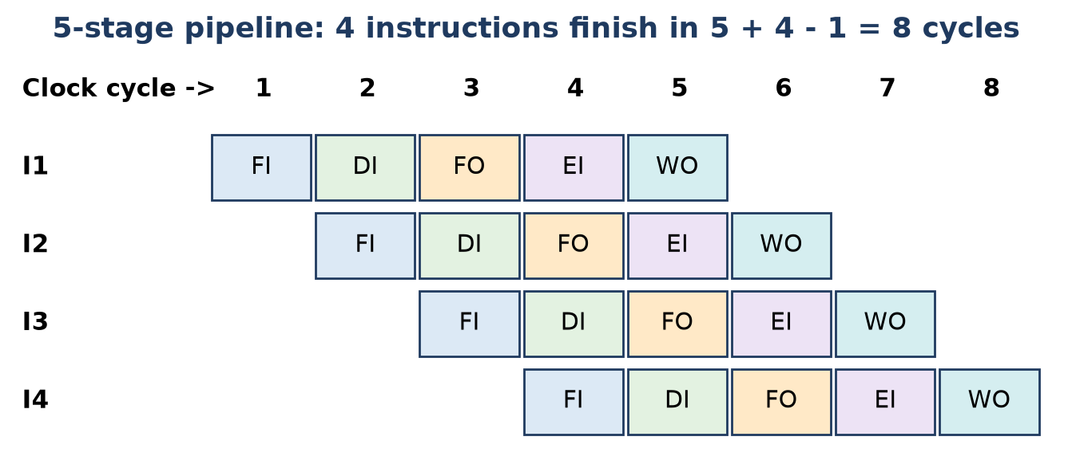
Figure: Instruction pipeline timing chart
Stages: FI (fetch instruction), DI (decode), FO (fetch operands), EI (execute), WO (write operand). For k stages and n instructions, time = (k + n − 1) cycles instead of k × n. Example: 5 stages, 4 instructions → 8 cycles instead of 20.
Advantages:
1. Higher throughput – ideally one instruction finishes per cycle.
2. Better use of CPU hardware – no stage sits idle.
3. Faster overall program execution without raising the clock.
4. Allows higher clock rate since each stage is short.
Hazards (limits): structural, data and control hazards.
Remember: Pipeline = laundry line: wash, dry, fold different loads at the same time.

Q6. Describe various instruction formats (zero-address, one-address, two-address, three-address) with examples.
Understand • Low • CO2
Instruction formats are classified by the number of address fields.
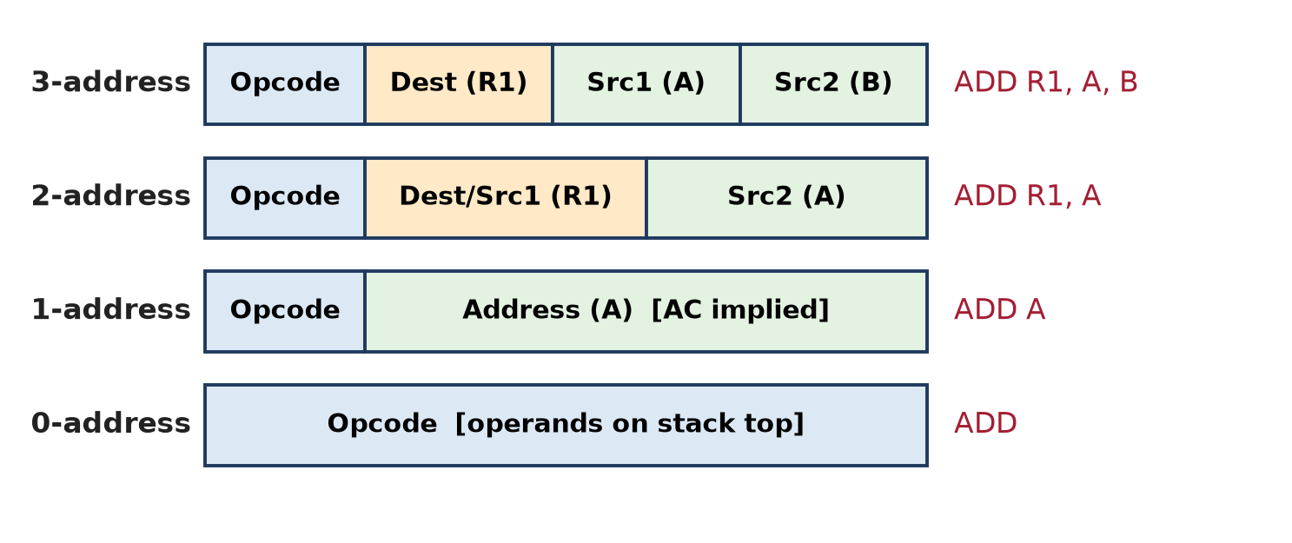
Figure: Instruction formats
1. Three-address – two sources and one destination. ADD R1, A, B → R1 ← M[A] + M[B]. Short programs but long instructions.
2. Two-address – first operand is both source and destination. ADD R1, A → R1 ← R1 + M[A]. Most common in commercial computers (x86).
3. One-address – uses an implied accumulator (AC). LOAD A (AC ← M[A]), ADD B (AC ← AC + M[B]).
4. Zero-address – used in stack-organized computers; operands are on top of stack. PUSH A, PUSH B, ADD (TOS ← A + B).
Example X = A + B:
3-address | 2-address | 1-address | 0-address
ADD X, A, B | MOV R1, A ; ADD R1, B ; MOV X, R1 | LOAD A ; ADD B ; STORE X | PUSH A ; PUSH B ; ADD ; POP X

Remember: More addresses per instruction = fewer instructions but longer each.

Q7. Classify different Types of Instructions used in Computer Organization with an example
Understand • Low • CO2
Instructions are grouped by the type of operation they perform.
Type | Purpose | Examples
Data transfer | Move data between registers, memory and stack | MOV, LOAD, STORE, PUSH, POP, XCHG
Arithmetic | Numeric calculation | ADD, SUB, MUL, DIV, INC, DEC, NEG
Logical | Bit-wise operations | AND, OR, XOR, NOT, CMP, TEST
Shift and rotate | Move bits left/right | SHL, SHR, SAR, ROL, ROR
Program control (transfer of control) | Change the sequence of execution | JMP, JZ, BEQ, CALL, RET, SKIP
Input / Output | Move data to/from devices | IN, OUT, INP
Conversion | Change data format | BCD to binary, CBW
System control | Privileged / CPU control | HLT, NOP, ION, IOF, INT

Example program: MOV R1, A (transfer) → ADD R1, B (arithmetic) → AND R1, #0Fh (logical) → JZ NEXT (control).
Remember: "DALS-PIC-S": Data, Arithmetic, Logic, Shift, Program control, I/O, Conversion, System.

Q8. Explain direct and immediate addressing Modes.
Understand • Low • CO2
1. Immediate addressing – the operand itself is in the address field of the instruction. Operand = A.
- Example: MOV R1, #25 → R1 ← 25; ADD 5 → AC ← AC + 5.
- No memory reference for the operand → fastest.
- Operand size is limited by the field size; used for constants.
2. Direct addressing – the address field holds the effective address of the operand. EA = A.
- Example: LDA 2000 → AC ← M[2000] (if M[2000] = 50, AC = 50).
- One memory reference, no address calculation.
- Limited address space (12-bit field → 4096 words).
Figure: Immediate and direct addressing (top-left panels)
Remember: Immediate = "here is the value"; Direct = "here is where the value lives".

Q9. Draw a neat diagram of a hardwired control unit and explain its working.
Understand • Low • CO2
A hardwired control unit generates control signals using fixed logic circuits (gates, flip-flops, decoders).
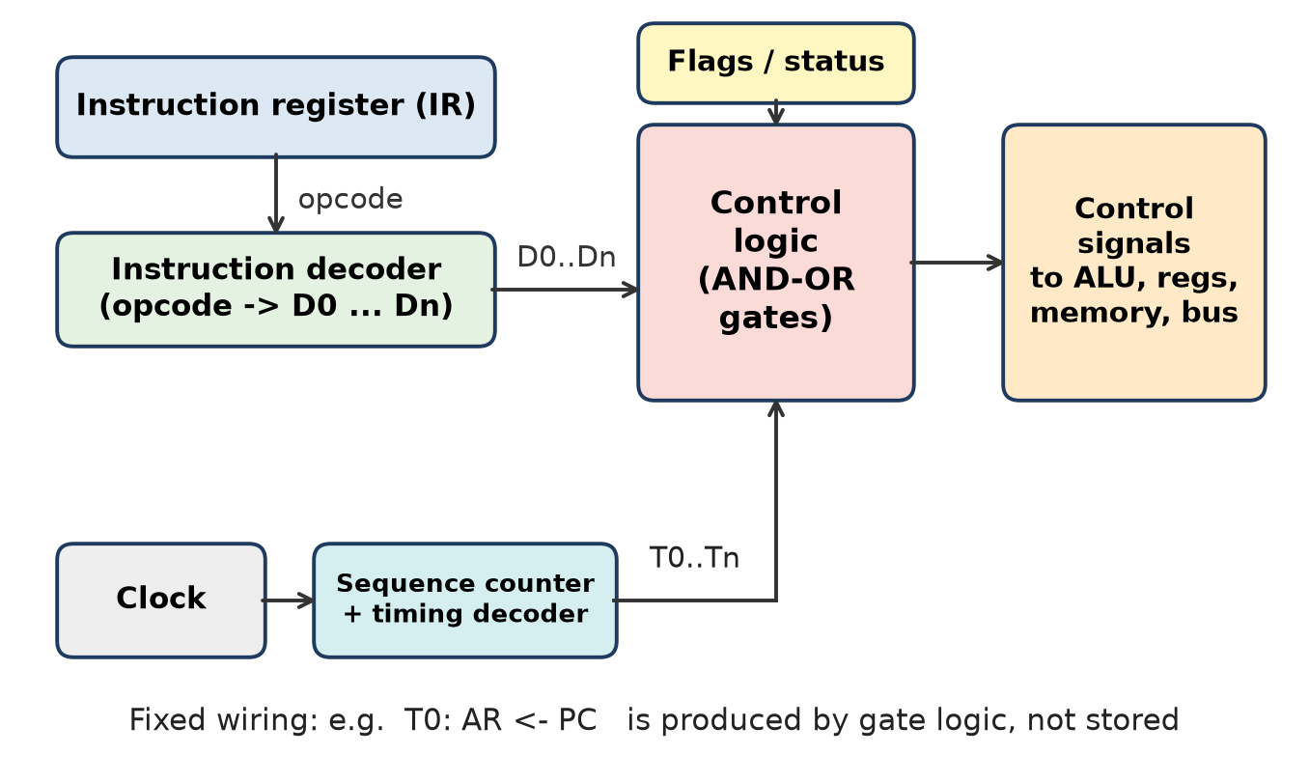
Figure: Hardwired control unit
Working:
1. Instruction register holds the instruction; its opcode goes to the instruction decoder, which activates one output (D0–D7 in Mano's computer).
2. A clock drives the sequence counter (SC); the timing decoder produces timing signals T0, T1, T2… one per clock.
3. The control logic (AND-OR gates) combines decoder outputs, timing signals and flags/status to produce each control signal. Example: D7′·T3 → execute memory-reference instruction; T0 → AR ← PC.
4. Control signals load registers, select the bus, command memory read/write and the ALU.
5. At the end of an instruction, SC is cleared (SC ← 0) to start the next fetch.
Features: very fast, but hard to modify; used in RISC processors.
Remember: Hardwired = control "soldered" into gates – fast but rigid.

Q10. Explain the design of a micro programmed control unit with the help of a block diagram.
Understand • Low • CO2
In a microprogrammed control unit, control signals are stored as microinstructions (control words) in a control memory and read out one by one.
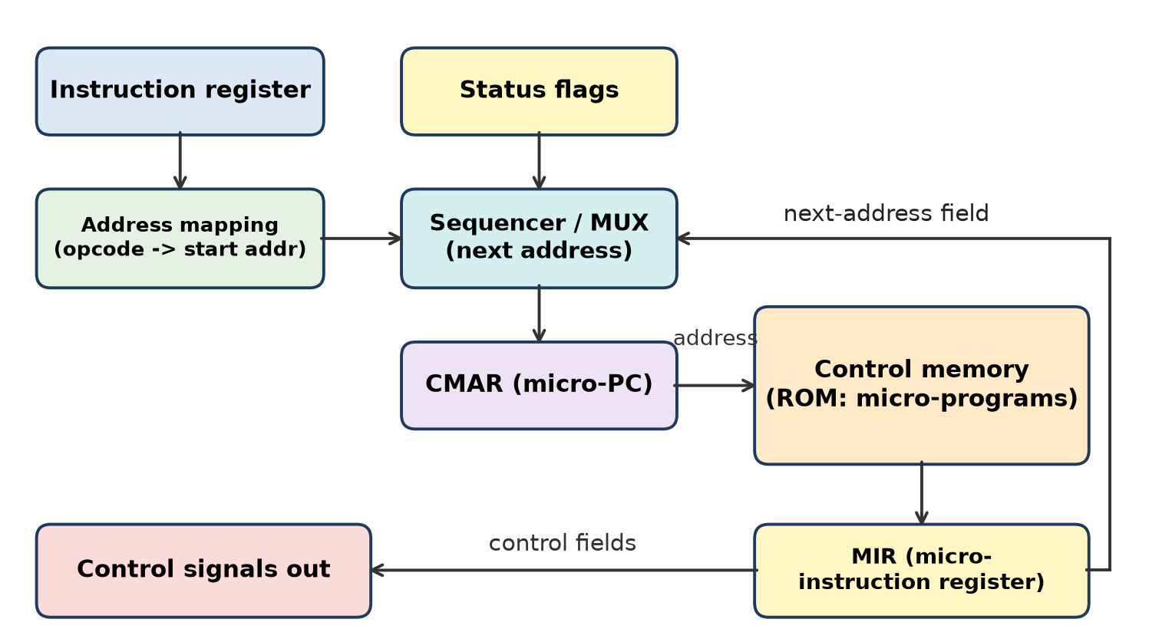
Figure: Microprogrammed control unit
Components and working:
1. Control memory (ROM) – stores microprograms; each machine instruction has a micro-routine.
2. Address mapping – converts the opcode in IR to the starting address of its micro-routine.
3. Sequencer / next-address logic – chooses the next address: increment, branch (using status flags) or map from opcode.
4. CMAR (control address register / micro-PC) – holds the address of the next microinstruction.
5. MIR (microinstruction register / control data register) – holds the microinstruction just read. Its control field bits become the control signals; its next-address field goes back to the sequencer.
Terms: control word (bits = control signals), microinstruction, micro-routine, microprogram, control store.
Features: flexible, easy to modify and debug, supports complex instruction sets (CISC), but slower.
Remember: Microprogrammed = a tiny computer inside the CU that "runs" control programs from ROM.

Q11. Illustrate the advantages of Direct addressing Mode with suitable example.
Understand • Low • CO2
In direct addressing, the address field contains the actual memory address of the operand: EA = A.
Example: LDA 2000 where M[2000] = 50 → AC ← 50. STA 3000 stores AC directly into location 3000.
Advantages:
1. Simple – no calculation is needed to find the effective address.
2. Only one memory reference to get the operand → faster than indirect, displacement or indexed modes.
3. Easy to understand and program – ideal for fixed global variables and constants stored in memory.
4. Simple hardware – address goes straight from IR to MAR.
Limitation: address space is limited by the size of the address field (12 bits → 4096 words), and the address is fixed in the instruction.
Remember: Direct = "go straight to house 2000" – one trip, no map reading.

Q12. Illustrate the advantages of Indirect addressing Mode with suitable example.
Understand • Low • CO2
In indirect addressing, the address field points to a memory word that contains the address of the operand: EA = M[A].
Example: ADD @3000 with M[3000] = 2000 and M[2000] = 50 → EA = 2000, AC ← AC + 50.
Advantages:
1. Large address space – a short address field can reach any location, because the pointer in memory is a full word (16-bit word → 64 K addresses).
2. Pointers and dynamic data – easy to implement pointers, linked lists, arrays passed to functions.
3. Flexible – the operand location can be changed by changing M[3000], without changing the instruction.
4. Subroutine return / parameter passing – e.g., BUN 0 I in Mano returns through an address saved in memory.
Disadvantage: needs two memory references, so it is slower than direct.
Remember: Indirect = "the note in box 3000 tells you which box has the money".

Q13. Illustrate the disadvantages of displacement addressing Mode with suitable example.
Understand • Low • CO2
Displacement addressing combines direct and register indirect: EA = A + (R). Its three common forms are relative (R = PC), base register (R = BR) and indexed (R = index register).
Example: LOAD R1, 1000(R2) with R2 = 1000 → EA = 1000 + 1000 = 2000, R1 ← M[2000].
Disadvantages:
1. Extra address calculation – an addition is needed for every operand → more time per instruction.
2. Longer instructions – both a displacement field and a register field are needed.
3. More complex hardware – an adder for address computation, more decoding.
4. Limited displacement range – a small field (e.g., 8 bits = −128 to +127) cannot reach far locations.
5. Register dependency – the register must be loaded correctly first; a wrong base/index gives a wrong EA, and it ties up a register.
Figure: Displacement addressing (bottom-right panel)
Remember: Displacement = base + offset: flexible, but you must "add before you go".

Q14. Draw and explain Processor and memory architecture of computer system.
Understand • Low • CO2
The top-level view (Stallings) shows the processor, main memory and I/O module connected by the system bus.
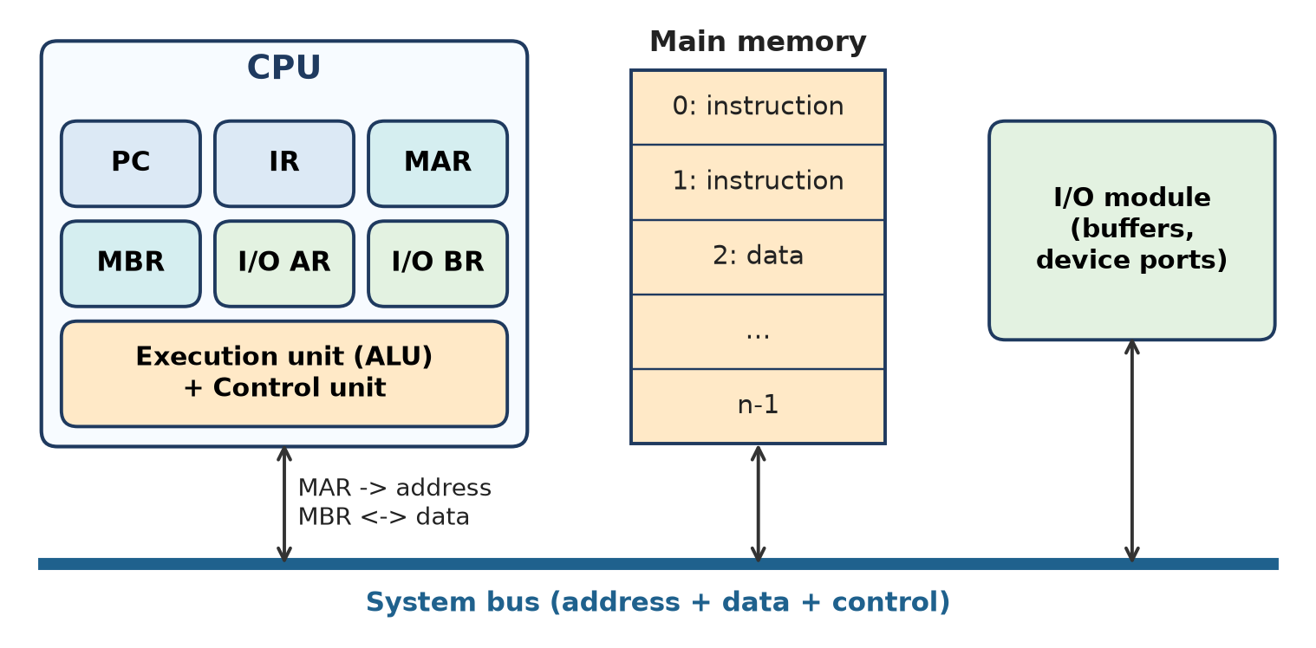
Figure: Processor and memory architecture
1. CPU registers for memory exchange:
- MAR – address of the location to read/write.
- MBR – word to be written to or read from memory.
- PC – address of the next instruction; IR – current instruction.
2. I/O registers: I/O AR selects the I/O device; I/O BR holds the data exchanged.
3. Execution unit (ALU + CU) – processes data and controls the operations.
4. Main memory – a set of locations 0 … n−1, each with an address, holding both instructions and data (stored-program concept).
5. I/O module – transfers data between external devices and the CPU/memory using internal buffers.
6. System bus – address, data and control lines link all of them.
Read operation: CPU puts address in MAR → Memory Read on control bus → word arrives in MBR.
Remember: MAR says "where", MBR says "what", the bus carries both.

Q15. Justify the significance of Instruction Format with suitable example. Define the opcode and operands.
Apply • Moderate • CO2
An instruction format defines how the bits of an instruction are divided into fields.
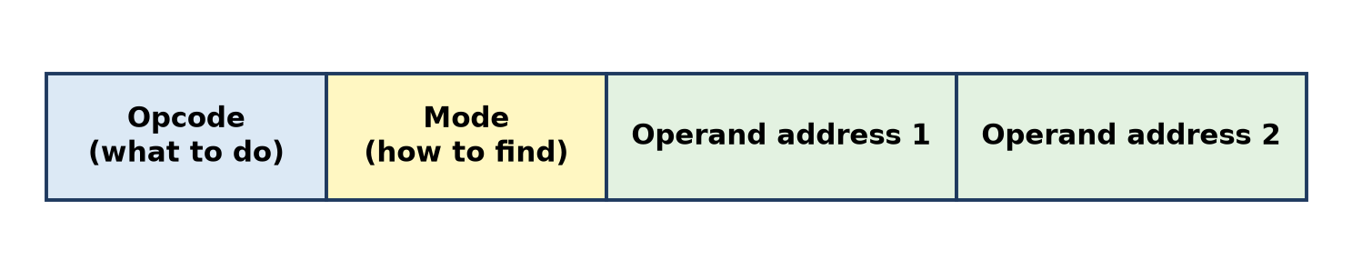
Figure: General instruction format
Definitions:
- Opcode (operation code) – the field that tells the CPU which operation to perform (ADD, LOAD, JMP). n bits → 2ⁿ operations.
- Operands – the data or addresses of data on which the operation acts (register, memory address or immediate value).
Significance (justification):
1. Decides instruction length – affects memory size and fetch time.
2. Number of operations – size of opcode field limits instruction set size.
3. Number of addressable locations – address field size decides memory range.
4. Addressing modes – mode field allows flexible ways to find operands.
5. Number of registers – register field width (e.g., 5 bits → 32 registers).
6. Ease of decoding and pipelining – fixed formats (RISC) decode faster than variable ones (CISC).
7. Program size – 3-address gives fewer instructions; 1-address gives shorter instructions.
Example (Mano, 16 bits): I = 1 bit, opcode = 3 bits (8 codes), address = 12 bits (4096 words). 0 001 0000 0100 0000 = ADD with direct address 040 hex: AC ← AC + M[040].
Remember: Format = grammar of machine language: opcode = verb, operands = nouns.

Q16. Compare CISC and RISC architectures based on: Instruction complexity, Execution time, Pipelining support, Hardware requirement
Apply • Moderate • CO2
Basis | CISC (Complex Instruction Set Computer) | RISC (Reduced Instruction Set Computer)
Instruction complexity | Hundreds of complex, variable-length instructions; many addressing modes; memory-to-memory operations | Small set of simple, fixed-length instructions; few addressing modes; load/store only access memory
Execution time | Many cycles per instruction (high CPI), but fewer instructions per program | About one cycle per instruction, more instructions per program but faster overall
Pipelining support | Difficult – variable length and multi-cycle instructions cause stalls | Easy and efficient – uniform instructions suit a deep pipeline
Hardware requirement | Complex decoder, usually microprogrammed control, fewer registers | Simple hardwired control, many registers, more work for compiler
Code size | Smaller | Larger
Power | Higher | Lower
Examples | Intel x86, AMD | ARM, SPARC, PowerPC, RISC-V

Conclusion: RISC gives speed and low power through simplicity; CISC gives compact code and powerful instructions.
Remember: CISC: "do much per instruction"; RISC: "do little, but very fast".

Q17. Compare hardwired control and micro programmed control in terms of speed, cost, and flexibility. Which is preferred for modern CPUs?
Apply • Moderate • CO2
Basis | Hardwired control | Microprogrammed control
Implementation | Fixed logic gates, decoders, flip-flops | Microinstructions stored in control memory (ROM)
Speed | Fast – signals produced directly by logic | Slower – each step needs a control-memory read
Cost | Low for simple sets; costly to redesign | Extra control memory, but cheap to change
Flexibility | Rigid – change needs rewiring / new chip | Flexible – change the microprogram
Design for complex ISA | Very complex | Easy and systematic
Debugging and upgrade | Difficult | Easy (even firmware updates)
Used in | RISC (ARM, MIPS, RISC-V) | CISC (classic x86, IBM 360)

Which is preferred for modern CPUs?
1. For high-performance designs, hardwired control is preferred because speed is critical and RISC instructions are simple.
2. Modern x86 CPUs use a hybrid: common simple instructions are decoded by hardwired decoders into micro-operations, while rare complex instructions use a microcode ROM (which can also be patched by updates).
Conclusion: modern CPUs mainly use hardwired control for speed, with microcode only for complex or legacy instructions.
Remember: Hardwired = speed; Microprogrammed = flexibility; modern chips mix both.

Q18. Draw and explain the flowchart of instruction cycle for Z=( (A+B)/(D*E)) Explain any three addressing modes with example.
Apply • High • CO2
Program (3-address) for Z = (A + B) / (D × E):
Instruction | RTL
ADD R1, A, B | R1 ← M[A] + M[B]
MUL R2, D, E | R2 ← M[D] × M[E]
DIV Z, R1, R2 | M[Z] ← R1 ÷ R2

Figure: Instruction cycle state diagram
Instruction cycle for each instruction (e.g., ADD R1, A, B):
1. IAC – PC gives the address of the instruction.
2. IF – instruction read into IR; PC ← PC + 1.
3. IOD – CU decodes "ADD, two memory sources, register destination".
4. OAC → OF – EA of A found and M[A] fetched; loop back (multiple operands) for B.
5. DO – ALU adds (MUL and DIV in the other instructions).
6. OAC → OS – result stored in R1 (in the last instruction, in memory location Z).
7. Check for interrupts, then go back to IAC for the next instruction.
Three addressing modes:
1. Direct – EA = address field. ADD R1, A, B uses A and B directly (A = 1000 → operand = M[1000]).
2. Register – operand is in a CPU register. DIV Z, R1, R2 takes R1 and R2 from registers – no memory access.
3. Immediate – operand is in the instruction. MOV R3, #10 → R3 ← 10; useful for constants.
Conclusion: the expression needs 3 instruction cycles; using registers for intermediate results avoids extra memory accesses.
Remember: IAC-IF-IOD-OAC-OF-DO-OS: "I If I Only Order Dosa, Order Sambar".

Q19. Explain how the expression X=A X B + C X C will be executed in one address, two address and three address processors in an accumulator organization.
Apply • Moderate • CO2
Expression: X = A × B + C × C (T = temporary memory location).
Three-address:
Instruction | RTL
MUL R1, A, B | R1 ← M[A] × M[B]
MUL R2, C, C | R2 ← M[C] × M[C]
ADD X, R1, R2 | M[X] ← R1 + R2

Two-address:
Instruction | RTL
MOV R1, A | R1 ← M[A]
MUL R1, B | R1 ← R1 × M[B]
MOV R2, C | R2 ← M[C]
MUL R2, C | R2 ← R2 × M[C]
ADD R1, R2 | R1 ← R1 + R2
MOV X, R1 | M[X] ← R1

One-address (accumulator organization):
Instruction | RTL
LOAD A | AC ← M[A]
MUL B | AC ← AC × M[B]
STORE T | M[T] ← AC
LOAD C | AC ← M[C]
MUL C | AC ← AC × M[C]
ADD T | AC ← AC + M[T]
STORE X | M[X] ← AC

Count: 3-address = 3, 2-address = 6, 1-address = 7 instructions. In the accumulator machine every operation uses AC implicitly, so a temporary T is needed to save the first product.
Remember: Fewer addresses → more instructions: 3 → 6 → 7.

Q20. Discuss design issues and performance trade-offs in RISC vs CISC processors with real-world examples (ARM, Intel).
Apply • Moderate • CO2
Performance equation: T = Ic × CPI × τ. CISC lowers Ic; RISC lowers CPI and τ.
Design issues and trade-offs:
1. Instruction length – ARM (AArch64) uses fixed 32-bit instructions (plus 16-bit Thumb in older ARM for code density); Intel x86 uses variable 1–15 byte instructions → compact code but complex decoding.
2. Memory access – ARM is load/store (only LOAD/STORE touch memory); x86 allows memory operands in ADD, MOV etc.
3. Registers – ARM64 has 31 general-purpose registers; x86-64 has 16 → RISC keeps more data on chip.
4. Control unit – ARM uses mainly hardwired control; Intel uses hardwired decoders + microcode for complex instructions.
5. Pipelining – fixed-length RISC instructions pipeline easily; modern Intel chips translate x86 instructions into RISC-like micro-ops internally to pipeline them.
6. Power and area – simpler ARM cores use less power → smartphones, tablets, Apple M-series laptops; Intel x86 focuses on high single-thread speed and backward compatibility → desktops and servers.
7. Compiler burden – RISC needs smarter compilers; CISC eases assembly programming.
Issue | RISC (ARM) | CISC (Intel x86)
Code size | Larger | Smaller
Decoder | Simple | Complex
Power | Low | Higher
Compatibility | Newer ISA | 40+ years backward compatible

Conclusion: the gap has narrowed – x86 is RISC-like inside and ARM has added complex features; choice depends on power, compatibility and performance needs.
Remember: ARM = efficiency (phones); Intel = compatibility and raw power (PCs) – both borrow from each other.

Q21. A machine supports 3-address, 2-address, and 1-address instructions. For a complex arithmetic expression like (A*B + C*D) / (E+F), show how the number of instructions varies with each format. Which format leads to minimal memory traffic?
Apply • High • CO2
Expression: X = (A × B + C × D) / (E + F)
3-address | 2-address | 1-address (AC)
MUL R1, A, B | MOV R1, A | LOAD E
MUL R2, C, D | MUL R1, B | ADD F
ADD R1, R1, R2 | MOV R2, C | STORE T1
ADD R2, E, F | MUL R2, D | LOAD C
DIV X, R1, R2 | ADD R1, R2 | MUL D
– | MOV R2, E | STORE T2
– | ADD R2, F | LOAD A
– | DIV R1, R2 | MUL B
– | MOV X, R1 | ADD T2
– | – | DIV T1
– | – | STORE X

Memory traffic (assume each instruction fetch = 1 memory access, each memory operand = 1 access):
Format | Instructions | Instruction fetches | Data accesses | Total memory accesses
3-address | 5 | 5 | 7 (A, B, C, D, E, F, X) | 12
2-address | 9 | 9 | 7 | 16
1-address | 11 | 11 | 11 (incl. T1, T2 save and reload) | 22

Analysis:
1. Number of instructions rises as addresses fall: 5 → 9 → 11.
2. 1-address needs temporary memory locations (T1, T2), adding extra data traffic.
3. 3-address keeps intermediate results in registers and needs the fewest fetches.
Answer: the 3-address format gives minimal memory traffic (≈12 accesses). Its instructions are longer, but the reduction in instruction count and temporaries outweighs this.
Remember: Fewer instructions + intermediates in registers = less memory traffic → 3-address wins.

Q22. For given complex arithmetic expressions (A + B) * (C + D), (((A+B)+C)+D), (AB) / (CD) + (E+F) ), Show how the number of instructions varies in 3-address, 2-address, and 1-address instructions.
Apply • High • CO2
(Third expression read as X = (A × B) / (C × D) + (E + F); T = temporary.)
(a) X = (A + B) × (C + D)
3-address | 2-address | 1-address
ADD R1, A, B | MOV R1, A ; ADD R1, B | LOAD A ; ADD B ; STORE T
ADD R2, C, D | MOV R2, C ; ADD R2, D | LOAD C ; ADD D
MUL X, R1, R2 | MUL R1, R2 ; MOV X, R1 | MUL T ; STORE X
3 | 6 | 7

(b) X = (((A + B) + C) + D)
3-address | 2-address | 1-address
ADD R1, A, B | MOV R1, A ; ADD R1, B | LOAD A ; ADD B
ADD R1, R1, C | ADD R1, C ; ADD R1, D | ADD C ; ADD D
ADD X, R1, D | MOV X, R1 | STORE X
3 | 5 | 5

(c) X = (A × B) / (C × D) + (E + F)
3-address | 2-address | 1-address
MUL R1, A, B | MOV R1, A ; MUL R1, B | LOAD C ; MUL D ; STORE T
MUL R2, C, D | MOV R2, C ; MUL R2, D | LOAD A ; MUL B ; DIV T
DIV R1, R1, R2 | DIV R1, R2 | ADD E
ADD R1, R1, E | ADD R1, E | ADD F
ADD X, R1, F | ADD R1, F ; MOV X, R1 | STORE X
5 | 8 | 9

Summary:
Expression | 3-address | 2-address | 1-address
(A+B)(C+D) | 3 | 6 | 7
((A+B)+C)+D | 3 | 5 | 5
AB/CD + (E+F) | 5 | 8 | 9

Observation: a chain like (b) suits the accumulator (no temporaries), so 1-address equals 2-address; expressions with two independent sub-results need temporaries in 1-address, increasing count.
Remember: Independent sub-expressions punish 1-address machines (need temporaries); chains do not.

Q23. Explain how interrupts can alter the normal instruction cycle. What architectural mechanisms are needed to preserve program correctness?
Apply • Moderate • CO2
Normally the CPU repeats fetch → decode → execute. With interrupts, an interrupt cycle is added after the execute phase.
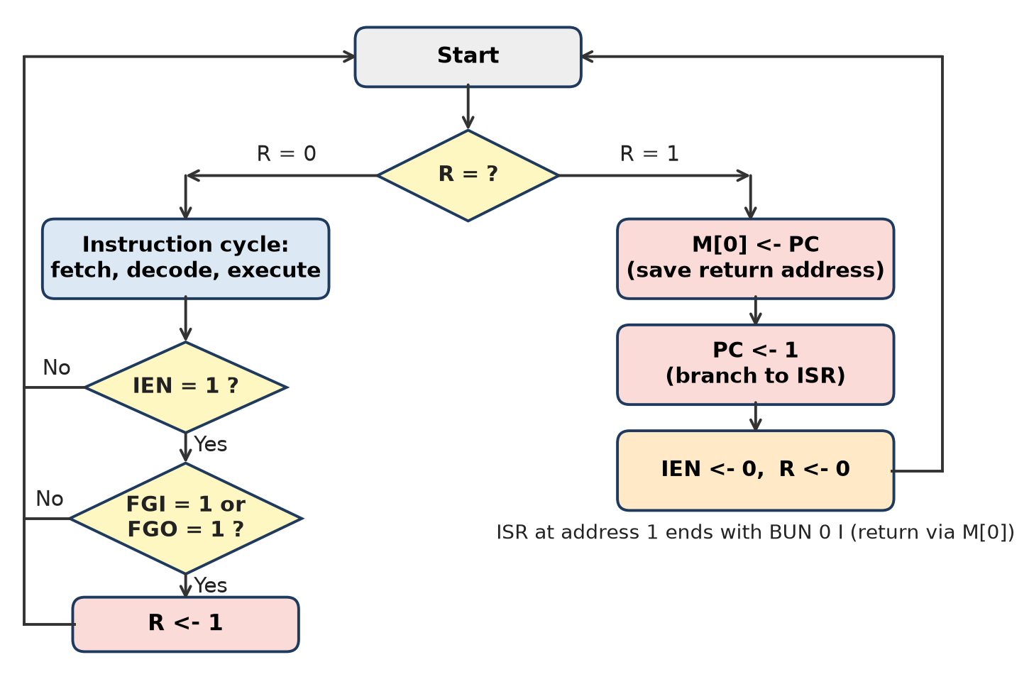
Figure: Instruction cycle with interrupt cycle (Mano)
How the cycle is altered:
1. After executing an instruction, the CPU checks: IEN = 1 and a device flag (FGI/FGO) set → R ← 1.
2. If R = 1, instead of fetching the next instruction, it enters the interrupt cycle: M[0] ← PC (save return address), PC ← 1 (branch to ISR), IEN ← 0, R ← 0.
3. The ISR runs; at its end, control returns to the saved address and normal execution continues.
Mechanisms needed for correctness:
1. Interrupt only at instruction boundary – the current instruction completes first.
2. Save the context – PC, PSW/flags and used registers saved (on a stack or fixed location) and restored.
3. Interrupt enable/disable (IEN, masking) – prevents unwanted or nested interrupts during critical steps.
4. Priority and vectoring – interrupt controller (e.g., 8259A) identifies the device and gives the ISR address.
5. Atomic return instruction (IRET) – restores PC and flags together.
6. Precise interrupts in pipelines – flush partly executed later instructions.
Remember: Interrupt = bookmark (save PC), answer the doorbell (ISR), return to the bookmark.

Q24. A machine uses a 32-bit instruction word. If 8 bits are reserved for opcode and 24 bits for addressing, how many unique instructions can be supported?
Apply • High • CO2
Formula: number of unique opcodes = 2ⁿ, where n = number of opcode bits.
Given: instruction word = 32 bits; opcode = 8 bits; address field = 24 bits.
Working:
1. Check: 8 + 24 = 32 bits (correct)
2. Unique instructions = 2⁸ = 256.
3. Address field: 2²⁴ = 16,777,216 locations = 16 M (16 MB if byte-addressable) can be addressed directly.
4. If the 24 bits are split into two 12-bit address fields (2-address format), each operand can address 2¹² = 4096 locations.
5. If one opcode is reserved (e.g., as an extension prefix), extra instructions can be created using expanding opcodes – but with a fixed 8-bit opcode the maximum is 256.
Field | Bits | Combinations
Opcode | 8 | 2⁸ = 256 instructions
Address | 24 | 2²⁴ = 16,777,216 addresses

Final answer: 256 unique instructions, each able to directly address 16 M (2²⁴) memory locations.
Conclusion: opcode width fixes the size of the instruction set; address width fixes the directly addressable memory.
Remember: Opcode bits n → 2ⁿ instructions: 8 bits → 256.

Q25. Explain with examples the following addressing modes: Immediate, Direct, Indirect, Indexed, and Relative.
Apply • Moderate • CO2
Assume memory: M[500] = 800, M[800] = 300, M[900] = 75, and index register XR = 400.
1. Immediate – operand is in the instruction. LOAD #500 → AC = 500. No memory access; for constants.
2. Direct – EA = A. LOAD 500 → EA = 500, AC = M[500] = 800. One memory access.
3. Indirect – EA = M[A]. LOAD @500 → EA = M[500] = 800, AC = M[800] = 300. Two memory accesses; supports pointers.
4. Indexed – EA = A + XR. LOAD 500(XR) → EA = 500 + 400 = 900, AC = M[900] = 75. Used for arrays: A = base address, XR = index.
5. Relative – EA = PC + A. Instruction at 825, PC after fetch = 826, A = 24 → EA = 826 + 24 = 850. Used in branches (BEQ LABEL); code becomes position-independent.
Mode | EA | Result in example
Immediate | – (operand = A) | 500
Direct | A | 800
Indirect | M[A] | 300
Indexed | A + XR | 75
Relative | PC + A | location 850

Figure: Addressing modes
Remember: Immediate = value, Direct = address, Indirect = address of address, Indexed = base + index, Relative = PC + offset.

Q26. Justify why is Indexed addressing mode widely used in array processing?
Apply • Moderate • CO2
In indexed addressing, EA = A + (XR), where A = starting (base) address of the array in the instruction and XR = index register holding the element offset.
Justification:
1. Natural match to arrays – element i is at Base + i × size; the instruction holds the base, the register holds i × size.
2. Same instruction reused in a loop – only XR changes (increment/decrement), so the code is short.
3. No self-modifying code – the address field never needs to be changed.
4. Fast – the hardware adds A + XR during address calculation; often combined with auto-increment.
5. Easy loop control – XR can also act as the loop counter.
6. Useful for tables, strings, matrices and stacks.
Example – sum of array of 5 words starting at 2000:
CLR R1 ; sum = 0
MOV XR, #0 ; index = 0
LOOP: ADD R1, 2000(XR) ; R1 = R1 + M[2000 + XR]
INC XR ; next element
CMP XR, #5
JNZ LOOP ; repeat 5 times
With 4-byte elements and XR = 5 × 4 = 20, A[5] is at 2000 + 20 = 2020.
Remember: Indexed = "array street": base in the instruction, house number in the register.

Q27. Justify why do RISC processors prefer simple, fixed-length instructions?
Apply • Moderate • CO2
RISC processors (ARM, MIPS, RISC-V) use simple, fixed-length (usually 32-bit) instructions because:
1. Easy and fast decoding – opcode and register fields are always in the same bit positions, so decoding is done by simple hardwired logic in one cycle.
2. Efficient pipelining – every instruction takes the same fetch time and similar stage times → fewer stalls, close to one instruction per cycle.
3. Simple fetch – the next instruction is always at PC + 4; no need to find where the next instruction begins.
4. Single-cycle execution – simple operations (load/store, register-register ALU) finish in one cycle.
5. Smaller control unit – saves chip area for more registers and larger cache.
6. Lower power – simpler hardware means less energy (important for mobiles).
7. Better compiler optimization – uniform instructions are easier to schedule.
Trade-off: programs become larger (more instructions, lower code density), but overall execution time is lower since T = Ic × CPI × τ falls through low CPI and short τ.
Example: ARM ADD R0, R1, R2 is always 32 bits, while an x86 instruction may be anywhere from 1 to 15 bytes.
Remember: Same-size bricks build the pipeline wall fastest.

Q28. Explain the difference between general-purpose registers (GPRs) and special-purpose registers (SPRs) with examples.
Moderate • CO2
General-purpose registers (GPRs) can hold any data or address as the program needs. Special-purpose registers (SPRs) have one fixed job, mostly used by the CPU or control unit.
Point | GPRs | SPRs
Purpose | Temporary data, operands, results, addresses | Fixed function for CPU control
Usage | Freely chosen by programmer / compiler | Used by hardware; limited or no direct access
Number | Many (8–32) | Few
Visibility | User-visible | Some visible (SP, flags), some hidden (MAR, MBR)
Examples | R0–R15 in ARM; EAX, EBX, ECX, EDX in x86 | PC, IR, MAR, MBR, SP, PSW/flags, AC
Effect on speed | More GPRs → fewer memory accesses | Needed for correct sequencing

SPR examples: PC – next instruction address; IR – current instruction; MAR/MBR – memory address/data; SP – top of stack; PSW – flags and status.
Conclusion: GPRs give flexibility and speed to programs; SPRs make the instruction cycle work.
Remember: GPR = any-use desk drawer; SPR = labelled drawer for one job only.

Q29. Draw the pipeline execution diagram for the following instructions: I1: LOAD R1, A I2: ADD R2, R1, R3 I3: SUB R4, R2, R5
Apply • High • CO2
Assume a 5-stage pipeline: IF (fetch), ID (decode/register read), EX (execute), MEM (memory access), WB (write back).
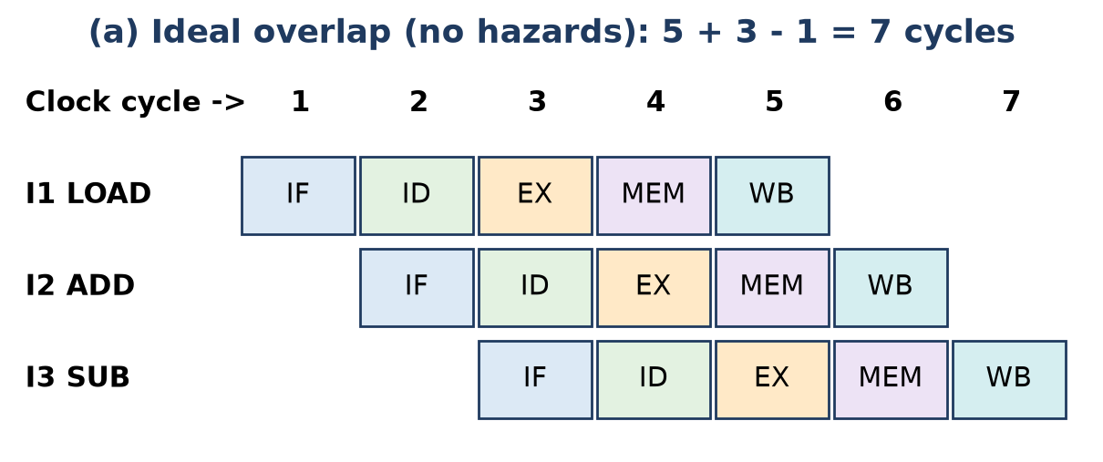
Figure: Ideal pipeline for I1-I3
Ideal case: cycles = k + n − 1 = 5 + 3 − 1 = 7 cycles.
Dependencies (RAW data hazards):
1. I1 → I2: I2 needs R1, which LOAD gets from memory only at the end of MEM (cycle 4).
2. I2 → I3: I3 needs R2, produced by ADD at the end of EX.
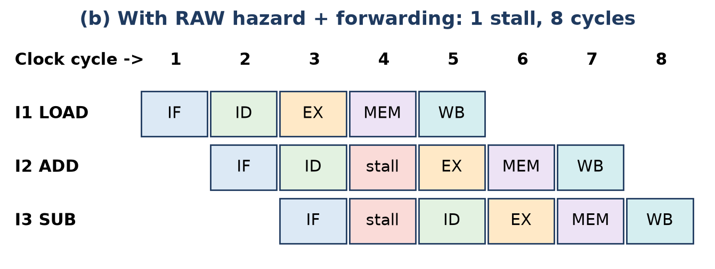
Figure: Pipeline with stall and forwarding
With operand forwarding:
1. LOAD's data is ready after cycle 4 → I2 can do EX only in cycle 5 → 1 stall (load-use hazard).
2. ADD's result (end of cycle 5) is forwarded directly to SUB's EX in cycle 6 – no further stall.
3. Total = 8 cycles.
Case | Cycles
Ideal (no hazards) | 7
With forwarding (1 load-use stall) | 8
Non-pipelined (3 × 5) | 15

Conclusion: pipelining cuts time from 15 to 8 cycles; forwarding removes most stalls, but a load followed by its use still needs one bubble (or the compiler can place an independent instruction there).
Remember: Load-use = one bubble; ALU-to-ALU = forward, no bubble.

Q30. Compare various addressing formats. (w.r.t.Instruction Format, Data Storage, Execution Speed, Used In,Instruction Length)
Apply • Moderate • CO2
Figure: Instruction (address) formats
Feature | 3-Address | 2-Address | 1-Address | 0-Address
Operands specified | 3 (2 sources, 1 destination) | 2 (1 source, 1 source+destination) | 1 (accumulator implied) | 0 (stack implied)
Instruction format | OP R1, R2, R3 | OP R1, R2 | OP M | OP
Data storage | Registers / memory | Registers / memory | Accumulator | Stack
Execution speed | Fast (fewest instructions) | Moderate | Slower | Slowest (many PUSH/POP)
Instruction length | Longest | Shorter than 3-address | Short | Shortest
Program length | Shortest | Medium | Long | Longest
Used in | RISC (ARM, MIPS) | CISC (Intel x86) | Early computers, simple CPUs (Mano basic computer) | Stack machines (Burroughs, JVM)

Example X = A + B: 3-address ADD X, A, B (1 instr.); 2-address 3 instr.; 1-address LOAD A, ADD B, STORE X (3 instr.); 0-address PUSH A, PUSH B, ADD, POP X (4 instr.).
Conclusion: as the number of addresses decreases, instructions get shorter but programs get longer.
Remember: Addresses ↓ → instruction length ↓, program length ↑.

Q31. Draw a suitable interrupt cycle diagram and justify the role of the Program Counter (PC), Stack Pointer (SP), and Interrupt Service Routine (ISR) during this process.
Apply • Moderate • CO2
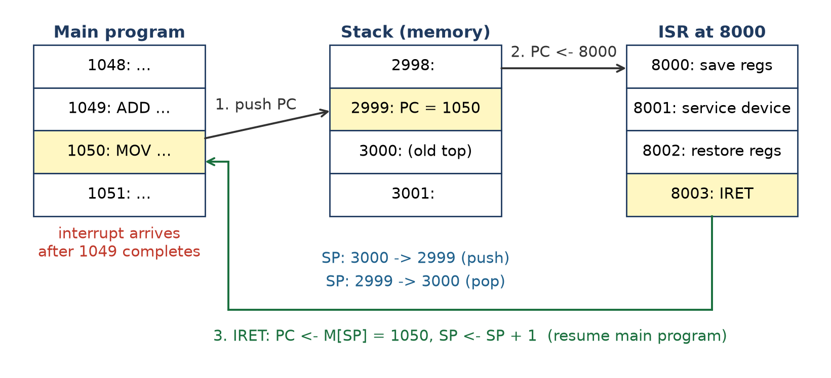
Figure: Interrupt cycle using PC, stack (SP) and ISR
Interrupt cycle steps (stack-based CPU):
1. Current instruction finishes; CPU checks for an enabled interrupt.
2. SP ← SP − 1, M[SP] ← PC (push return address; PSW is also pushed).
3. PC ← ISR address (from interrupt vector); interrupts disabled.
4. ISR executes; ends with IRET: PC ← M[SP], SP ← SP + 1.
Roles (justification):
1. Program Counter (PC) – holds the address of the next instruction of the interrupted program. Saving it lets the CPU return to the exact place; loading it with the ISR address transfers control to the handler.
2. Stack Pointer (SP) – points to the top of the stack in memory where PC, flags and registers are saved. Because the stack is LIFO, it supports nested interrupts: each new interrupt pushes on top and returns in the reverse order.
3. Interrupt Service Routine (ISR) – the program that services the device (reads keyboard data, handles timer). It saves/restores any registers it uses and ends with a return-from-interrupt so the main program continues unaffected.
Example: PC = 1050 when a keyboard interrupt comes; 1050 is pushed (SP: 3000 → 2999), PC ← 8000 (ISR); after IRET, PC = 1050 and SP = 3000 again.
Remember: PC = bookmark, SP = where the bookmark is kept, ISR = the urgent job.

Q32. ADD R1, Operand where the CPU needs to add an operand (say the value of variable X = 50) to register R1. write the same instruction using different addressing modes with very simple examples. Assume as: Variable X = 50 is stored at memory location 2000
Apply • High • CO2
Given: X = 50 stored at M[2000]. Assume R1 = 10 initially, so the result should be R1 = 60.
Mode | Instruction | Assumption | Effective address | Operand | Action
Immediate | ADD R1, #50 | value in instruction | – | 50 | R1 ← R1 + 50
Direct | ADD R1, 2000 | – | 2000 | 50 | R1 ← R1 + M[2000]
Indirect | ADD R1, @3000 | M[3000] = 2000 | M[3000] = 2000 | 50 | R1 ← R1 + M[M[3000]]
Register | ADD R1, R2 | R2 = 50 (loaded earlier) | – (register) | 50 | R1 ← R1 + R2
Register indirect | ADD R1, (R2) | R2 = 2000 | 2000 | 50 | R1 ← R1 + M[R2]
Auto-increment | ADD R1, (R2)+ | R2 = 2000 | 2000, then R2 = 2001 | 50 | R1 ← R1 + M[R2]; R2 ← R2 + 1
Indexed | ADD R1, 1000(XR) | XR = 1000 | 1000 + 1000 = 2000 | 50 | R1 ← R1 + M[1000 + XR]
Base register | ADD R1, 500(BR) | BR = 1500 | 1500 + 500 = 2000 | 50 | R1 ← R1 + M[BR + 500]
Relative | ADD R1, 500(PC) | PC = 1500 after fetch | 1500 + 500 = 2000 | 50 | R1 ← R1 + M[PC + 500]

Observations:
1. Immediate is fastest (no memory access) but X must be a constant.
2. Direct needs 1 memory access; indirect needs 2.
3. Register mode is fast if X is already in a register.
4. Indexed / base / relative are forms of displacement addressing – useful for arrays, relocatable programs and position-independent code.
In every case the result is R1 = 10 + 50 = 60.
Remember: Same ADD, nine roads to reach X = 50 – all end at 60.

Quick Revision – Unit II
Term | Key fact
CPU parts | CU + ALU + registers + internal bus
Hardwired CU | Fixed logic; fast, rigid; used in RISC
Microprogrammed CU | Microinstructions in control memory; flexible, slower; CISC
Instruction format | Opcode + mode + address fields
Opcode bits | n bits → 2ⁿ instructions (8 bits → 256)
3/2/1/0-address | Fewer addresses → shorter instructions, longer programs
Immediate / Direct / Indirect | Operand = A / EA = A / EA = M[A]
Register indirect | EA = (R)
Displacement | EA = A + (R): relative (PC), base (BR), indexed (XR)
Instruction cycle | IAC → IF → IOD → OAC → OF → DO → OS
Interrupt cycle | Save PC (stack or M[0]) → PC ← ISR → disable interrupts
Pipeline time | k + n − 1 cycles for n instructions in k stages
Pipeline hazards | Structural, data (RAW), control (branches)
RISC vs CISC | Simple fixed-length, load/store, many registers vs complex variable-length, memory operands
GPR vs SPR | Any-use registers vs fixed-job registers (PC, IR, SP, PSW)

Unit III: Memory Subsystem

Q1. List and explain the different types of computer memory with suitable examples.
Understand • Low • CO3
Memory is the part of the computer that stores data and instructions. It is divided into primary (internal) and secondary (external) memory.
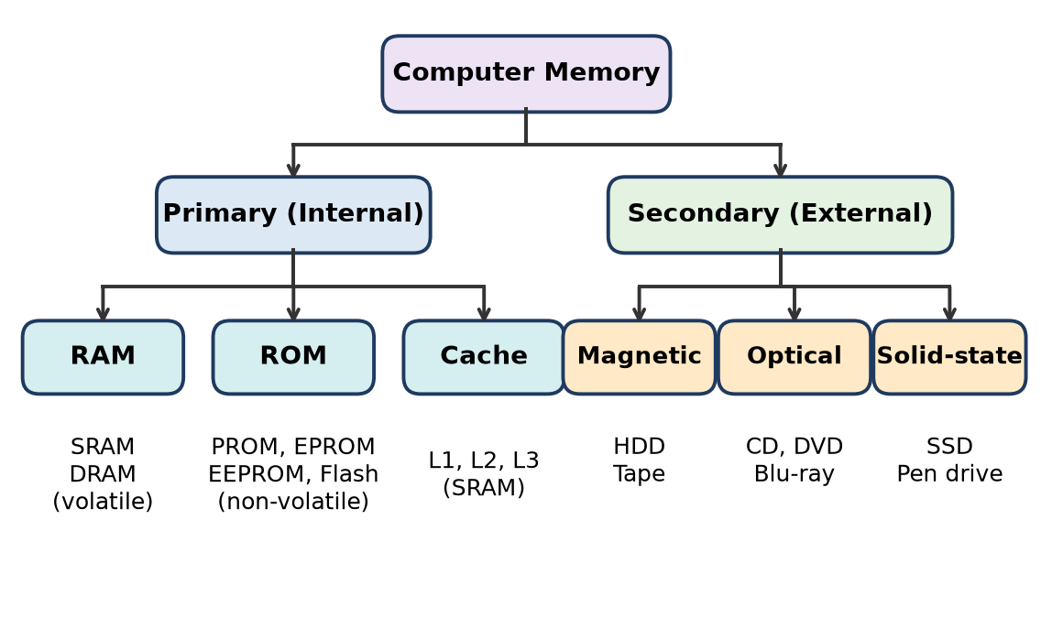
Figure: Classification of computer memory
1. RAM (Random Access Memory) – read/write, volatile main memory. Types: SRAM (used for cache) and DRAM (main memory, e.g. DDR4/DDR5 sticks).
2. ROM (Read Only Memory) – non-volatile, holds firmware such as BIOS. Types: PROM, EPROM, EEPROM, Flash.
3. Cache memory – small, very fast SRAM between CPU and RAM (L1, L2, L3).
4. Registers – fastest storage inside the CPU (e.g. PC, accumulator).
5. Secondary memory – large, permanent storage: HDD (magnetic), SSD (flash), CD/DVD/Blu-ray (optical), magnetic tape (backup).
Remember: "Primary is fast but forgets; secondary is slow but remembers."

Q2. Discuss the function and significance of cache memory in improving system performance.
Understand • Low • CO3
Cache is a small, very fast SRAM memory placed between the CPU and main memory that keeps copies of the most frequently used instructions and data.
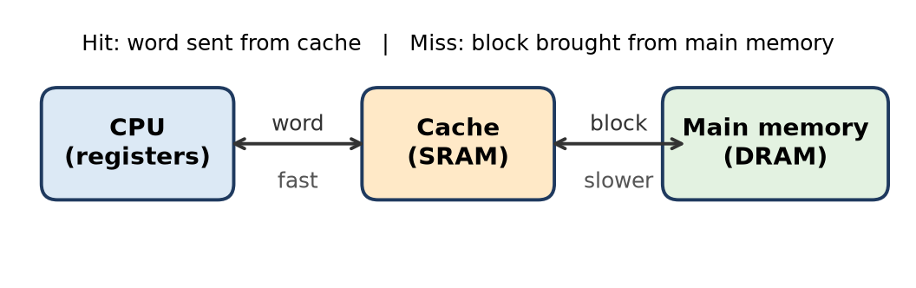
Figure: Position of cache
Function
1. CPU first checks the cache. If the word is there, it is a cache hit and the word is sent at once.
2. If not, it is a cache miss: the whole block containing the word is brought from main memory into the cache, then the word is given to the CPU.
Significance
- Works because of locality of reference (temporal and spatial): programs reuse the same and nearby addresses.
- Reduces average memory access time, so the CPU waits less.
- Bridges the speed gap between a fast CPU and slow DRAM; costs far less than making all memory SRAM.
Remember: Cache is the CPU's "pocket" – keep what you use most within hand's reach.

Q3. Define SRAM and DRAM. Explain their structure, operation, and applications.
Understand • Low • CO3
SRAM (Static RAM) stores each bit in a flip-flop (latch) and keeps it as long as power is on. DRAM (Dynamic RAM) stores each bit as charge on a capacitor, which leaks and must be refreshed every few milliseconds.
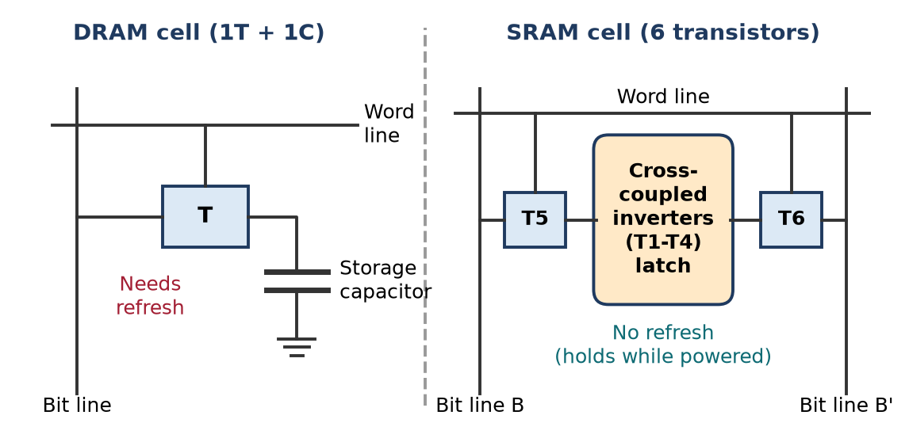
Figure: DRAM and SRAM cells
Structure and operation
1. DRAM cell = 1 transistor + 1 capacitor. Word line turns the transistor on; the bit line charges the capacitor (write) or senses its charge (read). Reading is destructive, so the value is rewritten; periodic refresh is needed.
2. SRAM cell = 6 transistors (6T). Four transistors form two cross-coupled inverters (the latch); two access transistors connect the latch to bit lines B and B' when the word line is high. No refresh needed.
3. DDR-DRAM (Double Data Rate) transfers data on both rising and falling clock edges – used in modern PCs.
Applications: SRAM – cache memory (L1/L2/L3), registers files; DRAM – main memory of PCs, laptops, phones.
Remember: "S = Stays (latch), D = Drains (capacitor, needs refresh)."

Q4. What is ROM? Explain its purpose and describe different types of ROM.
Understand • Low • CO3
ROM (Read Only Memory) is non-volatile semiconductor memory whose contents are written once (or rarely) and mostly read.
Purpose: stores permanent programs (firmware) such as the BIOS/boot loader, look-up tables and micro-programs in control units; no power is needed to keep the data.
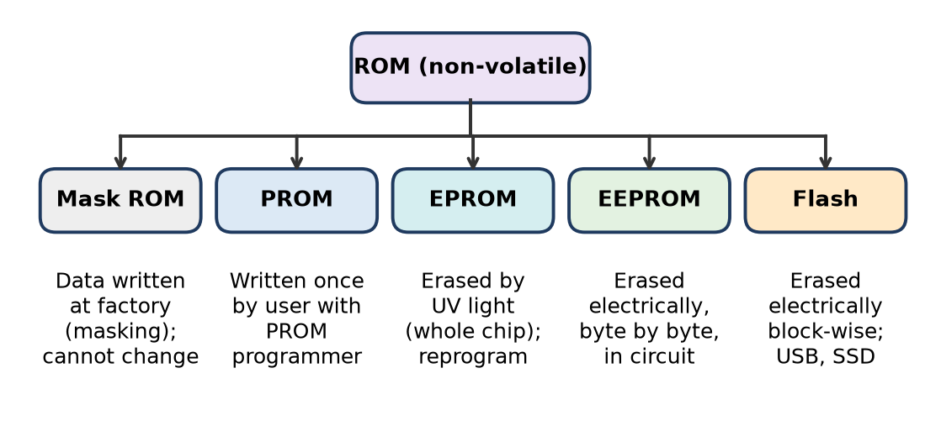
Figure: Types of ROM
1. Mask ROM – data wired in during chip manufacture; cheap in bulk, cannot be changed.
2. PROM – blank chip programmed once by the user using a PROM programmer (fuses blown).
3. EPROM – erased by ultraviolet light through a quartz window (whole chip), then reprogrammed.
4. EEPROM – erased and rewritten electrically, byte by byte, even in the circuit.
5. Flash memory – electrically erased block-wise in one "flash"; used in pen drives, SSDs, phone storage.
Remember: Order of flexibility – "Mask, P, E, EE, Flash" (factory → once → UV → electric byte → electric block).

Q5. Explain the concept of memory hierarchy with a neat diagram.
Understand • Low • CO3
Memory hierarchy arranges memories in levels so that a small amount of fast, costly memory is near the CPU and a large amount of slow, cheap memory is farther away. It answers three questions: how much, how fast, how expensive.
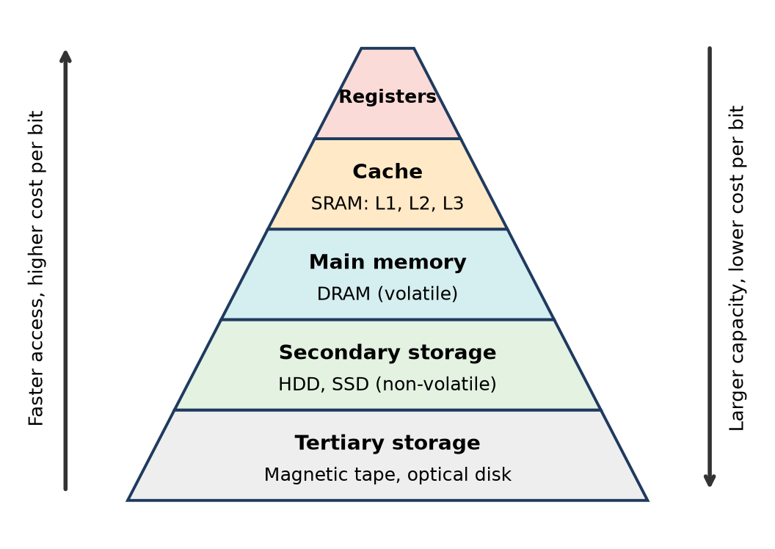
Figure: Memory hierarchy
1. Registers – inside CPU, fastest, few bytes.
2. Cache (SRAM) – L1, L2, L3; very fast, KB–MB.
3. Main memory (DRAM) – GBs, volatile, holds running programs.
4. Secondary storage – HDD/SSD, non-volatile, hundreds of GB–TB.
5. Tertiary storage – magnetic tape, optical disks for backup/archive.
Going down: capacity increases, cost per bit decreases, access time increases, and the CPU accesses the level less frequently. Because of locality of reference, most accesses are served by the upper levels.
Remember: "Real Cool Machines Save Time" – Registers, Cache, Main, Secondary, Tertiary.

Q6. Explain the need and role of secondary memory in a computer system with examples.
Understand • Low • CO3
Secondary memory is non-volatile, high-capacity storage that is not directly accessed by the CPU; data is first copied into main memory.
Need
1. Main memory (RAM) is volatile – data is lost at power-off.
2. RAM is costly and limited; programs and files need TBs of space.
Role
- Permanent storage of the OS, applications and user files.
- Backup and archival of data.
- Acts as backing store for virtual memory (paging/swap area).
- Transfer of data between computers (pen drive, DVD).
Examples: HDD (magnetic), SSD and pen drive (flash), CD/DVD/Blu-ray (optical), magnetic tape (backup).
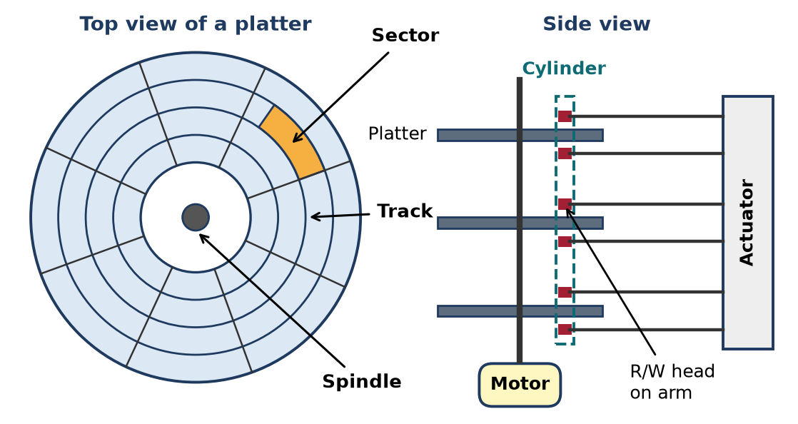
Figure: Magnetic disk: tracks, sectors and cylinders
Remember: RAM is the "work desk", secondary memory is the "cupboard".

Q7. Describe the basic RAID levels and their features.
Understand • Low • CO3
RAID (Redundant Array of Independent Disks) combines several physical disks into one logical drive to improve performance (striping) and/or reliability (mirroring or parity).
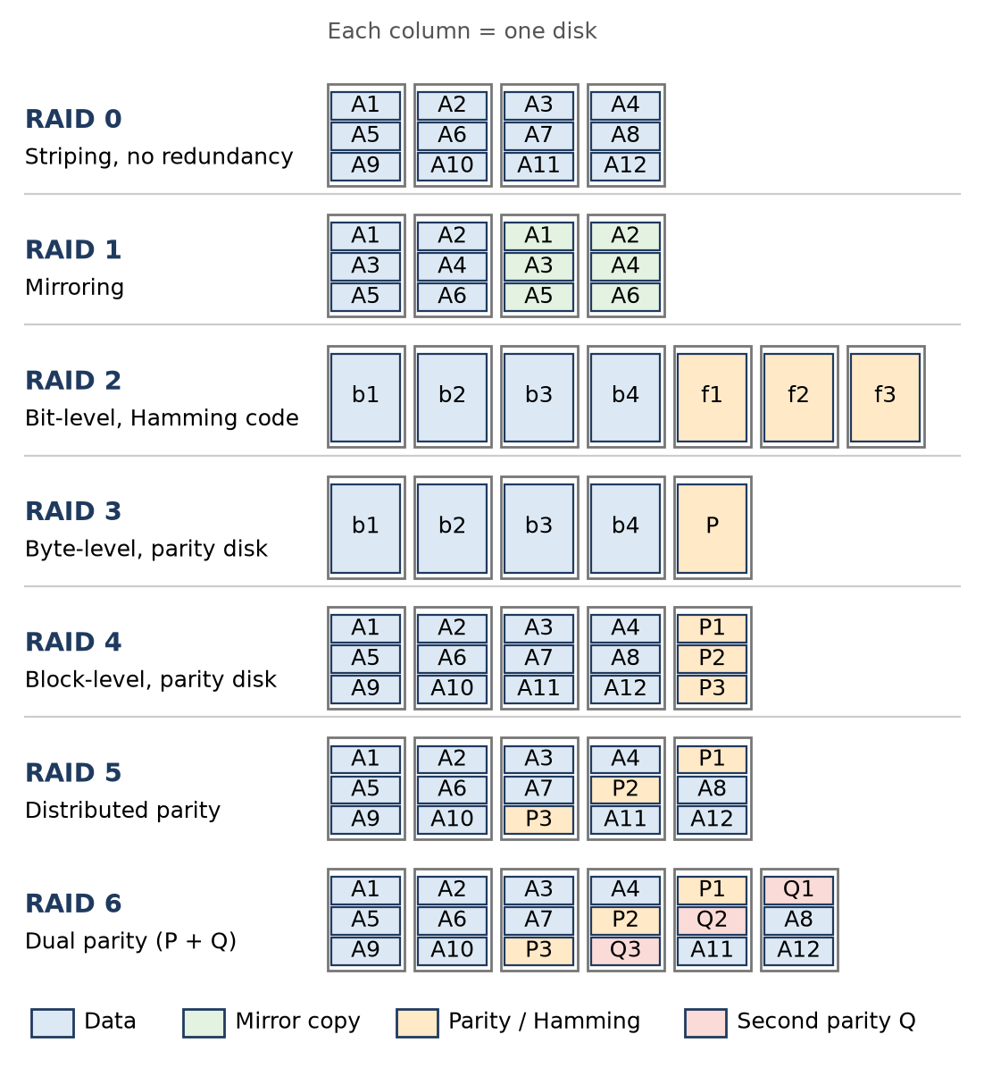
Figure: RAID levels 0 to 6
Level | Technique | Key feature
RAID 0 | Block striping | Fastest, no redundancy; one disk fails → all data lost
RAID 1 | Mirroring | Exact copy on second disk; 50% capacity used
RAID 2 | Bit striping + Hamming code | Error correction disks; not used today
RAID 3 | Byte striping + one parity disk | Good for large sequential transfers
RAID 4 | Block striping + one parity disk | Parity disk becomes bottleneck on writes
RAID 5 | Block striping + distributed parity | Survives 1 disk failure; most popular
RAID 6 | Two distributed parities (P + Q) | Survives 2 disk failures

Remember: "0 = zero safety, 1 = one copy, 5 = parity spread, 6 = double parity."

Q8. Explain the function and operation of hard disk drives (HDD) and solid-state drives (SSD).
Understand • Low • CO3
HDD is a magnetic secondary storage device with spinning platters; SSD stores data in NAND flash memory chips and has no moving parts.
Figure: HDD structure
HDD operation
1. Platters coated with magnetic material rotate on a spindle (5400–15000 RPM).
2. Each surface has concentric tracks divided into sectors (512 B or 4 KB); same tracks on all surfaces form a cylinder.
3. The actuator arm moves the read/write head to the track (seek time), then waits for the sector (rotational latency), then transfers data.
SSD operation
1. A controller reads/writes pages in flash chips electronically; erasing is done block-wise.
2. Wear levelling spreads writes; data is accessed in microseconds with no seek delay.
Function of both: permanent storage of OS, programs and files.
Remember: HDD = "spinning record player", SSD = "big pen drive".

Q9. List and explain any two types of optical storage devices.
Understand • Low • CO3
Optical disks store data as microscopic pits and lands on a reflective layer, read by a laser beam.
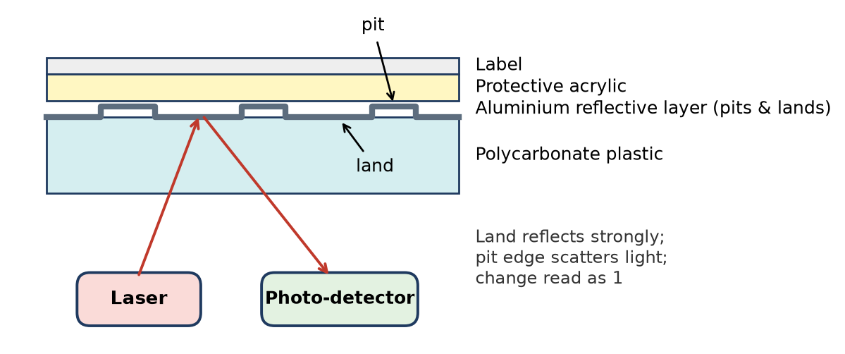
Figure: Optical disk reading
1. CD (Compact Disc) – about 700 MB; uses an infrared laser (780 nm). Variants: CD-ROM (read only, pressed at factory), CD-R (write once), CD-RW (rewritable). Used for music and software distribution.
2. DVD (Digital Versatile Disc) – about 4.7 GB single layer (8.5 GB dual layer); red laser (650 nm), smaller pits and tracks packed closer. Used for movies and backups.
- (Also Blu-ray – 25 GB per layer, blue-violet laser 405 nm, for HD video.)
Working: land reflects light strongly, pit edges scatter it; the photo-detector senses the change and decodes it as bits.
Remember: Shorter laser wavelength → smaller pits → more capacity (CD < DVD < Blu-ray).

Q10. Compare SRAM and DRAM in terms of speed, cost, and usage.
Apply • Medium • CO3
Both are volatile semiconductor RAMs, but they store a bit differently, which changes speed, cost and use.
Feature | SRAM | DRAM
Storage element | Flip-flop (6 transistors) | Capacitor + 1 transistor
Speed | Very fast (about 1–10 ns) | Slower (about 50–70 ns)
Refresh | Not needed | Needed every few ms
Density | Low (big cell) | High (small cell)
Cost per bit | High | Low
Power | Low standby, no refresh | Refresh power needed
Usage | Cache (L1, L2, L3), CPU register files | Main memory (DDR4/DDR5 modules)

Explanation
- SRAM needs no refresh and uses the same logic as the CPU, so it is fast but takes about 6 times more area per bit, so it is costly.
- DRAM's single-capacitor cell gives very high density and low cost, so GBs of main memory are DRAM, though refresh and sensing make it slower.
Conclusion: SRAM is chosen for speed (cache), DRAM for capacity at low cost (main memory).
Figure: SRAM vs DRAM cell
Remember: "SRAM = Speed, DRAM = Density."

Q11. Justify How cache memory reduces average memory access time.
Apply • Medium • CO3
Cache keeps recently and frequently used blocks in fast SRAM. Due to locality of reference, most CPU requests are found in the cache (high hit ratio), so the average time per access drops close to the cache's speed.
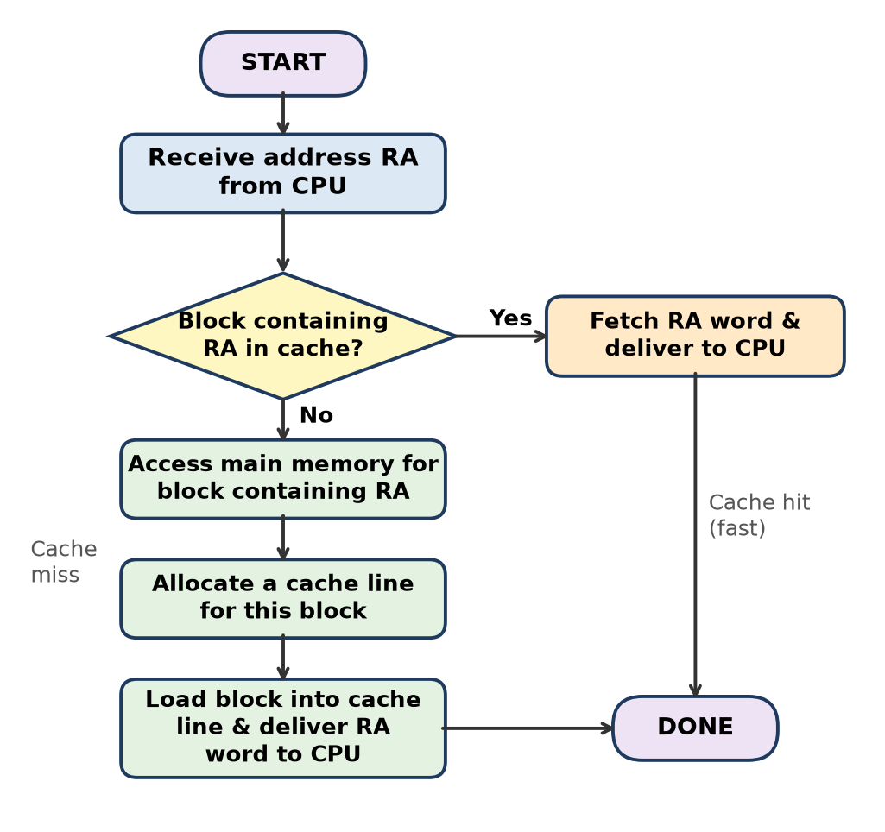
Figure: Cache read operation
Formula (two-level memory)
- Hit ratio H = hits ÷ total accesses
- Average access time T = H × Tc + (1 − H) × (Tc + Tm)
- where Tc = cache access time, Tm = main memory access time (on a miss, the cache is checked first and then memory is accessed).
Example: Tc = 10 ns, Tm = 100 ns, H = 0.95
1. Hit part = 0.95 × 10 = 9.5 ns
2. Miss part = 0.05 × (10 + 100) = 0.05 × 110 = 5.5 ns
3. T = 9.5 + 5.5 = 15 ns
Without cache every access takes 100 ns. So the cache makes memory about 6.7 times faster on average (100 ÷ 15).
Justification points
- Higher hit ratio (bigger cache, good mapping, good replacement) → lower T.
- Larger block size exploits spatial locality.
- Lower miss penalty (multilevel cache) further reduces T.
Remember: "Hit often, pay rarely" – AMAT = hit time + miss rate × miss penalty.

Q12. Analyze how RAID improves performance and reliability in secondary storage.
Analyze • Medium • CO3
RAID spreads data over several disks working in parallel and adds redundancy so data survives a disk failure.
Performance improvement
1. Striping (RAID 0, 4, 5, 6): a file is split into strips placed on different disks; n disks read/write together → nearly n times the transfer rate.
2. Parallel independent requests: different small requests can be served by different disks at the same time (high I/O rate).
3. Mirroring (RAID 1): a read can be served by whichever copy is free → faster reads.
Reliability improvement
1. Mirroring (RAID 1): exact duplicate; if one disk fails, the copy is used.
2. Parity (RAID 3, 4, 5): P = D1 XOR D2 XOR D3 XOR D4. A lost block is rebuilt: D2 = P XOR D1 XOR D3 XOR D4.
3. Dual parity (RAID 6): tolerates two simultaneous disk failures.
4. Hot swapping and rebuild while the system keeps running.
Level | Performance | Reliability
RAID 0 | Very high | None
RAID 1 | High read | High (mirror)
RAID 5 | High read, slower small writes | 1 disk failure
RAID 6 | Good read, slower writes | 2 disk failures

Conclusion: striping gives speed, mirroring/parity give safety; RAID 5/6 balance both.
Remember: "Stripe for speed, mirror or parity for safety."

Q13. Discuss the trade-off between speed, cost, and capacity across the memory hierarchy.
Apply • Medium • CO3
Memory design must balance three conflicting goals: high speed, low cost, large capacity. No single technology gives all three.
The three relations (Stallings)
1. Faster access time → greater cost per bit (SRAM costs more than DRAM).
2. Greater capacity → smaller cost per bit (HDD is cheapest per GB).
3. Greater capacity → slower access time.
Level | Speed | Cost per bit | Capacity
Registers | Fastest (< 1 ns) | Highest | Bytes
Cache (SRAM) | 1–10 ns | Very high | KB–MB
Main memory (DRAM) | 50–100 ns | Moderate | GB
SSD / HDD | µs / ms | Low | 100s GB–TB
Tape / optical | Seconds | Lowest | TB+

How the hierarchy solves it
- Small fast levels sit near the CPU; large cheap levels below.
- Due to locality of reference, the CPU accesses upper levels most of the time, so the system behaves almost as fast as the top level while costing almost as little as the bottom level.
- Frequency of access by the CPU decreases as we go down.
Figure: Memory hierarchy
Conclusion: the hierarchy gives the illusion of a memory that is large, cheap and fast.
Remember: "Fast, cheap, big – pick two per level; the hierarchy gives all three overall."

Q14. Compare HDD, SSD, and Optical disks in terms of speed, cost, and storage capacity.
Apply • Medium • CO3
All three are non-volatile secondary storage, but use different technology: magnetic (HDD), flash (SSD) and laser/optical (CD/DVD/Blu-ray).
Feature | HDD | SSD | Optical disk
Technology | Magnetic platters + moving head | NAND flash chips, no moving parts | Laser reads pits and lands
Access time | About 5–10 ms (seek + rotation) | About 0.1 ms or less | About 100 ms or more
Transfer speed | About 100–200 MB/s | About 500 MB/s (SATA) to several GB/s (NVMe) | Low (a few MB/s to tens of MB/s)
Cost per GB | Low | Higher than HDD | Very low per disc
Capacity | 500 GB – 20+ TB | 128 GB – several TB | 700 MB (CD), 4.7 GB (DVD), 25–100 GB (Blu-ray)
Durability | Shock-sensitive | Shock-resistant, limited write cycles | Scratches can damage
Typical use | Bulk storage, NAS, backup | OS boot drive, laptops, phones | Distribution, archive

Conclusion: SSD is the fastest, HDD gives the most capacity per rupee, optical disks are slow but cheap and portable for distribution/archival.
Remember: Speed order "SSD > HDD > Optical"; cost per GB order "SSD > HDD > Optical".

Q15. Design a memory hierarchy for an efficient embedded system.
Apply • High • CO3
Situation: an embedded system (e.g. a smart meter or drone controller) needs real-time response, low power, low cost and small size, so the hierarchy is smaller and simpler than in a PC.
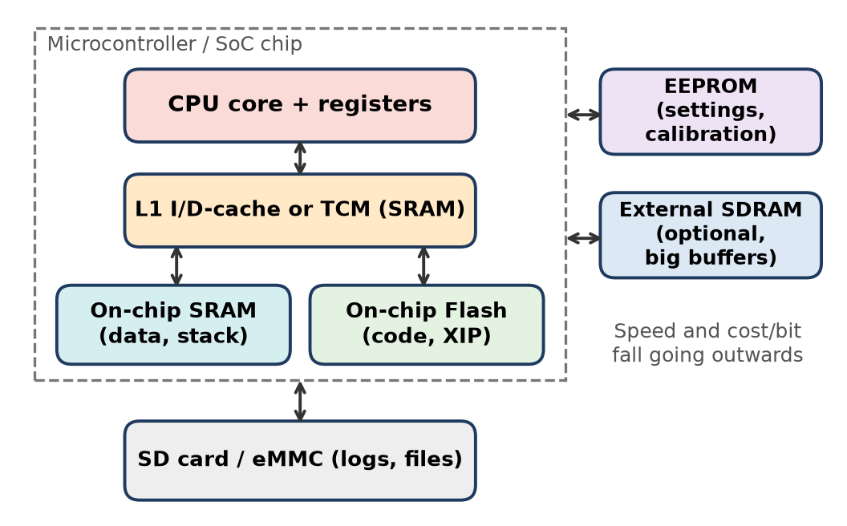
Figure: Embedded memory hierarchy design
Proposed design (top to bottom)
1. CPU registers – hold working variables; compiler keeps critical loop variables here.
2. Small L1 I-cache / D-cache or TCM (Tightly Coupled Memory) – a few KB of SRAM. TCM gives fixed, predictable access time, which suits hard real-time tasks better than a cache.
3. On-chip SRAM (tens to hundreds of KB) – data, stack and buffers; volatile, fast, low power.
4. On-chip Flash – stores program code and constants; supports XIP (execute in place), so no need to copy code to RAM.
5. EEPROM – small non-volatile area for settings and calibration values that change rarely (byte-wise update).
6. External SDRAM (optional) – only if large buffers are needed (images, audio).
7. SD card / eMMC – for data logging and files.
Design reasons
- Keep most accesses on-chip → low power and low latency.
- Use non-volatile Flash/EEPROM so the device boots instantly after power loss.
- Place time-critical ISR code and data in TCM/SRAM for deterministic timing.
- Add DRAM/SD only if the application really needs capacity (cost and power trade-off).
Conclusion: a small, mostly on-chip hierarchy with Flash for code and SRAM/TCM for data gives fast, predictable and power-efficient operation.
Remember: Embedded rule – "Code in Flash, data in SRAM, settings in EEPROM, logs on SD."

Q16. Critically evaluate the shift from HDD to SSD in modern computing systems.
Evaluate • High • CO3
Context: Laptops, phones and servers have largely moved from magnetic HDDs to flash-based SSDs for the main (boot) drive.
Why the shift happened (advantages of SSD)
1. Speed – no seek time or rotational latency; random access in microseconds. Boot and application load times drop sharply.
2. High IOPS – thousands of random I/O operations per second, ideal for databases and virtual machines.
3. No moving parts – shock-resistant, silent, cooler; suits laptops and phones.
4. Lower power – longer battery life.
5. Smaller form factor – M.2/NVMe drives connect directly to PCIe lanes for multi-GB/s transfer.
Limitations (critical side)
1. Cost per GB is still higher than HDD, so bulk storage (archives, video surveillance, data-centre cold storage) still uses HDDs.
2. Limited write endurance – flash cells wear out after a finite number of program/erase cycles; needs wear levelling and over-provisioning.
3. Data recovery after failure is harder than with HDD.
4. Long-term data retention without power is lower than HDD/tape for archival.
Factor | HDD | SSD | Winner
Speed | ms | µs | SSD
Cost/GB | Low | Higher | HDD
Capacity per drive | Very high | High | HDD
Durability (shock) | Poor | Good | SSD
Power | Higher | Lower | SSD
Write endurance | Not limited by writes | Limited P/E cycles | HDD

Evaluation: the shift is justified for primary storage because speed, robustness and power matter most there. However, HDD remains useful as cheap bulk/secondary storage, so modern systems use a tiered approach: SSD for OS and hot data, HDD (or tape) for cold data.
Remember: "SSD for speed, HDD for size" – modern systems use both in tiers.

Q17. Evaluate how cache levels (L1, L2, L3) affect CPU performance.
Evaluate • High • CO3
A multilevel cache uses several cache levels so that a miss in a small fast cache is caught by a larger cache before going to slow DRAM.
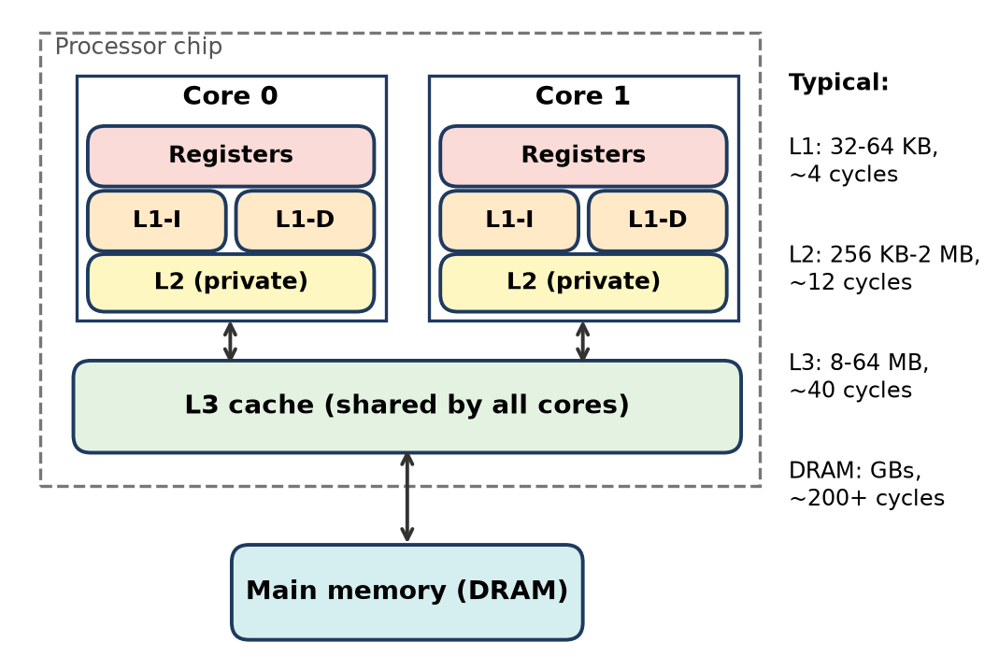
Figure: Multilevel cache organisation
Role of each level
1. L1 – smallest (32–64 KB per core), fastest (few cycles); split into L1-I (instructions) and L1-D (data) so fetch and data access happen together. Decides the CPU's hit time.
2. L2 – larger (256 KB–2 MB), private per core; catches most L1 misses, reducing the miss penalty of L1.
3. L3 – largest (several MB), shared by all cores; reduces DRAM traffic and lets cores share data.
Effect on performance (worked example)
- AMAT = HitL1 + MissL1 × (HitL2 + MissL2 × (HitL3 + MissL3 × Tmem))
- Take: L1 = 1 ns, miss 5%; L2 = 5 ns, local miss 20%; L3 = 20 ns, local miss 30%; DRAM = 100 ns.
1. L3 part = 20 + 0.3 × 100 = 50 ns
2. L2 part = 5 + 0.2 × 50 = 15 ns
3. AMAT = 1 + 0.05 × 15 = 1.75 ns
With only L1: AMAT = 1 + 0.05 × 100 = 6 ns. So L2 + L3 make average access about 3.4 times faster.
Evaluation
- More levels → lower miss penalty and fewer stalls → higher IPC.
- But each level adds chip area, power and lookup latency; a miss that goes through all levels takes longer than with one level.
- Shared L3 helps multicore programs but needs coherence protocols.
Conclusion: L1 keeps hit time low, L2/L3 keep miss penalty low; together they let a GHz CPU run near full speed despite slow DRAM.
Remember: "L1 = speed, L2 = backup, L3 = shared warehouse."

Q18. A 128×16 RAM is used in a system. How many address and data lines are needed?
Apply • High • CO3
Formula: For an N × M memory, address lines = log2(N), data lines = M.
Given: N = 128 words, M = 16 bits per word.
Working
1. 128 = 2^7 → address lines = 7 (A0–A6)
2. Word size 16 bits → data lines = 16 (D0–D15)
3. Total address + data lines = 7 + 16 = 23
Answer: 7 address lines and 16 data lines (23 lines in all).
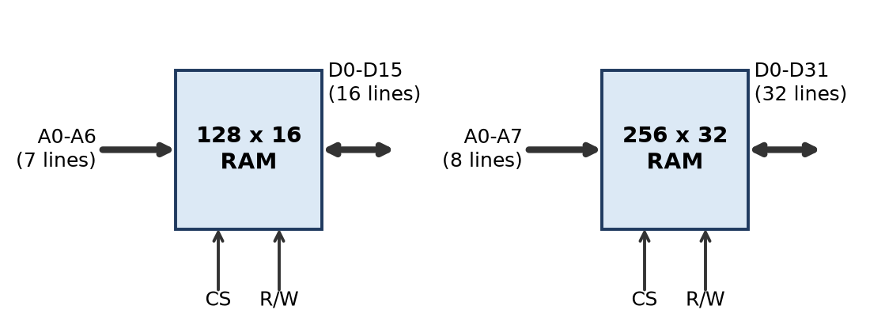
Figure: RAM chip pins
Remember: "Rows give the address (log2), width gives the data."

Q19. Determine the total number of external pins for a 256×32 RAM, assuming 2 control lines
Apply • High • CO3
Formula: Pins = address lines + data lines + control lines, where address lines = log2(number of words).
Given: 256 words × 32 bits, control lines = 2 (e.g. CS and R/W).
Working
1. 256 = 2^8 → address lines = 8
2. Data lines = 32
3. Control lines = 2
4. Total = 8 + 32 + 2 = 42
Answer: 42 external pins (power and ground pins, if counted, would add 2 more → 44).
Remember: 256×32 → "8 + 32 + 2 = 42".

Q20. Consider a direct mapped cache / Fully associative cache of size 16 KB with block size 256 bytes. The size of main memory is 128 KB. Find- Number of bits in tag; Tag directory size
Apply • Medium • CO3
Formulas: Address bits = log2(MM size); Offset = log2(block size); Lines = cache size ÷ block size; Tag directory = lines × tag bits.
Given: Cache = 16 KB, block = 256 B, MM = 128 KB.
Common steps
1. MM = 128 KB = 2^17 B → physical address = 17 bits
2. Block offset = log2(256) = 8 bits
3. Number of lines = 16 KB ÷ 256 B = 2^14 ÷ 2^8 = 2^6 = 64 lines
(a) Direct mapped
- Line (index) bits = log2(64) = 6
- Tag = 17 − 6 − 8 = 3 bits
- Tag directory = 64 × 3 = 192 bits = 24 bytes
(b) Fully associative (no line field)
- Tag = 17 − 8 = 9 bits
- Tag directory = 64 × 9 = 576 bits = 72 bytes
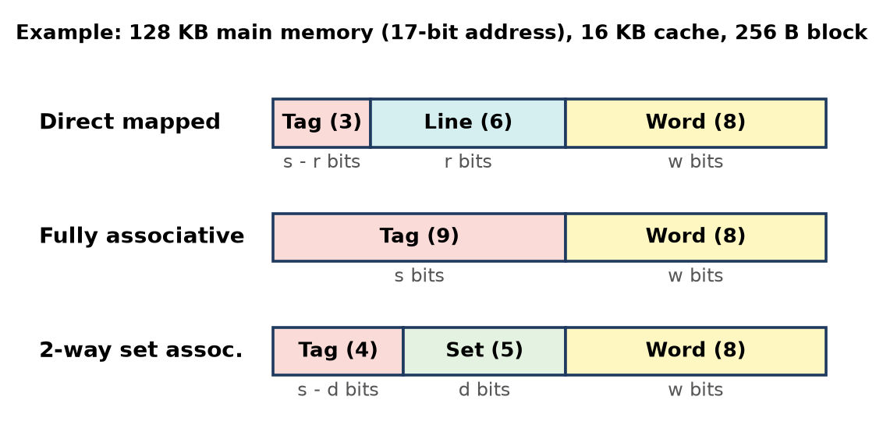
Figure: Address formats for this example
Remember: Direct = Tag + Line + Offset; Fully associative = Tag + Offset.

Q21. Consider a direct mapped cache / Fully associative cache of size 512 KB with block size 1 KB. There are 7 bits in the tag. Find- Size of main memory; Tag directory size
Apply • Medium • CO3
Given: Cache = 512 KB, block = 1 KB, tag = 7 bits.
Common steps
1. Block offset = log2(1 KB) = log2(2^10) = 10 bits
2. Lines = 512 KB ÷ 1 KB = 512 = 2^9 → 512 lines
(a) Direct mapped
- Line bits = 9
- Address bits = tag + line + offset = 7 + 9 + 10 = 26
- Main memory = 2^26 B = 64 MB
- Tag directory = 512 × 7 = 3584 bits = 448 bytes
(b) Fully associative
- Address bits = tag + offset = 7 + 10 = 17 → MM = 2^17 B = 128 KB
- Tag directory = 512 × 7 = 3584 bits = 448 bytes
- Note: 128 KB is smaller than the 512 KB cache, so this data is realistic only for the direct-mapped case; for a fully associative cache the method is shown above.
Remember: Work backwards – add the field widths to get the address bits, then MM = 2^(address bits).

Q22. Consider a direct mapped / Fully associative cache with block size 4 KB. The size of main memory is 16 GB and there are 10 bits in the tag. Find- Size of cache memory; Tag directory size
Apply • Medium • CO3
Given: Block = 4 KB, MM = 16 GB, tag = 10 bits.
Common steps
1. MM = 16 GB = 2^4 × 2^30 = 2^34 B → address = 34 bits
2. Block offset = log2(4 KB) = 12 bits
(a) Direct mapped
- Line bits = 34 − 10 − 12 = 12 → lines = 2^12 = 4096
- Cache size = 4096 × 4 KB = 2^12 × 2^12 B = 2^24 B = 16 MB
- Tag directory = 4096 × 10 = 40960 bits = 5 KB (5120 bytes)
(b) Fully associative
- In fully associative mapping, tag = address − offset = 34 − 12 = 22 bits always; it does not depend on cache size.
- So a 10-bit tag is not possible here, and the cache size cannot be found from the tag. (If the 16 MB cache found above were fully associative, tag directory = 4096 × 22 = 90112 bits = 11 KB.)
Remember: In direct mapping, Tag + Line + Offset = address bits; the "missing" field gives the cache size.

Q23. An 8 KB direct-mapped write back cache is organized as multiple blocks, each of size 32 bytes. The processor generates 32 bit addresses. The cache controller maintains the tag information for each cache block comprising of the following- 1 valid bit; 1 modified bit; As many bits as the minimum needed to identify the memory block mapped in the cache. What is the total size of memory needed at the cache controller to store meta data (tags) for the cache?
Apply • High • CO3
Formula: Metadata = number of lines × (tag + valid + modified bits).
Given: Cache = 8 KB, block = 32 B, address = 32 bits, direct mapped, write back.
Working
1. Offset = log2(32) = 5 bits
2. Lines = 8 KB ÷ 32 B = 2^13 ÷ 2^5 = 2^8 = 256 lines → line bits = 8
3. Tag = 32 − 8 − 5 = 19 bits
4. Bits per line = 19 (tag) + 1 (valid) + 1 (modified/dirty) = 21 bits
5. Total = 256 × 21 = 5376 bits (= 672 bytes)
Answer: 5376 bits.
Remember: The modified (dirty) bit exists only because the cache is write-back.

Q24. Consider a 2-way set associative mapped cache of size 16 KB with block size 256 bytes. The size of main memory is 128 KB. Find- Number of bits in tag; Tag directory size
Apply • Medium • CO3
Formulas: Sets = lines ÷ k (k = ways); Tag = address − set bits − offset.
Given: Cache = 16 KB, block = 256 B, MM = 128 KB, k = 2.
Working
1. Address = log2(128 KB) = log2(2^17) = 17 bits
2. Offset = log2(256) = 8 bits
3. Lines = 16 KB ÷ 256 B = 64
4. Sets = 64 ÷ 2 = 32 → set bits = 5
5. Tag = 17 − 5 − 8 = 4 bits
6. Tag directory = 64 lines × 4 = 256 bits = 32 bytes
Answer: Tag = 4 bits; tag directory = 256 bits (32 bytes).
Remember: Doubling the ways halves the sets, which moves 1 bit from Set to Tag.

Q25. Consider a 8-way set associative mapped cache of size 512 KB with block size 1 KB. There are 7 bits in the tag. Find- Size of main memory; Tag directory size
Apply • Medium • CO3
Given: Cache = 512 KB, block = 1 KB, k = 8, tag = 7 bits.
Working
1. Offset = log2(1 KB) = 10 bits
2. Lines = 512 KB ÷ 1 KB = 512
3. Sets = 512 ÷ 8 = 64 → set bits = 6
4. Address = tag + set + offset = 7 + 6 + 10 = 23 bits
5. Main memory = 2^23 B = 8 MB
6. Tag directory = 512 × 7 = 3584 bits = 448 bytes
Answer: MM = 8 MB; tag directory = 3584 bits (448 B).
Remember: Tag directory always = (total lines) × (tag bits), whatever the mapping.

Q26. Consider a 4-way set associative mapped cache with block size 4 KB. The size of main memory is 16 GB and there are 10 bits in the tag. Find- Size of cache memory; Tag directory size
Apply • Medium • CO3
Given: k = 4, block = 4 KB, MM = 16 GB, tag = 10 bits.
Working
1. Address = log2(16 GB) = log2(2^34) = 34 bits
2. Offset = log2(4 KB) = 12 bits
3. Set bits = 34 − 10 − 12 = 12 → sets = 2^12 = 4096
4. Lines = 4096 × 4 = 16384 (2^14)
5. Cache size = 16384 × 4 KB = 2^14 × 2^12 B = 2^26 B = 64 MB
6. Tag directory = 16384 × 10 = 163840 bits = 20 KB
Answer: Cache = 64 MB; tag directory = 163840 bits (20 KB).
Remember: Cache size = sets × ways × block size.

Q27. Consider a 8-way set associative mapped cache. The size of cache memory is 512 KB and there are 10 bits in the tag. Find the size of main memory.
Apply • Medium • CO3
Key idea: Set bits + offset bits = log2(number of sets × block size) = log2(cache size ÷ k). So block size is not needed.
Given: Cache = 512 KB, k = 8, tag = 10 bits.
Working
1. Cache size ÷ k = 512 KB ÷ 8 = 64 KB = 2^16 B → set + offset = 16 bits
2. Address = tag + 16 = 10 + 16 = 26 bits
3. Main memory = 2^26 B = 64 MB
Answer: Main memory = 64 MB.
Remember: (Set + Offset) bits = log2(one way's size).

Q28. Given a cache with 4 block slots (initially empty) and the following block reference string: Reference Sequence: 1, 2, 3, 4, 1, 2, 5, 1, 2, 3, 4. Calculate the number of Cache Misses, Cache Hits, Hit Ratio and Miss Ratio using: FIFO (First-In, First-Out); LRU (Least Recently Used); MRU (Most Recently Used); LFU (Least Frequently Used)
Apply • Medium • CO3
Total references = 11. Hit ratio = hits ÷ 11, miss ratio = misses ÷ 11. M = miss, H = hit; F1–F4 are the four slots.
(a) FIFO – replace the block that entered first
Ref | 1 | 2 | 3 | 4 | 1 | 2 | 5 | 1 | 2 | 3 | 4
F1 | 1 | 1 | 1 | 1 | 1 | 1 | 5 | 5 | 5 | 5 | 4
F2 | - | 2 | 2 | 2 | 2 | 2 | 2 | 1 | 1 | 1 | 1
F3 | - | - | 3 | 3 | 3 | 3 | 3 | 3 | 2 | 2 | 2
F4 | - | - | - | 4 | 4 | 4 | 4 | 4 | 4 | 3 | 3
H/M | M | M | M | M | H | H | M | M | M | M | M

Misses = 9, Hits = 2 → Hit ratio = 2/11 = 0.18, Miss ratio = 9/11 = 0.82
(b) LRU – replace the block not used for the longest time
Ref | 1 | 2 | 3 | 4 | 1 | 2 | 5 | 1 | 2 | 3 | 4
F1 | 1 | 1 | 1 | 1 | 1 | 1 | 1 | 1 | 1 | 1 | 1
F2 | - | 2 | 2 | 2 | 2 | 2 | 2 | 2 | 2 | 2 | 2
F3 | - | - | 3 | 3 | 3 | 3 | 5 | 5 | 5 | 5 | 4
F4 | - | - | - | 4 | 4 | 4 | 4 | 4 | 4 | 3 | 3
H/M | M | M | M | M | H | H | M | H | H | M | M

At 5: LRU is 3; at 3: LRU is 4; at 4: LRU is 5. Misses = 7, Hits = 4 → Hit ratio = 4/11 = 0.36, Miss ratio = 7/11 = 0.64
(c) MRU – replace the block used most recently
Ref | 1 | 2 | 3 | 4 | 1 | 2 | 5 | 1 | 2 | 3 | 4
F1 | 1 | 1 | 1 | 1 | 1 | 1 | 1 | 1 | 2 | 2 | 2
F2 | - | 2 | 2 | 2 | 2 | 2 | 5 | 5 | 5 | 5 | 5
F3 | - | - | 3 | 3 | 3 | 3 | 3 | 3 | 3 | 3 | 3
F4 | - | - | - | 4 | 4 | 4 | 4 | 4 | 4 | 4 | 4
H/M | M | M | M | M | H | H | M | H | M | H | H

At 5: MRU is 2; at 2: MRU is 1. Misses = 6, Hits = 5 → Hit ratio = 5/11 = 0.45, Miss ratio = 6/11 = 0.55
(d) LFU – replace the block with the lowest use count (tie → the older block, i.e. FIFO among equals; count restarts when a block is reloaded)
Ref | 1 | 2 | 3 | 4 | 1 | 2 | 5 | 1 | 2 | 3 | 4
F1 | 1 | 1 | 1 | 1 | 1 | 1 | 1 | 1 | 1 | 1 | 1
F2 | - | 2 | 2 | 2 | 2 | 2 | 2 | 2 | 2 | 2 | 2
F3 | - | - | 3 | 3 | 3 | 3 | 5 | 5 | 5 | 5 | 4
F4 | - | - | - | 4 | 4 | 4 | 4 | 4 | 4 | 3 | 3
H/M | M | M | M | M | H | H | M | H | H | M | M

At 5: counts 1→2, 2→2, 3→1, 4→1 → evict 3 (older). At 3: counts 4→1, 5→1 → evict 4. At 4: counts 5→1, 3→1 → evict 5. Misses = 7, Hits = 4 → Hit ratio = 0.36, Miss ratio = 0.64
Summary
Policy | Hits | Misses | Hit ratio | Miss ratio
FIFO | 2 | 9 | 0.18 | 0.82
LRU | 4 | 7 | 0.36 | 0.64
MRU | 5 | 6 | 0.45 | 0.55
LFU | 4 | 7 | 0.36 | 0.64

For this string MRU does best because block 1 and 2 are reused after 5, while FIFO does worst because it throws out the heavily used blocks 1 and 2.
Remember: FIFO = oldest out, LRU = longest-unused out, MRU = just-used out, LFU = least-counted out.

Q29. Explain the three main cache mapping techniques—Direct Mapping, Fully Associative Mapping, and Set-Associative Mapping. Provide their block address structure and discuss the primary trade-offs of each.
Apply • Medium • CO3
Cache mapping decides in which cache line a main-memory block can be placed and how it is found.
Figure: Address structure of the three mappings
1. Direct mapping – each block goes to exactly one line: i = j mod m (j = block number, m = number of lines).
- Address: Tag | Line | Word.
- Trade-off: simplest and fastest (one comparator, cheap) but conflict misses / thrashing when two used blocks map to the same line.
2. Fully associative mapping – a block can go into any line.
- Address: Tag | Word (tag = whole block number).
- Trade-off: best hit ratio, no conflict misses, free choice of replacement, but needs one comparator per line (costly, slow, power-hungry); used only for small caches/TLBs.
3. k-way set-associative mapping – lines are grouped into v sets of k lines; block goes to set i = j mod v, any line inside that set.
- Address: Tag | Set | Word.
- Trade-off: compromise – fewer conflict misses than direct, only k comparators; slightly more hardware and hit time than direct. 2-, 4-, 8- or 16-way is common in real CPUs.
Conclusion: direct = cheap but conflict-prone, fully associative = flexible but expensive, set-associative = best balance.
Remember: "Direct = one seat, Fully = any seat, Set = any seat in your row."

Q30. Compare the hardware lookup mechanisms of a Direct-Mapped Cache versus a 4-Way Set-Associative Cache. Explain why fully associative caches are rarely implemented for large L2/L3 caches in modern processors.
Apply • High • CO3
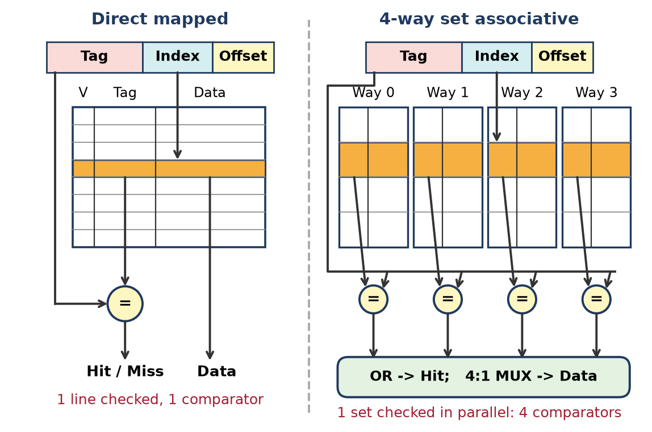
Figure: Lookup hardware: direct mapped vs 4-way
Direct-mapped lookup
1. The index field selects exactly one line.
2. The stored tag (and valid bit) is read and compared with the address tag by one comparator.
3. Data can be read at the same time as the tag check, so hit time is shortest.
4-way set-associative lookup
1. The index selects a set of 4 lines.
2. All 4 tags are read and compared in parallel by 4 comparators.
3. An OR of the match signals gives Hit; a 4:1 multiplexer selects the data of the matching way.
4. Replacement logic (e.g. LRU bits) chooses the victim among 4 lines.
Point | Direct mapped | 4-way set associative
Lines checked | 1 | 4 (one set)
Comparators | 1 | 4
Extra logic | None | 4:1 MUX, LRU bits
Hit time | Lowest | Slightly higher (MUX delay)
Power per access | Lowest | About 4 tag + data reads
Conflict misses | High | Much lower

Why fully associative is rare for large L2/L3
1. Comparator explosion: a 1 MB cache with 64 B lines has 16384 lines → 16384 tag comparators (CAM) working on every access.
2. Area and power: CAM cells are much larger and use far more power than SRAM.
3. Slow: a huge match network increases hit time.
4. Replacement: true LRU over thousands of lines is impractical.
5. Diminishing returns: 8- to 16-way set-associative caches already achieve almost the same miss rate.
Fully associative designs are used only for small structures such as TLBs and victim caches.
Remember: "More ways = more comparators"; beyond 16 ways the cost grows, the gain doesn't.

Q31. What is cache thrashing? Describe a software code example that causes severe thrashing in a direct-mapped cache, and explain two architectural ways to mitigate it.
Understand • High • CO3
Cache thrashing is a situation where two or more frequently used memory blocks keep evicting each other from the same cache line, so almost every access becomes a miss and the cache gives no benefit.
Example (32 KB direct-mapped cache, 32 B blocks)
#define N 8192 /* 8192 floats x 4 B = 32 KB per array */
float A[N], B[N]; /* placed back to back: B starts 32 KB after A */
float sum = 0;
for (int i = 0; i < N; i++)
sum += A[i] * B[i]; /* A[i] and B[i] map to the SAME cache line */
- Address of B[i] = address of A[i] + 32 KB = exactly one cache size apart, so index bits are equal.
- Access A[i] → loads block into line x; access B[i] → evicts it; next A[i+1] (same block as A[i]) → miss again.
- Result: close to 100% miss rate, every access goes to slow DRAM.
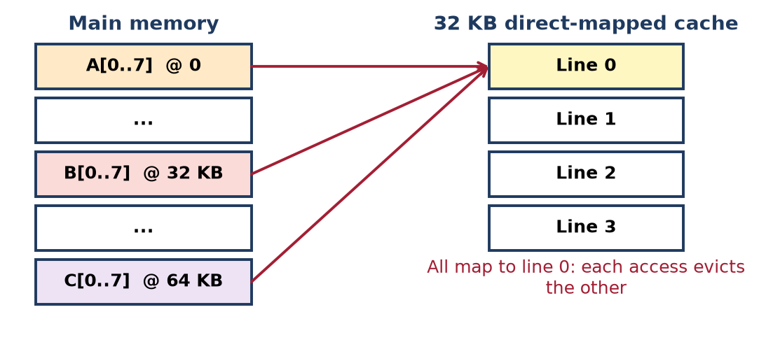
Figure: Thrashing in a direct-mapped cache
Architectural ways to mitigate
1. Increase associativity – make the cache 2-way (or more) set-associative; A-block and B-block can now sit in the same set, different ways, so both stay in cache.
2. Victim cache – a small fully associative buffer (e.g. 4–16 lines) that holds recently evicted lines; when A is thrown out by B it goes to the victim cache and is found there on the next access, avoiding a DRAM trip.
- (Other options: larger cache, skewed/hashed index functions. Software fix: pad the arrays, e.g. float A[N + 8], so they no longer map to the same lines.)
Conclusion: thrashing comes from conflict misses; associativity or a victim cache removes them in hardware.
Remember: Thrashing = "two blocks, one seat, endless fight"; give them more seats (ways) or a waiting room (victim cache).

Q32. Compare Direct-Mapped, Set-Associative, and Fully Associative cache mapping techniques
Understand • Medium • CO3
Feature | Direct mapped | Set associative (k-way) | Fully associative
Placement rule | One fixed line: j mod m | Any line in set j mod v | Any line
Address fields | Tag, Line, Word | Tag, Set, Word | Tag, Word
Comparators | 1 | k | One per line
Hardware cost | Lowest | Moderate | Highest
Hit time | Fastest | Medium | Slowest (large search)
Conflict misses | High (thrashing possible) | Low | None
Hit ratio | Lowest | Good | Highest
Replacement algorithm | Not needed | Needed within set | Needed over all lines
Typical use | Simple/embedded caches | L1, L2, L3 of modern CPUs | TLBs, small caches

Conclusion: set-associative mapping is the practical middle path used in most processors – nearly the hit ratio of fully associative at close to the cost of direct mapping.
Remember: Direct and fully associative are the two extremes; set-associative is k-way "in between" (direct = 1-way, fully = m-way).

Quick Revision – Unit III
Term | Key fact
Memory hierarchy | Registers → Cache → Main → Secondary → Tertiary; down = bigger, cheaper, slower
Locality of reference | Temporal (reuse) + spatial (nearby) – why cache works
SRAM | 6-transistor latch, no refresh, fast, costly → cache
DRAM | 1 transistor + 1 capacitor, needs refresh, dense, cheap → main memory
DDR-DRAM | Transfers data on both clock edges
ROM family | Mask ROM, PROM (once), EPROM (UV), EEPROM (byte, electric), Flash (block)
Hard vs soft error | Hard = permanent defect; soft = random bit flip (alpha particles, power)
Hamming code | Adds check bits to detect and correct single-bit memory errors
Average access time | T = H × Tc + (1 − H) × (Tc + Tm)
Direct mapping | Line = block mod lines; Tag, Line, Word
Set associative | Set = block mod sets; Tag, Set, Word
Fully associative | Tag, Word; one comparator per line
Tag directory | Lines × (tag + valid/dirty bits)
Replacement | FIFO, LRU, LFU, MRU, Random
RAID 5 / RAID 6 | Distributed parity (1 failure) / dual parity (2 failures)
Disk geometry | Tracks → sectors; same track on all surfaces = cylinder

Unit IV: I/O Subsystem

Q1. Explain the concept of an I/O subsystem and its role in computer architecture.
Understand • Low • CO4
The I/O subsystem is the set of I/O modules, buses, interfaces and transfer techniques that lets the CPU and memory exchange data with external (peripheral) devices. It is the third key element after CPU and memory.
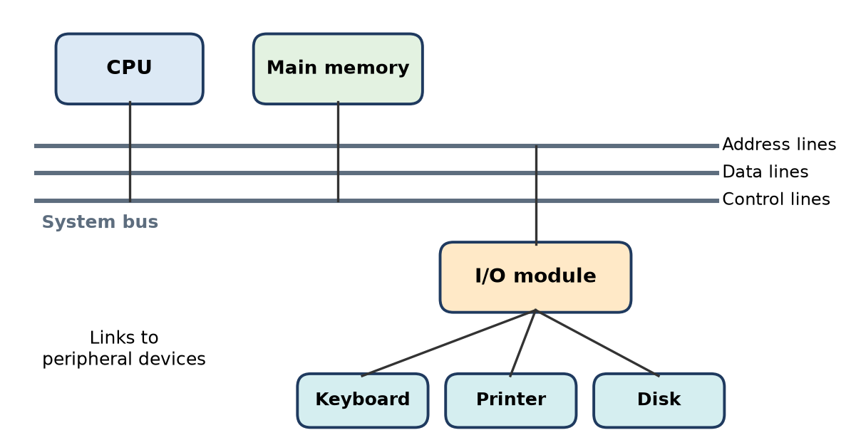
Figure: I/O module on the system bus
Why it is needed: peripherals differ in speed, data format and amount of data, and are much slower than CPU/RAM, so they cannot be connected directly to the system bus.
Role
1. Interface between system bus and devices (via I/O modules).
2. Buffering and speed matching, format conversion, error detection.
3. Supports three transfer techniques: programmed I/O, interrupt-driven I/O, DMA.
4. Hides device details so the CPU uses simple read/write commands.
Remember: I/O subsystem = "translator + buffer" between fast CPU and slow devices.

Q2. Draw and explain the functions of an I/O module with suitable examples.
Understand • Low • CO4
An I/O module connects to the system bus on one side and to one or more peripherals on the other.
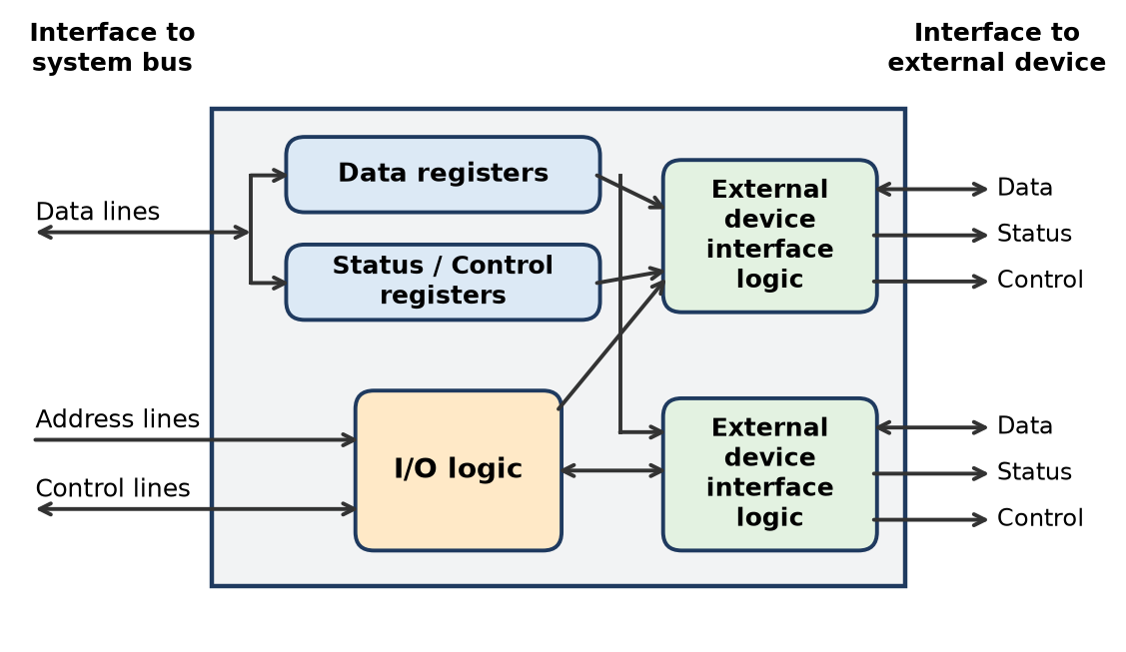
Figure: Block diagram of an I/O module
Structure: data registers (buffer data), status/control registers, I/O logic (decodes address and commands), external device interface logic (one per device).
Five functions
1. Control and timing – coordinates traffic between CPU/memory and device (e.g. CPU checks status, then requests data).
2. Processor communication – command decoding (READ SECTOR, SEEK), data exchange, status reporting (BUSY/READY), address recognition.
3. Device communication – sends commands, receives status and data from the device.
4. Data buffering – holds data to match speeds (e.g. printer buffer).
5. Error detection – reports mechanical errors (paper jam) and transmission errors (parity bit).
Remember: "CPD-BE" – Control, Processor comm., Device comm., Buffering, Error detection.

Q3. What are I/O commands? Describe the different types of I/O commands used.
Understand • Low • CO4
An I/O command is the signal the CPU sends to an I/O module (along with the module/device address) to make it perform an operation. Each I/O instruction of the program is mapped to an I/O command.
Four types
1. Control – activates the peripheral and tells it what to do, e.g. rewind/forward a tape, seek a disk track.
2. Test – checks status conditions of the I/O module and device: is it powered, available, has the last operation completed, any error?
3. Read – the module gets a data item from the device into its internal buffer; the CPU then takes it from the data bus.
4. Write – the module takes data from the data bus and sends it to the device.
Remember: "CTRW" – Control, Test, Read, Write ("Can The Robot Work?").

Q4. Explain the working principle of Programmed I/O and mention its limitations.
Understand • Low • CO4
In programmed I/O the CPU executes a program that directly controls the whole I/O operation – sending the command, repeatedly checking status (polling/busy waiting) and moving every word.
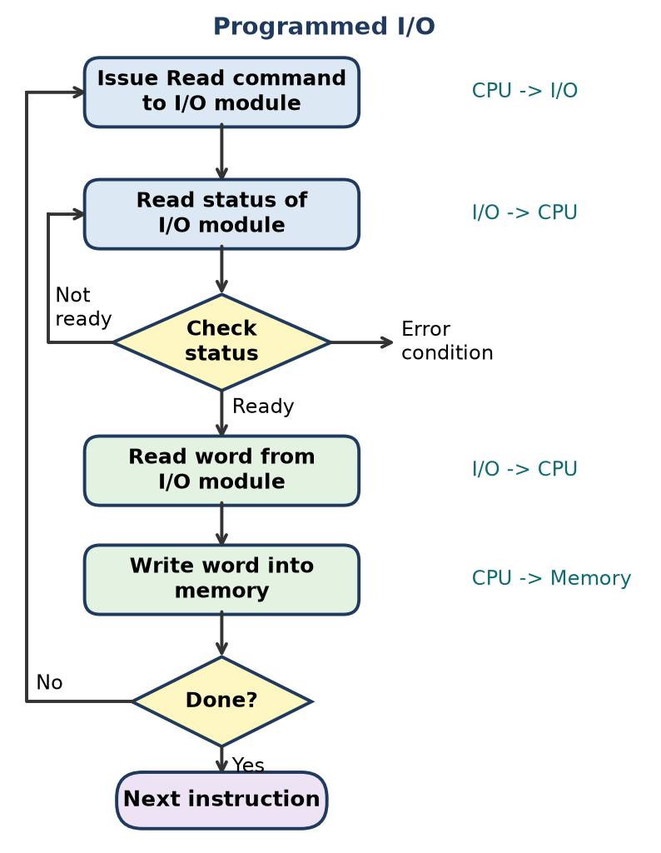
Figure: Programmed I/O flowchart
Working
1. CPU issues a READ command to the I/O module.
2. CPU reads the status register; if not ready, it loops and checks again.
3. When ready, CPU reads the word from the module.
4. CPU writes the word into memory; repeats until all words are done.
Limitations
- CPU wastes time in busy waiting; cannot do other work.
- Transfer rate limited by how fast the CPU can poll.
- Every word passes through the CPU → poor for bulk data.
Remember: Programmed I/O = "CPU keeps asking: are you ready yet?"

Q5. Define Memory-Mapped I/O and describe how it differs from Isolated I/O.
Understand • Low • CO4
Memory-mapped I/O: I/O device registers are given addresses inside the memory address space, and the CPU uses normal memory instructions (MOV/LOAD/STORE) to access them.
Isolated I/O (I/O-mapped): I/O devices have a separate I/O address space, selected by separate control lines, and special instructions (IN/OUT) are used.
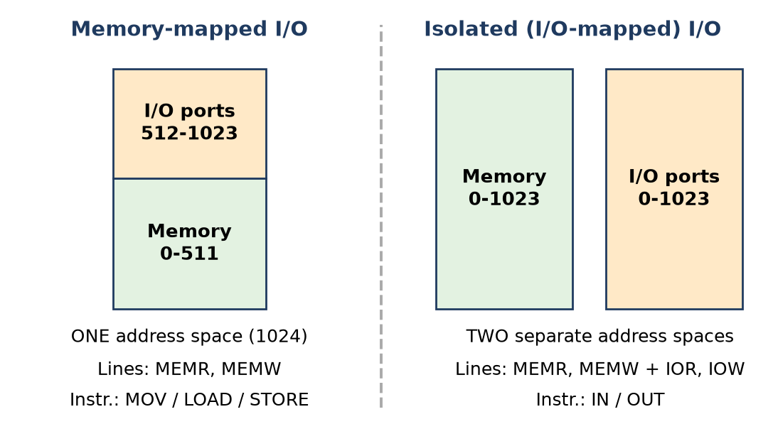
Figure: Memory-mapped vs isolated I/O
Point | Memory-mapped I/O | Isolated I/O
Address space | Shared with memory | Separate
Instructions | All memory instructions | Only IN / OUT
Control lines | MEMR, MEMW | MEMR, MEMW + IOR, IOW
10 address lines | 1024 total (memory + I/O) | 1024 memory + 1024 I/O

Remember: Memory-mapped = "devices pretend to be memory"; Isolated = "devices live in a separate street".

Q6. Explain the concept of Interrupt Driven I/O with its advantages over Programmed I/O.
Understand • Low • CO4
In interrupt-driven I/O the CPU issues a command and then continues other work; when the device is ready, the I/O module sends an interrupt and the CPU transfers the data.
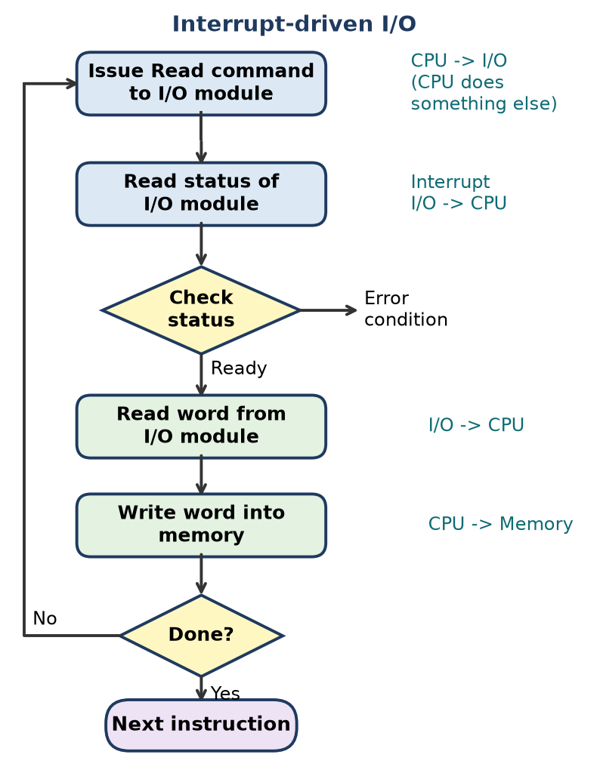
Figure: Interrupt-driven I/O flowchart
Steps
1. CPU issues READ command to the I/O module and goes on with another program.
2. I/O module gets the data from the device into its buffer.
3. I/O module interrupts the CPU.
4. At the end of the current instruction, CPU saves context, reads the data and stores it in memory, then resumes.
Advantages over programmed I/O
- No busy waiting – CPU time is not wasted polling.
- CPU and device work in parallel → better throughput.
- Suits slow devices (keyboard, printer) and many devices at once.
Remember: Interrupt I/O = "Don't call us, we'll call you."

Q7. Describe the purpose and features of the Intel 82C59A Interrupt Controller.
Understand • Low • CO4
The Intel 82C59A Programmable Interrupt Controller (PIC) collects interrupt requests from many devices and passes them to the processor (e.g. 8086, which has only one INTR line) one at a time, by priority, along with the vector of the service routine.
Purpose: combine multiple interrupt sources into a single interrupt output, resolve priority and supply the interrupt type number.
Features
1. 8 interrupt inputs (IR0–IR7) per chip.
2. Cascadable: 1 master + up to 8 slaves → 64 interrupt levels.
3. Programmable priority modes: fully nested, automatic rotation, specific rotation, special mask, polled.
4. Individual masking of each input via the IMR.
5. Vectored interrupts: puts an 8-bit type number on the data bus during INTA.
6. Edge- or level-triggered inputs; programmed by ICW1–ICW4 and OCW1–OCW3 command words.
Remember: 82C59A = "8 in, 1 out, up to 64 with cascading."

Q8. Define Direct Memory Access (DMA) and explain its need in a computer system.
Understand • Low • CO4
DMA is a technique in which a DMA controller transfers a block of data directly between an I/O device and main memory without the CPU moving each word; the CPU is involved only at the start and end.
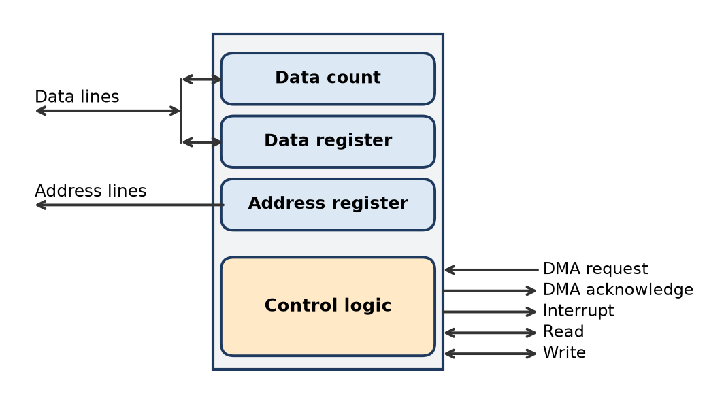
Figure: Typical DMA module
Need for DMA
1. In programmed and interrupt I/O, the transfer rate is limited by how fast the CPU can test and service the device.
2. The CPU is tied up executing many instructions for every word transferred.
3. Fast devices (disk, network card, sound/video) move large blocks – CPU-based transfer would waste most CPU time.
How it helps: CPU sends read/write, device address, memory start address and word count to the DMA module; DMA takes the bus, moves the block, then interrupts the CPU once.
Remember: DMA = "CPU gives the order, DMA does the delivery."

Q9. Explain how I/O devices are interfaced to the processor and memory.
Understand • CO4
I/O devices are not connected directly to the system bus; they are connected through an I/O module (interface/controller) that sits on the bus.
Figure: Interfacing devices through an I/O module
Interfacing method
1. System bus side: the I/O module connects to the address, data and control lines. Its I/O logic recognises its own address (address decoding) and decodes commands.
2. Device side: external device interface logic exchanges data, status and control signals with each device over a dedicated link.
3. Addressing scheme: either memory-mapped I/O (device registers in memory address space) or isolated I/O (separate I/O space with IN/OUT).
4. Transfer technique:
- Programmed I/O – CPU polls and moves data.
- Interrupt-driven I/O – device interrupts when ready.
- DMA – DMA controller moves data directly to/from memory.
5. External interfaces: point-to-point (keyboard) or multipoint buses (USB, PCIe, FireWire, InfiniBand) for many devices.
Example: a keyboard controller has a data register and status register; the CPU reads the status to know a key is pressed, then reads the data register.
Remember: Device → Interface logic → I/O module → System bus → CPU / Memory.

Q10. Discuss the working/ role and operation of the Intel 8237A DMA Controller.
Understand • Low • CO4
The Intel 8237A is a programmable DMA controller used with 8085/8086/8088 systems. It supplies memory address and control signals so data moves between I/O and memory without the CPU.
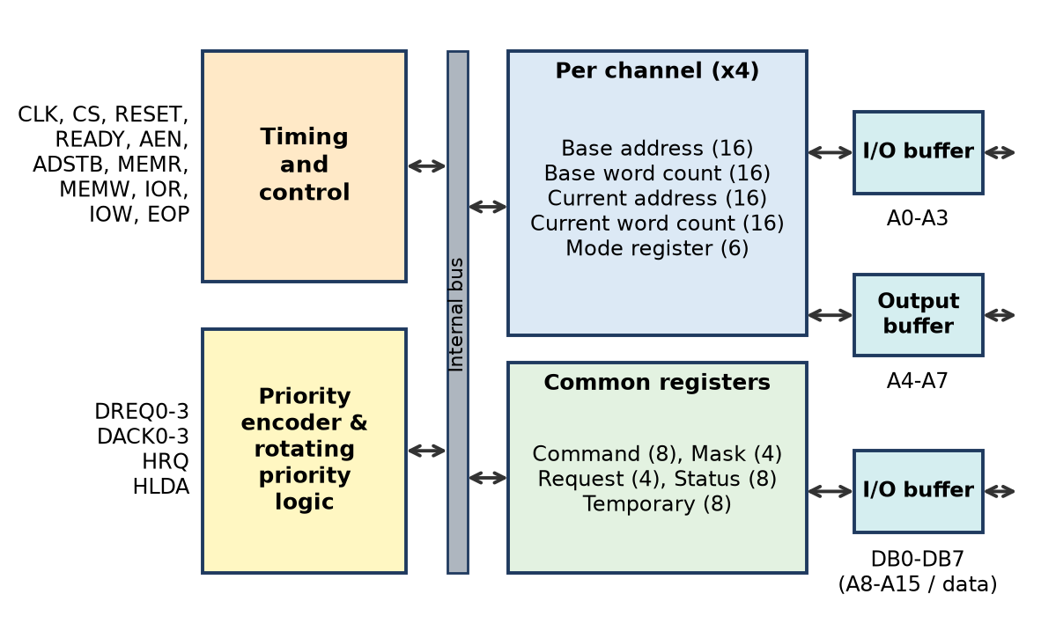
Figure: 8237A internal block diagram
Role / features: 4 independent channels (0–3), 16-bit address and count (64 KB per channel), modes single, block, demand, cascade, transfer types read/write/verify, fixed or rotating priority, memory-to-memory using channels 0 and 1, about 1.6 MB/s.
Operation
1. Device raises DREQ on its channel.
2. 8237A sends HRQ to CPU's HOLD pin.
3. CPU finishes its bus cycle and replies with HLDA.
4. 8237A activates DACK to the device and puts the address on the bus.
5. Data moves directly using MEMR + IOW (memory → device) or IOR + MEMW (device → memory); current address and word count update.
6. When the count ends, TC/EOP is generated, bus is returned to the CPU, and the CPU is informed.
Remember: Handshake order – "DREQ → HRQ → HLDA → DACK → transfer → EOP."

Q11. What is an I/O interface? Explain how it helps connect peripherals to the processor.
Understand • Low • CO4
An I/O interface is the hardware (plus its control logic) that connects a peripheral to the system bus, converting signals, formats and timing so the CPU can treat the device simply.
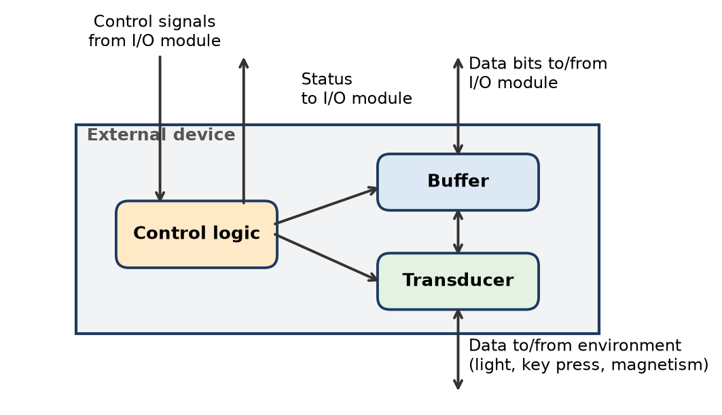
Figure: Block diagram of an external device and its signals
How it helps
1. Signal and format conversion – the device's transducer changes light/keystroke/magnetism into electrical bits and the interface converts serial ↔ parallel.
2. Speed matching – buffers data between fast CPU and slow device.
3. Control and status – passes control signals (start, read, seek) to the device and returns status (ready, busy, error).
4. Address decoding – responds only to its own port address.
5. Error detection – parity checks, reports faults.
Examples: keyboard controller, USB controller, disk controller, network card.
Remember: Interface = "adapter plug" between the CPU's language and the device's language.

Q12. Define an Interrupt and explain its classification based on functionality.
Understand • Low • CO4
An interrupt is a signal that makes the processor suspend the current program, run an interrupt service routine (ISR), and then resume the program from where it stopped.
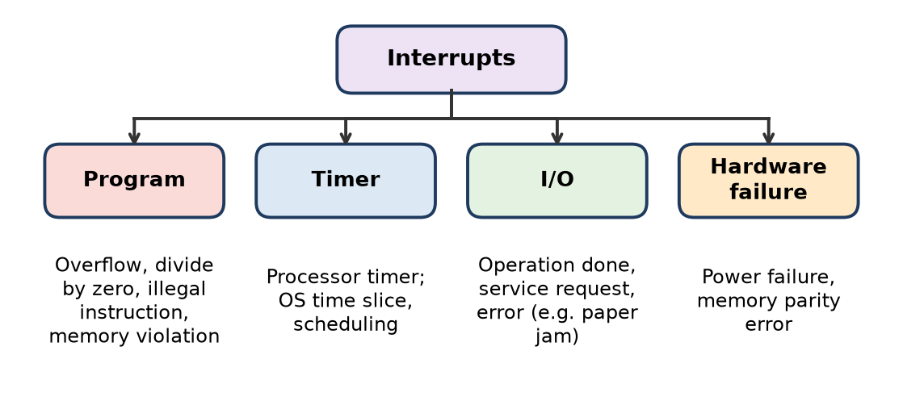
Figure: Classes of interrupts
Classification by function (Stallings)
1. Program – caused by an instruction: arithmetic overflow, divide by zero, illegal instruction, memory protection violation.
2. Timer – generated by the processor's timer; lets the OS do time-slicing and scheduling.
3. I/O – from an I/O controller: operation completed, request for service, or error.
4. Hardware failure – power failure, memory parity error.
Other classifications: hardware vs software (INT n), maskable vs non-maskable (INTR vs NMI), vectored vs non-vectored.
Remember: "PTIH" – Program, Timer, I/O, Hardware failure.

Q13. Draw and discuss the functions of Intel 82C59A Interrupt Controller.
Understand • Low • CO4
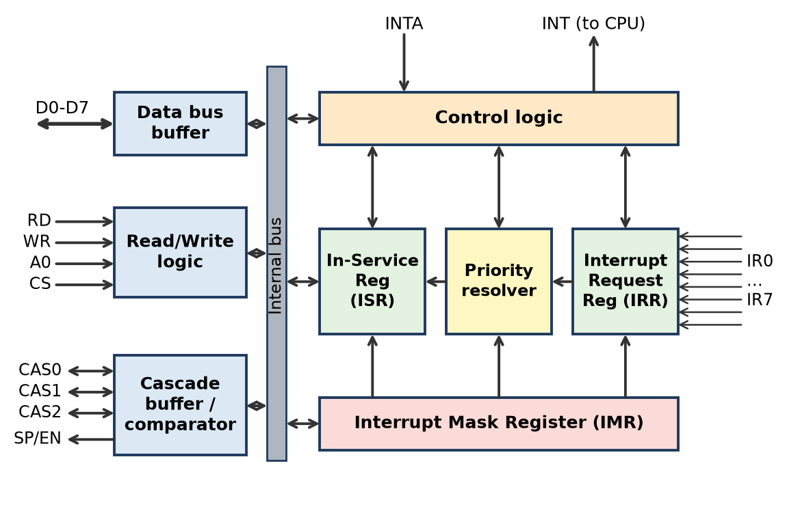
Figure: 82C59A PIC block diagram
Functional blocks
1. Interrupt Request Register (IRR) – 8-bit; stores all requests arriving on IR0–IR7.
2. Priority Resolver – picks the highest-priority request from IRR (using IMR and ISR).
3. In-Service Register (ISR) – 8-bit; marks which interrupt(s) are being serviced.
4. Interrupt Mask Register (IMR) – 8-bit; a 1 bit masks (disables) that IR line.
5. Control logic – sends INT to the CPU and receives INTA; places the vector on the bus.
6. Data bus buffer – 8-bit bidirectional link (D0–D7) for command words, status and vector.
7. Read/Write logic – accepts RD, WR, A0, CS to program ICWs/OCWs.
8. Cascade buffer/comparator – CAS0–CAS2 and SP/EN for master/slave cascading.
Remember: Request flows "IRR → Priority Resolver → ISR", with IMR as the gatekeeper.

Q14. Explain the interrupt processing steps with a flow diagram.
Understand • Low • CO4
When an interrupt occurs, a sequence of hardware and software events takes place.
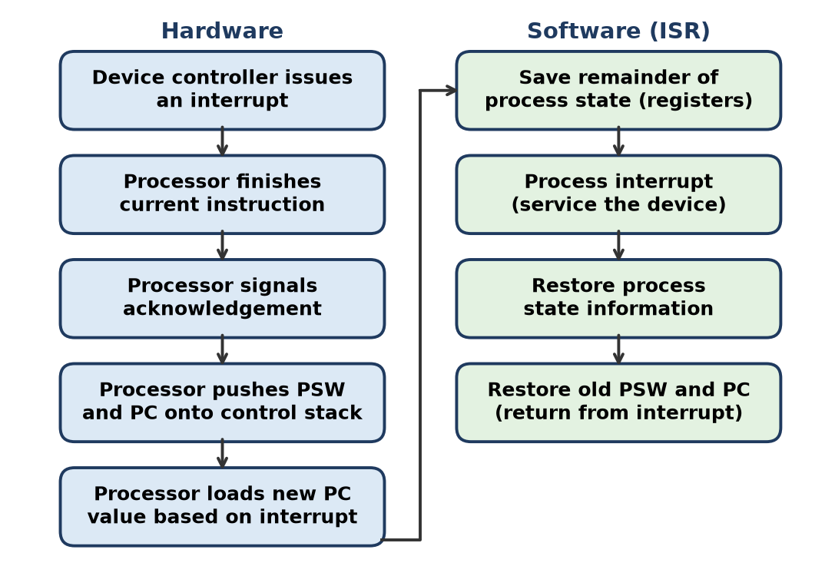
Figure: Simple interrupt processing
Hardware steps
1. Device controller issues an interrupt signal.
2. Processor finishes the current instruction.
3. Processor tests for interrupt and sends an acknowledgement (device removes its signal).
4. Processor pushes PSW and PC onto the control stack.
5. Processor loads the new PC (ISR address) based on the interrupt.
Software (ISR) steps
6. Save remaining registers (process state).
7. Process the interrupt (read status, transfer data).
8. Restore the saved registers.
9. Restore old PSW and PC – the interrupted program resumes.
Remember: "Finish, Acknowledge, Save, Jump, Serve, Restore, Return."

Q15. Compare Programmed I/O and Interrupt Driven I/O.
Analyze • Medium • CO4
Both techniques move data through the CPU, but differ in how the CPU knows the device is ready.
Point | Programmed I/O | Interrupt-driven I/O
Readiness check | CPU polls status repeatedly | Device interrupts CPU when ready
CPU during wait | Busy waiting, wasted | Executes other programs
CPU utilisation | Poor | Better
Hardware | Simple, no interrupt logic | Needs interrupt lines, controller (82C59A)
Software overhead | Polling loop | Context save/restore per interrupt
Response to device | Delayed by polling interval | Fast (end of current instruction)
Data path | Through CPU | Through CPU
Suitable for | Simple, dedicated, very fast-ready devices | Slow devices, multitasking systems

Analysis
- Programmed I/O is easy but wastes CPU cycles proportional to device delay.
- Interrupt I/O removes waiting but still costs one interrupt per word, so it is not ideal for bulk data (DMA is used there).
Conclusion: interrupt-driven I/O gives better CPU utilisation; programmed I/O is acceptable only when simplicity matters more than efficiency.
Remember: Polling = "child asking 'are we there yet?'"; Interrupt = "driver announces arrival."

Q16. Analyze the advantages of DMA over Programmed I/O.
Analyze • Medium • CO4
In programmed I/O the CPU moves every word and polls status; in DMA a DMA controller moves the whole block and the CPU only starts and finishes the job.
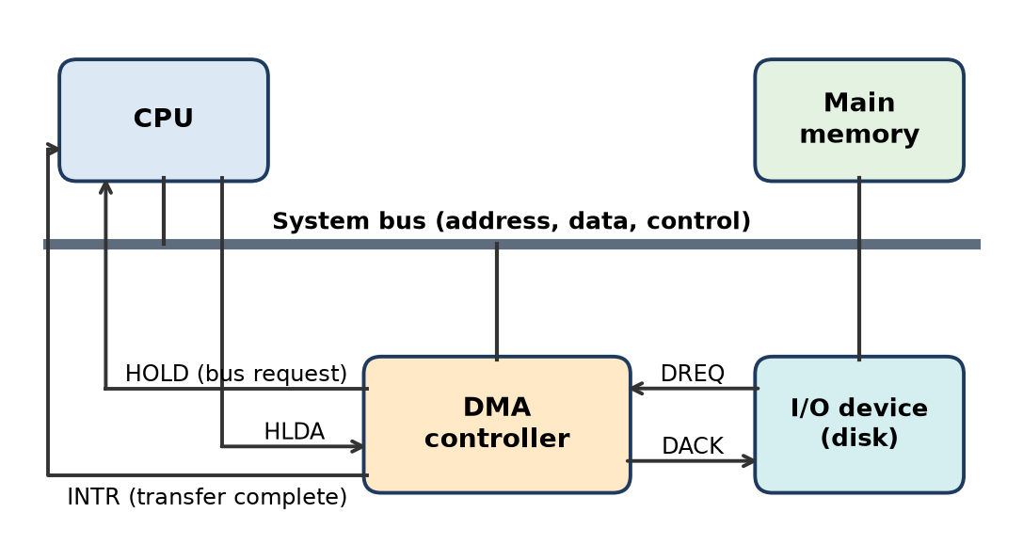
Figure: DMA controller in the system
Advantages of DMA
1. CPU is free – after giving the command (read/write, device address, memory address, count) the CPU runs other programs.
2. Higher transfer rate – limited by memory/bus speed, not by CPU instruction speed; ideal for disks, network and video.
3. No busy waiting – the CPU never loops on status.
4. Only one interrupt per block instead of per word → far less overhead.
5. Efficient bulk transfer – thousands of bytes with one setup.
6. Data path does not go through CPU registers, saving instruction fetches.
Point | Programmed I/O | DMA
CPU involvement | Every word | Start and end only
Speed | Slow | Fast
CPU waiting | Yes (polling) | No
Hardware | Simple | Needs DMA controller
Best for | Small, slow transfers | Large block transfers

Limitation: needs extra hardware and bus arbitration; CPU may pause briefly when DMA steals bus cycles.
Remember: DMA = "CPU signs the cheque once; DMA carries all the boxes."

Q17. Elaborate how the CPU interacts with peripheral devices through I/O ports.
Apply • Medium • CO4
An I/O port is an addressable register in an I/O interface (data, status or control register) through which the CPU talks to a device.
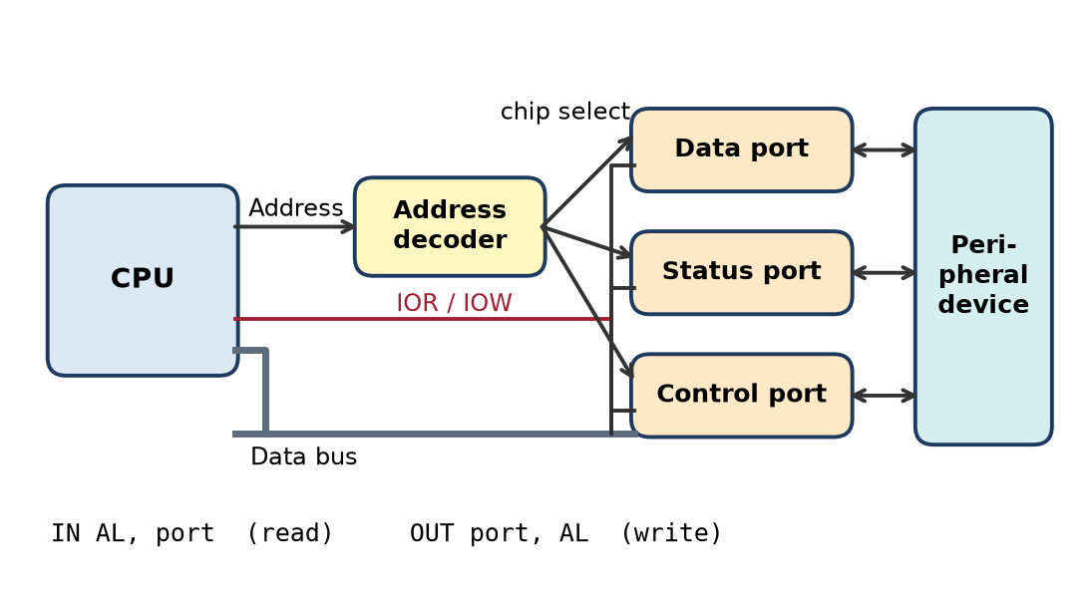
Figure: CPU and I/O ports
Interaction steps
1. Addressing: the CPU puts the port address on the address bus; the address decoder in the interface activates chip select of that port.
2. Command: the CPU activates IOW (write) or IOR (read) in isolated I/O, or MEMW/MEMR in memory-mapped I/O.
3. Control port: CPU writes a command byte (e.g. start, mode, baud rate).
4. Status port: CPU reads status bits (READY, BUSY, ERROR) – by polling or after an interrupt.
5. Data port: CPU reads input data (keyboard scan code) or writes output data (character to printer) over the data bus.
Instructions (x86, isolated I/O): IN AL, port reads a byte from a port into AL; OUT port, AL sends AL to a port. In memory-mapped I/O, normal MOV instructions are used.
Example – printing a character: read status port until READY = 1 → OUT the character to the data port → write "strobe" bit in the control port.
Remember: Three ports, three jobs – Control (tell), Status (ask), Data (give/take).

Q18. Differentiate between Memory-Mapped I/O differs and Isolated I/O.
Apply • Medium • CO4
Figure: Memory-mapped vs isolated I/O
Point | Memory-mapped I/O | Isolated (I/O-mapped) I/O
Address space | One space shared by memory and I/O | Separate spaces for memory and I/O
Instructions | Any memory instruction (MOV, ADD, AND) | Special IN / OUT only
Control signals | MEMR, MEMW only | MEMR, MEMW and IOR, IOW
Memory available | Reduced (part used by I/O) | Full memory space available
Programming | Flexible, any addressing mode | Limited to IN/OUT forms
Address decoding | Full address width, more logic | Smaller I/O addresses (e.g. 8/16-bit port)
Example | ARM processors, video RAM | Intel x86 ports

Example (10 address lines): memory-mapped → 1024 addresses shared (e.g. 0–511 memory, 512–1023 I/O); isolated → 1024 memory + 1024 I/O addresses.
Conclusion: memory-mapped I/O gives programming flexibility at the cost of address space; isolated I/O keeps memory space free but needs special instructions.
Remember: "Mapped = mixed in memory; Isolated = IN/OUT only."

Q19. Analyze the timing sequence of an interrupt-driven I/O operation.
Analyse • Medium • CO4
The timing shows overlap: the CPU runs another program while the slow device prepares data.
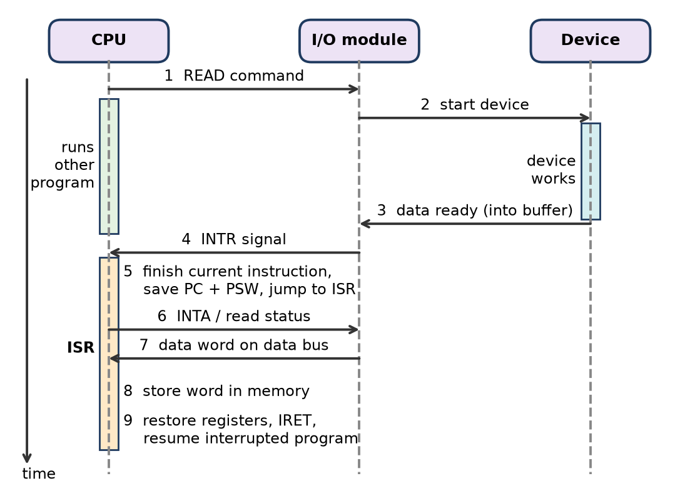
Figure: Timing sequence of interrupt-driven input
Sequence
1. t1: CPU issues READ command to the I/O module.
2. t2: I/O module starts the device; CPU returns to other work (useful time).
3. t3: device delivers data into the I/O module buffer.
4. t4: I/O module raises INTR.
5. t5: CPU completes the current instruction, checks for interrupt, saves PC and PSW, loads ISR address.
6. t6–t7: ISR sends INTA/reads status; module places the data word on the data bus.
7. t8: CPU stores the word in memory.
8. t9: registers restored, IRET; interrupted program continues. Repeat for the next word.
Analysis
- CPU idle time is replaced by useful work during the device delay.
- Overhead per word = interrupt latency + context save/restore + ISR.
- For slow devices this overhead is small; for fast block devices it becomes large → DMA is preferred.
Remember: "Command – work elsewhere – INTR – save – serve – restore."

Q20. Compare the performance of Programmed I/O vs DMA in data transfer.
Apply • Medium • CO4
Point | Programmed I/O | DMA
Who moves data | CPU, word by word | DMA controller
CPU involvement | Entire transfer | Only setup and final interrupt
CPU waiting | Busy-waits on status | None; continues other work
Transfer rate | Limited by CPU loop speed | Limited by memory/bus speed (much higher)
Interrupts / polls | One status check (or more) per word | One interrupt per block
Bus usage | Each word crosses bus twice (device → CPU → memory) | Once (device → memory) in integrated / I/O-bus DMA
Hardware cost | Low | Extra DMA controller
Best for | Small, slow, simple transfers | Large blocks: disk, network, audio/video

Illustration – reading a 4 KB block, 1 byte per transfer
- Programmed I/O: CPU performs 4096 status checks, 4096 reads from the module and 4096 writes to memory, plus extra polling loops while the device is not ready.
- DMA: CPU writes a few registers (address, count, mode), one interrupt at the end; the 4096 transfers are done by the DMA controller (in burst or cycle-stealing mode).
Conclusion: DMA gives much higher throughput and frees the CPU; programmed I/O is acceptable only for tiny, infrequent transfers.
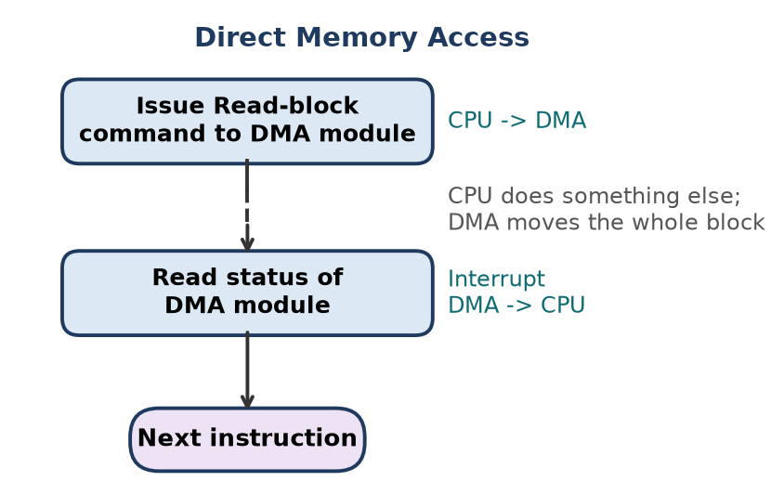
Figure: DMA flow
Remember: "PIO = CPU as porter; DMA = conveyor belt."

Q21. Design an I/O subsystem for high-speed data transfer using DMA.
Apply • High • CO4
Situation: a system must move large blocks of data at high speed (e.g. disk, Gigabit Ethernet, camera) without loading the CPU.
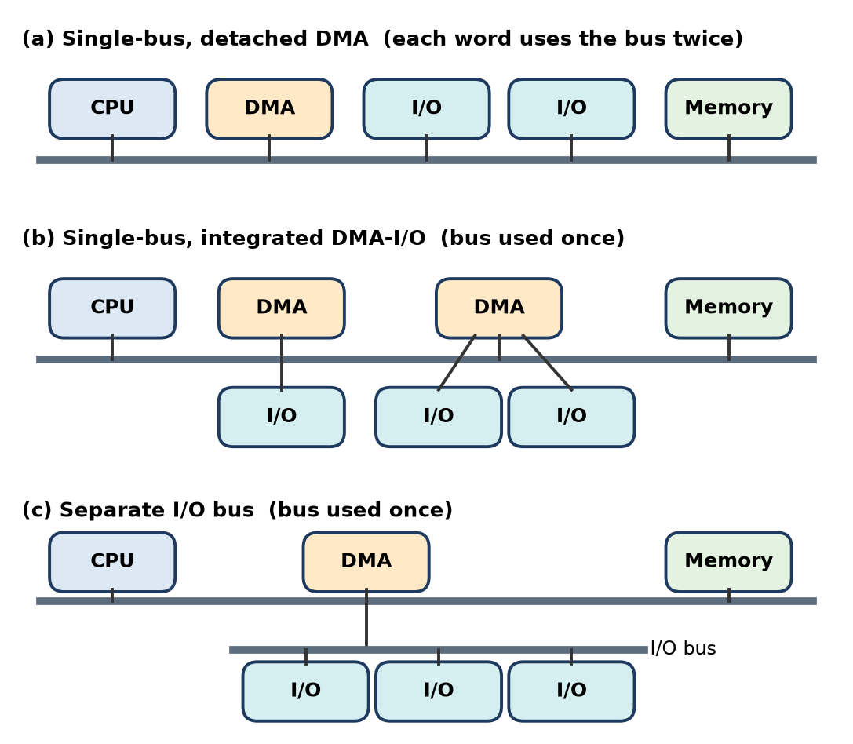
Figure: DMA configurations
Design
1. Use a DMA controller (e.g. 8237A-type, or bus-master DMA in the device) with several channels – one per high-speed device, with programmable priority.
2. Choose the configuration:
- Avoid (a) single-bus detached DMA – each word uses the bus twice.
- Prefer (b) integrated DMA-I/O or (c) a separate I/O bus, so each word uses the system bus only once.
3. Registers per channel: memory address, word count, mode (direction, burst/cycle-steal, auto-initialise).
4. Transfer mode: burst/block mode for disks (data cannot be paused); cycle stealing for devices sharing the bus with the CPU; demand mode for devices with bursts.
5. Handshake: DREQ/DACK with devices; HOLD/HLDA (bus request/grant) with CPU; interrupt at terminal count.
6. Buffering: FIFO buffers in each device interface to absorb speed differences.
7. Scatter-gather / descriptor chaining: DMA follows a list of buffers so the CPU sets up many transfers at once.
8. Cache coherence: flush/invalidate cache for DMA buffers (or use coherent DMA hardware).
Working: CPU programs the channel → device asserts DREQ → DMAC gets bus (HOLD/HLDA) → DACK → data moves memory ↔ device → count reaches zero → EOP/interrupt → CPU checks status.
Figure: DMA controller connections
Conclusion: a multi-channel DMA with an I/O bus or integrated DMA-I/O, burst mode and FIFO buffers gives maximum throughput with minimal CPU load.
Remember: Design checklist – "Channels, Configuration, Mode, Handshake, Buffer, Interrupt."

Q22. Propose a method to prioritize multiple interrupt sources using Intel 82C59A.
Apply • High • CO4
Problem: many devices (timer, keyboard, disk, network, printer…) interrupt the 8086, which has one INTR pin. The 82C59A resolves who is served first.
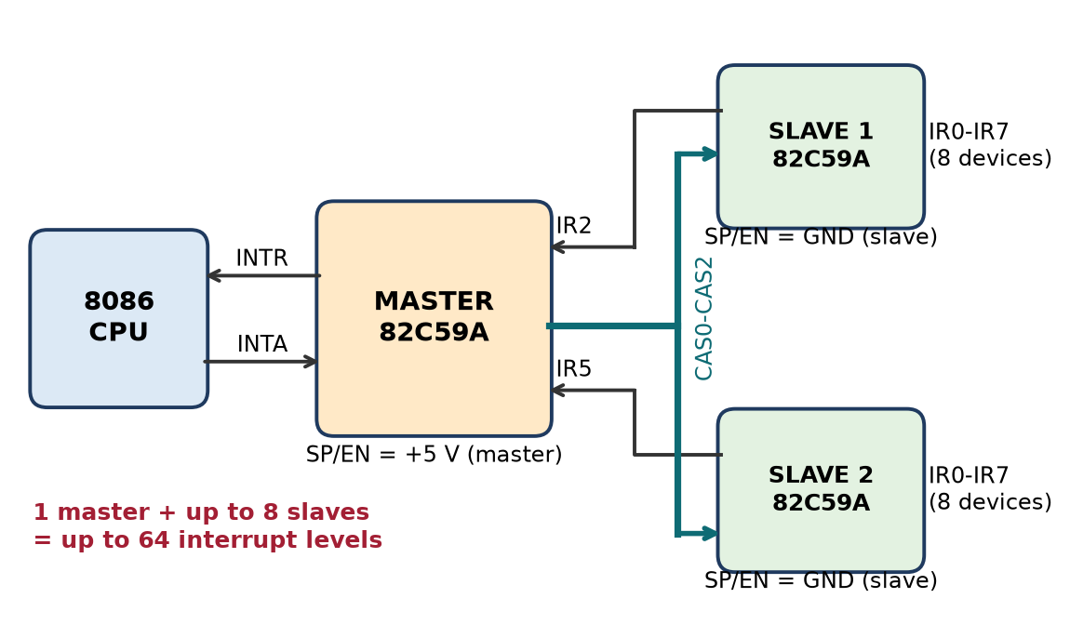
Figure: Cascading 82C59A controllers
Proposed method
1. Assign IR lines by importance: IR0 = system timer (highest), IR1 = keyboard, IR3/IR4 = serial ports, IR5 = disk, IR6 = floppy, IR7 = printer (lowest).
2. Cascade for more than 8 sources: master's IR2 (and others) connected to slave INT outputs; SP/EN = +5 V for master and GND for slaves; CAS0–CAS2 carry the slave ID. 1 master + 8 slaves = 64 levels.
3. Program with ICWs: ICW1 (edge/level, cascade), ICW2 (vector base, e.g. 08H), ICW3 (which IR has a slave), ICW4 (8086 mode, normal or auto EOI).
4. Select priority mode with OCWs:
- Fully nested mode (default) – IR0 highest, IR7 lowest; higher priority can interrupt a lower ISR.
- Automatic rotation – equal-priority devices; a serviced device becomes lowest next time (fair).
- Specific rotation – software sets which IR is lowest.
- Special mask mode – lets lower-priority devices interrupt while a high ISR is running.
5. Masking (OCW1/IMR): disable sources that must not interrupt at a given time.
6. End of interrupt (OCW2): ISR sends EOI so the next request can be accepted.
Working: requests set IRR bits → priority resolver compares with ISR and IMR → highest gets INT → CPU INTA → vector = base + IR number → its ISR runs.
Conclusion: priority = IR line position + programmable mode, with cascading for scale.
Remember: "Lower IR number = higher priority" in fully nested mode.

Q23. Justify the need for interrupt hierarchy in multiprocessor systems.
Apply • High • CO4
Interrupt hierarchy means interrupts are given priority levels and are routed through a structured set of controllers to the right processor.
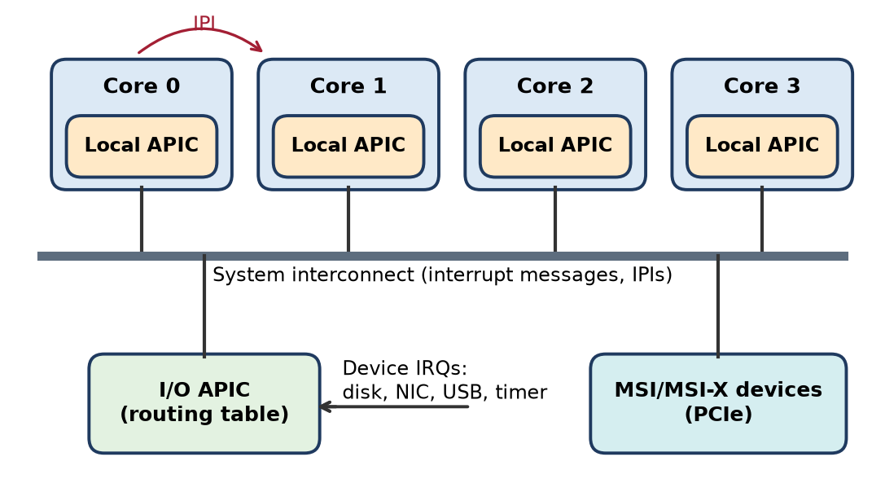
Figure: Interrupt hierarchy in a multicore system (APIC)
Why it is needed (justification)
1. Many sources, many CPUs: dozens of devices plus timers and inter-processor messages; without a hierarchy, all would collide on a single line.
2. Urgency differs: power failure, machine check and NMI must pre-empt everything; a keyboard can wait. Priority levels ensure critical events are never delayed by minor ones.
3. Nested interrupts: a higher-priority interrupt can interrupt a lower ISR, giving bounded response time for real-time tasks.
4. Load balancing / affinity: the I/O controller can send device interrupts to a less busy core, so one CPU is not overloaded.
5. Inter-Processor Interrupts (IPIs): processors need to signal each other (TLB shootdown, scheduling, shutdown) with defined priority.
6. Avoiding starvation and deadlock: clear priority and masking rules stop low-priority devices from being ignored forever or two CPUs servicing the same interrupt.
Typical implementation (x86):
- Local APIC in each core: handles its timer, IPIs and priority (task priority register).
- I/O APIC: receives device IRQs and routes them to chosen cores by a redirection table.
- MSI/MSI-X: PCIe devices send interrupts as memory writes directly to a core.
Conclusion: a hierarchy keeps multiprocessor systems responsive, fair and scalable as the number of devices and cores grows.
Remember: "Right interrupt, right priority, right processor."

Q24. Develop a flowchart for interrupt processing using the Intel 82C59A controller.
Apply • High • CO4
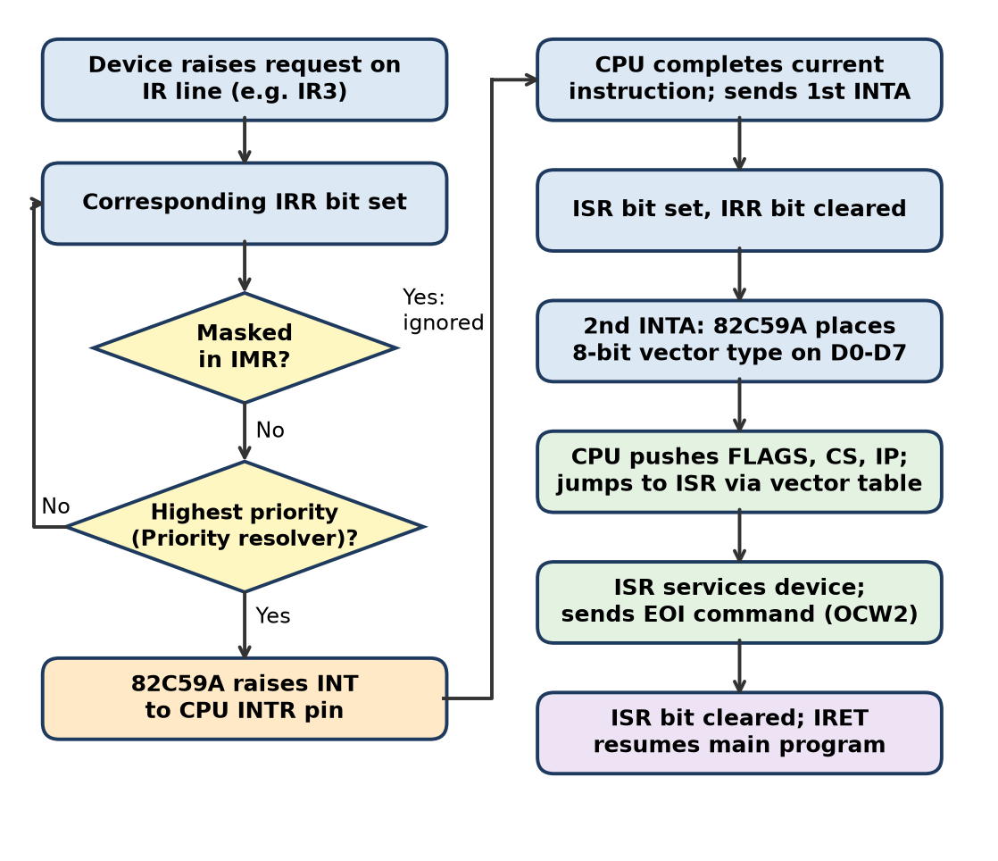
Figure: Interrupt processing with 82C59A
Explanation of the flow
1. A device raises its IR line; the matching IRR bit is set.
2. If the bit is masked in the IMR, the request is ignored (it stays pending).
3. The priority resolver checks whether it is the highest pending request and higher than any interrupt in service (ISR). If not, it waits.
4. 82C59A drives INT high to the CPU's INTR pin (if CPU interrupts are enabled, IF = 1).
5. CPU completes the current instruction and sends the first INTA pulse; the 82C59A sets the ISR bit and clears the IRR bit.
6. On the second INTA, the 82C59A places the 8-bit interrupt type (vector) on D0–D7 (type = ICW2 base + IR number).
7. CPU pushes FLAGS, CS, IP, clears IF/TF, and jumps to the ISR address from the vector table (address = type × 4).
8. ISR services the device and sends an EOI command (OCW2), unless auto-EOI is used.
9. EOI clears the ISR bit; IRET restores IP, CS, FLAGS and the main program resumes.
Note: in a cascaded system, the master sends the slave's ID on CAS0–CAS2 at the first INTA, and that slave supplies the vector.
Remember: Two INTA pulses – first "freeze & mark ISR", second "send the vector."

Q25. Critically evaluate DMA vs Interrupt-Driven I/O for real-time applications.
Evaluate • High • CO4
Real-time applications (industrial control, medical monitors, audio/video, automotive) need guaranteed, predictable response and often continuous data streams.
Criterion | Interrupt-driven I/O | DMA
Response to an event | Very fast (next instruction boundary) | Needs setup; good for planned transfers
Throughput for bulk data | Low – one interrupt per word | High – one interrupt per block
CPU load | High at high data rates | Low
Determinism | Good for few, rare events; poor under interrupt storms | Predictable transfer time; but bus stealing can delay CPU
Latency per item | ISR overhead per word | Very small per word
Hardware cost | Low | DMA controller, bus arbitration
Complexity | Simple ISR | Buffer setup, cache coherence

Evaluation
1. Interrupt-driven I/O is better for sporadic, low-volume, time-critical events – e.g. an emergency stop button or a sensor threshold – because the CPU reacts immediately and can decide what to do.
2. DMA is better for high-rate continuous streams – ADC sampling, audio buffers, camera frames, network packets – because per-word interrupts would overload the CPU and cause missed deadlines.
3. Risks: with interrupts, high data rates cause interrupt overload and jitter; with DMA in burst mode the CPU can be blocked from the bus, which may delay its own real-time tasks (cycle stealing reduces this).
4. Best practice: combine both – DMA moves data into double (ping-pong) buffers and raises an interrupt when a buffer is full; the CPU processes one buffer while DMA fills the other.
Conclusion: neither alone is ideal; interrupts for control events, DMA for data streams, used together, give real-time systems both fast response and high throughput.
Remember: "Interrupt for urgency, DMA for volume."

Q26. Propose enhancements to I/O device interfacing for improved data throughput.
Apply • High • CO4
Goal: move more data per second between devices and memory while using less CPU time.
Proposed enhancements
1. DMA and bus mastering – let devices (disk, NIC, GPU) transfer directly to memory; use scatter-gather lists to avoid copying.
2. I/O channels / I/O processors – a dedicated processor runs I/O programs from memory and interrupts the CPU only at completion (selector channel for fast devices, multiplexer channel for many slow ones).
3. Faster serial point-to-point links – replace wide shared parallel buses with PCIe lanes, USB 3.x, SATA/NVMe; more lanes give more bandwidth and no bus contention.
4. NVMe-style multiple queues – many command queues (one per core) allow parallel requests without locking.
5. Buffering and FIFOs – larger device buffers and double buffering so devices never wait for the CPU.
6. Interrupt coalescing / moderation – generate one interrupt for many packets or blocks, cutting overhead.
7. Memory-mapped I/O with write combining – group small writes into burst transactions.
8. Caching and prefetching – disk caches, read-ahead, SSD caching in front of HDD.
9. RAID striping – read/write several disks in parallel.
10. Switched fabrics – InfiniBand-type switches for servers to connect many devices with high bandwidth.
Enhancement | Benefit
DMA / bus mastering | CPU-free block transfer
I/O processor | Offloads full I/O programs
PCIe / NVMe | High bandwidth, parallel queues
Interrupt coalescing | Less overhead per byte
Buffering / RAID | Smoother, parallel data flow

Conclusion: combining DMA, fast serial interconnects, deep buffers and reduced interrupt overhead gives the largest gain in I/O throughput.
Remember: "Offload, widen, buffer, batch" – four ways to push more I/O.

Q27. Suggest improvements in interrupt handling mechanisms for modern processors.
Apply • High • CO4
Interrupts add latency and overhead (context save, pipeline flush, cache pollution). Modern systems with many cores and very fast devices need better handling.
Suggested improvements
1. Vectored interrupts – the device/controller supplies the ISR address directly, avoiding software polling.
2. Advanced interrupt controllers (APIC / x2APIC, ARM GIC) – programmable priorities, per-core delivery, inter-processor interrupts.
3. Message Signaled Interrupts (MSI/MSI-X) – a PCIe device writes a message to a special address instead of using a shared wire; no line sharing, many vectors per device, can target a specific core.
4. Interrupt affinity / steering – route each device's interrupts to a chosen core to balance load and keep its data in that core's cache.
5. Interrupt coalescing – NICs and SSDs raise one interrupt for a batch of events.
6. Hybrid polling (e.g. Linux NAPI) – under heavy load switch from interrupts to polling, then back to interrupts when traffic is low.
7. Split handlers (top half / bottom half) – keep the ISR very short; do the rest in a deferred task or thread so other interrupts are not blocked.
8. Faster context switching – banked/shadow registers (e.g. ARM FIQ mode has extra registers) so fewer registers are saved.
9. Priority and nesting with tail-chaining – e.g. ARM Cortex-M NVIC can go from one ISR to the next without fully restoring context.
10. Virtualised interrupts – deliver interrupts directly to virtual machines to cut hypervisor overhead.
Problem | Improvement
Too many interrupts | Coalescing, NAPI polling
Long latency | Vectoring, shadow registers, tail-chaining
One core overloaded | Affinity, MSI-X
Shared IRQ lines | MSI/MSI-X

Conclusion: fewer, faster and better-targeted interrupts make modern processors more responsive and efficient.
Remember: "Fewer, faster, targeted" – the three goals of modern interrupt handling.

Q28. Evaluate how I/O subsystem architecture affects overall system performance.
Apply/Evaluate • High • CO4
Overall performance depends not only on CPU speed but on how fast data can move into and out of the system. A slow I/O design becomes the bottleneck, as explained by Amdahl's law – speeding up the CPU alone gives little gain if much of the time is spent waiting for I/O.
Factors and their effect
1. I/O technique
- Programmed I/O – CPU wastes time polling → low throughput.
- Interrupt-driven – CPU overlaps work, but overhead per word.
- DMA / I/O processors – CPU almost free, highest throughput.
2. Bus / interconnect architecture – shared parallel bus causes contention; separate I/O bus, integrated DMA-I/O or point-to-point links (PCIe) raise bandwidth.
3. Buffering and caching – buffers in I/O modules and disk caches smooth speed differences and hide latency.
4. Interrupt structure – priority controllers (82C59A, APIC) give fast response to important devices; poor design causes interrupt storms and jitter.
5. Addressing scheme – memory-mapped I/O gives flexible instructions; isolated I/O saves memory space.
6. Storage organisation – RAID striping, SSDs and NVMe queues increase I/O rate.
7. Parallelism – I/O channels, multiple DMA channels and multicore interrupt steering allow many transfers at once.
Architecture choice | Effect on performance
Polling only | CPU utilisation low
Interrupts | Better overlap, overhead per item
DMA / channels | High throughput, low CPU load
Shared bus | Contention, bottleneck
Point-to-point / switched | Scalable bandwidth
Buffers and caches | Lower latency seen by CPU

Example: a database server with a fast CPU but a single HDD on a shared bus spends most time waiting; moving to NVMe SSDs with DMA and multiple queues greatly improves transactions per second without changing the CPU.
Conclusion: a balanced system needs an I/O subsystem matched to CPU and memory speed – DMA, fast interconnects, buffering and good interrupt handling turn I/O from a bottleneck into a strength.
Remember: "A computer is only as fast as its slowest door" – I/O is that door.

Quick Revision – Unit IV
Term | Key fact
I/O module functions | Control & timing, processor comm., device comm., buffering, error detection
External device types | Human-readable, machine-readable, communication
I/O commands | Control, Test, Read, Write
Programmed I/O | CPU polls status and moves every word (busy waiting)
Interrupt-driven I/O | Device interrupts when ready; CPU does other work meanwhile
DMA | DMA controller moves block directly; CPU only at start and end
Memory-mapped I/O | One address space; MOV/LOAD/STORE; MEMR/MEMW
Isolated I/O | Separate I/O space; IN/OUT; IOR/IOW
Interrupt classes | Program, Timer, I/O, Hardware failure
Device identification | Multiple lines, software poll, daisy chain, bus arbitration
82C59A | 8 IR inputs, cascade to 64; IRR, ISR, IMR, priority resolver; ICW1–4, OCW1–3
82C59A modes | Fully nested, automatic rotation, specific rotation, special mask, polled
8237A | 4 channels, 64 KB each; single, block, demand, cascade modes
DMA handshake | DREQ → HRQ/HOLD → HLDA → DACK → transfer → EOP/TC
DMA transfer modes | Burst, cycle stealing, transparent
DMA configurations | Detached single bus (bus used twice), integrated DMA-I/O, separate I/O bus

